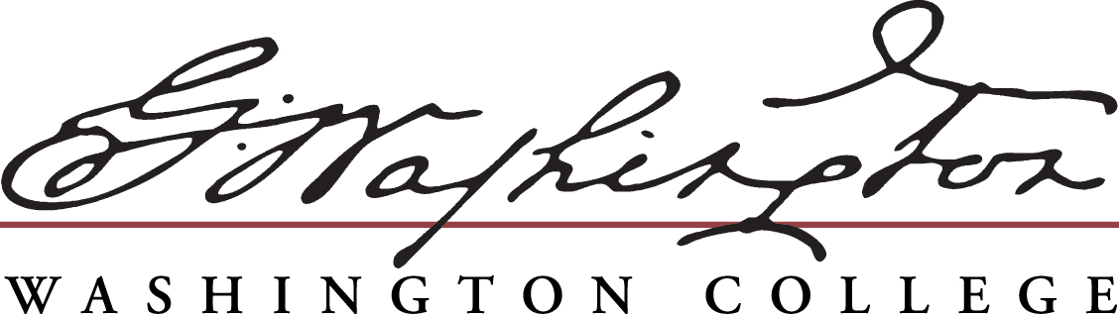

**2014**

**Student Employee of the Year Nomination Form**

The Student Employment Advisory Group will accept nominations for Washington College’s Student Employee of the Year award. The recipient of this award will be a student nominated by their department and selected as one who best embodies service excellence, dedication, a stellar work ethic, and academic quality.

**Eligibility**

* Student nominated may either be a Federal Work-Study student, or employed as a regular student employee.
* Student must have been employed by your department for a minimum of two semesters.
* Students must be nominated by their supervisor.
* Nominee must be in good academic standing, with a cumulative GPA of at least 2.5.

**Nominations**

To nominate your student employee submit a nomination form to Natalie Story, by FRIDAY, FEBRUARY 14, 2014 at 4:30PM. Supervisors may only nominate one student employee.

**Application Tips**

* We welcome supporting materials such as performance evaluations, samples of work, resumes, etc.
* Nominations will be judged on presentation and accuracy as well as on content.
* Make copies of all nomination materials.
* Outstanding Nominee applications will include solid evidence to back up the superlatives they contain.

**Recognition**

* The winner will be announced during the Student Employee of the Year Award Celebration held during the week of April 14 - 18, 2014.
* Information regarding prizes will be available at a later date.



**Nominations accepted December 2, 2013 – February 14, 2014**

|  |  |  |
| --- | --- | --- |
| **Student Name** | **Student Job Title** | **Length of Employment** |
| **Name of Nominator** | **Nominator’s Campus Department** | **Nominator’s Phone Number and Email** |

Student’s Washington College ID Number: ______________

Each nominee is being judged on six qualities for the Student Employee of the Year competition. Please respond to the following questions or statements describing why this student is deserving of being named **Washington College’s Student Employee of the Year.** To complete your nomination, also include a **resume** from the student employee and the student’s **job description**.

1. Tell how this student exhibited reliability beyond your expectations.
2. Describe the outstanding quality of work of your nominee.
3. Give details of a time in which your nominee showed extraordinary initiative.
4. How does this employee’s attitude exceed your expectations?
5. How does the employee display exceptional professionalism in his or her duties?
6. What unique contribution has this employee given to your department?
7. How many Washington College sponsored Student Employment Enrichment Programs has this student attended in the past year?

**Washington College Student Employee of the Year Nomination Rubric**

**RATING SCORE: RANGE LIMITS:**

(To be completed by Nominator)

|  |  |  |  |  |  |
| --- | --- | --- | --- | --- | --- |
| **CRITERIA** | **MET**  **EXPECTATIONS** | **FREQUENTLY**  **EXCEEDED**  **EXPECTATIONS** | **CONSISTENTLY**  **EXCEEDED**  **EXPECTATIONS** |  | **NUMERICAL**  **PERFORMANCE**  **RATING** |
| **Rating** | **1 – 5** | **6 – 10** | **11 – 15** |  | **1 - 15** |
| **Service Excellence**  *Relationships with the college community and the general public and response to their needs.* | Attentive to needs. Asked questions to identify service needs and expectations. | Actively explored needs and exceeded their expectations. Responded promptly for requests for service. | Anticipated needs and provided a level of service that elicited favorable responses. Took responsibility for resolving conflict. |  |  |
| **Innovation and Achievement**  *Creativity used to improve job productivity and efficiency, including new ideas and suggestions.* | Often made suggestions for improving methods and procedures by benchmarking. | Frequently sought potential beneficial changes and improvements; contributed to a departmental improvement effort. Exhibited ability to learn and apply new skills. | Very innovative; suggested and implemented a significant contribution to improve operations, utilizing best practices. Pursued development opportunities. |  |  |
| **Diversity and Respect**  *Treatment of people who are different from him/herself* | Saw individual differences in others as opportunities to learn; was sensitive to own behavior and its impact on others before acting. Understands the value of diversity. | Confronted behavior that did not value differences in an appropriate and nonjudgmental manner; puts him/herself in “another’s position” and demonstrates consideration for others. | Contributed to an environment where differences were valued and encouraged; understood all points of view with empathy.  Supported building a diverse workforce. |  |  |
| **Teamwork and Cooperation**  *Willingness to develop partnerships with others.* | Established rapport with appropriate ease; sought others for support and involvement. Gave back welcomed feedback. | Pursued opportunities to work as part of a team; willingly shared resources. Established collaborative relationships to achieve objectives. | Actively sought partnerships; built strong relationships with people at all levels and across units. Contributed to building a positive team spirit. |  |  |
| **Leadership/Initiative**  *Ability of student to embody the vision of the College.* | Played a lead role in the accomplishment of an assignment or project. Took responsibility for work produced | Mobilized others in the accomplishment of an assignment or project without being asked; willingly took on projects beyond his/her normal scope. Reacted well under pressure. | Inspired others to perform at a higher level than they believed possible; volunteered for challenging assignments and expanded scope of contribution. Showed courage to take action. |  |  |
|  |  |  | Total Score |  |  |

15 Meritorious

11 – 14 Consistently Met Expectations

6 – 10 Frequently Met Expectations

1 – 5 Met expectations

**_____________________________________________________________________________________________________________________**

**DEADLINE: February 14, 2014 at 4:30 PM**

**Please return this nomination form to:**

**Natalie Story, Associate Director**

**Office of Student Aid**

**410-778-7214**

**Email:** [**nstory2@washcoll.edu**](mailto:nstory2@washcoll.edu)