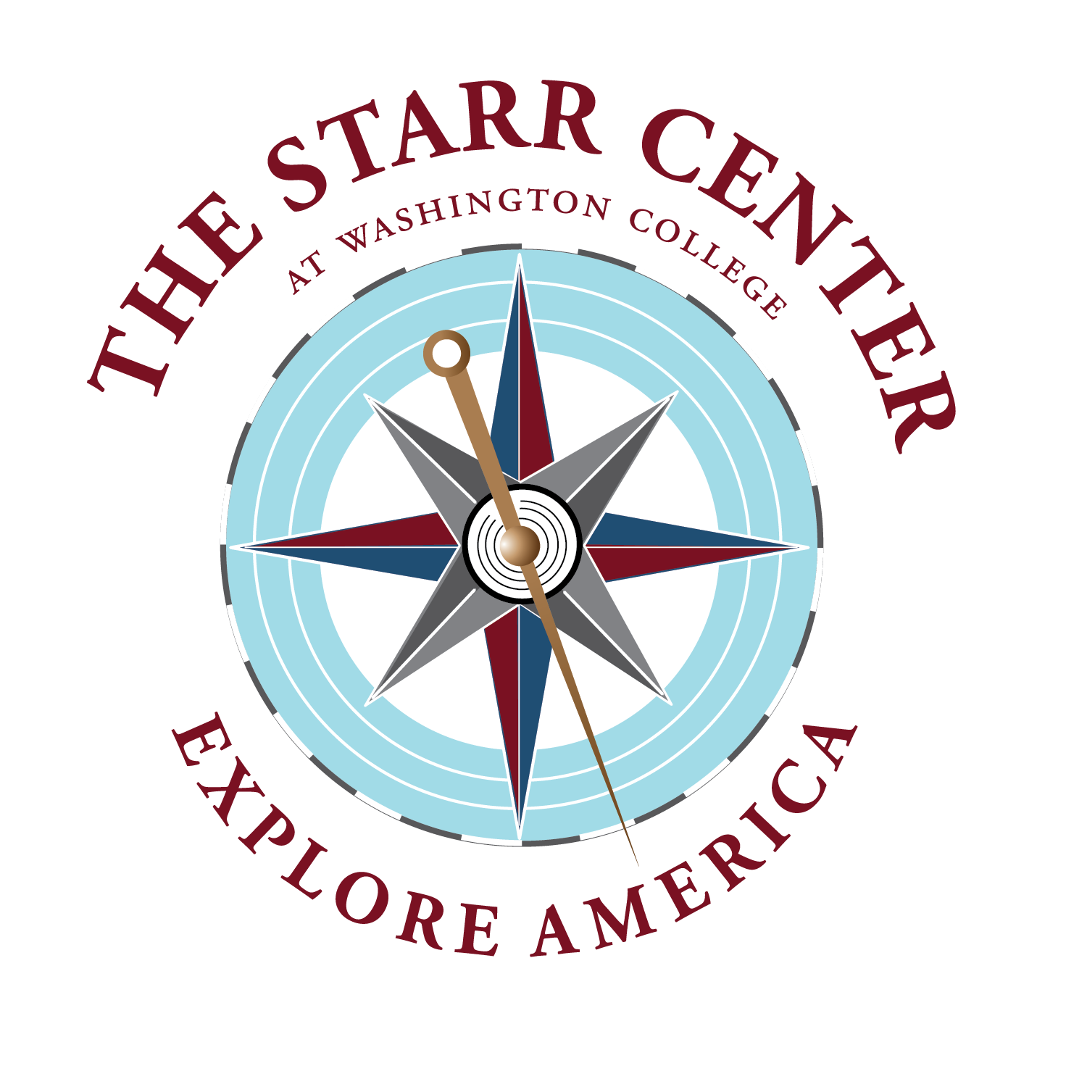

Patrick Henry History Fellowship
The Starr Center for the Study of the American Experience invites applications for its full-time residential fellowship, which supports outstanding work on American history and culture by both scholars and nonacademic authors. The deadline for applications for the 2022-2023 Patrick Henry History Fellowship is November 15, 2021.
The Center’s Patrick Henry History Fellowship includes a $45,000 stipend, health benefits, faculty privileges, a book allowance, and a nine-month residency (during the academic year 2022-2023) in historic Chestertown, Md. Applicants working on a broad range of topics related to American history and culture are eligible; academic affiliations or advanced degrees are not required.
Applicants should have a significant project currently in progress – a book, film, oral history archive, podcast series, museum exhibition, or similar work. The project should address the history and/or legacy – broadly defined – of the U.S. founding era and/or the nation’s founding ideas. It might focus directly on early America, or on the myriad ways the questions that preoccupied the nation’s founding generation have shaped America’s later history. Innovative work that contributes to ongoing national conversations about America’s past and present, with the potential to reach a wide public, is particularly sought.
Please note that neither the fellowship, Washington College, nor the Starr Center have any political agenda or orientation. We encourage a broad reading of such terms as “founders” and “founding ideas.” Past fellowship topics have ranged as broadly as the early history of the slave trade, American religious minorities, and the LGBTQ rights movement.
Applications from published writers and established scholars are welcome. Dissertation projects will not be considered; first book projects are likewise discouraged, unless the applicant has an otherwise extensive publication history. Candidates who have completed the majority of their research and are focused on the writing phase of their projects are especially encouraged to apply.
The Starr Center, located at Washington College in Chestertown, Md., is an interdisciplinary center dedicated to fostering innovative approaches to the American past, and to promoting excellent writing on history, for general as well as academic audiences.
The 2022-2023 Patrick Henry Fellow will maintain full-time residence in Chestertown throughout the term of the award, although short-term research travel is permitted. (Chestertown is located on the Eastern Shore of Maryland, approximately 90 minutes from Washington and Philadelphia, and three hours from New York City.) In addition to use of the fellowship residence (which is large enough to accommodate a family), the fellow will also receive office space in the 18th-century waterfront Custom House, home of the Starr Center.
The fellow will teach an undergraduate seminar at Washington College in the spring semester and give at least one public lecture or workshop related to his or her work. The fellowship must begin before September 15, 2022.
Applications should include the following:
- A cover letter;
- The applicant’s curriculum vitae, including a list of past publications, as well as the names and telephone numbers of at least three references;
- At least one substantial sample of the candidate’s writing (published or unpublished);
- A short (1-2 paragraph) description of a course that the candidate might teach;
- A brief but persuasive narrative description of the work-in-progress, its potential contributions to ongoing national conversations or debates, and the candidate’s plan for his or her fellowship year.
Questions may be directed to Assistant Director Amber McGinnis at amcginnis3@washcoll.edu
Deadline for the 2022-2023 fellowship is November 15, 2021.
Applications may be submitted via email on a single pdf document mailed to: applications_starrcenter@washcoll.edu
All email correspondence must include applicant’s full name in the subject line.
Support for the Starr Center Fellowships at Washington College comes from the National Endowment for the Humanities, the Starr Foundation, the Hodson Trust, the Barksdale-Dabney-Patrick Henry Family Foundation, and other donors and friends. The Patrick Henry Fellowship is cosponsored by the Rose O’Neill Literary House.

