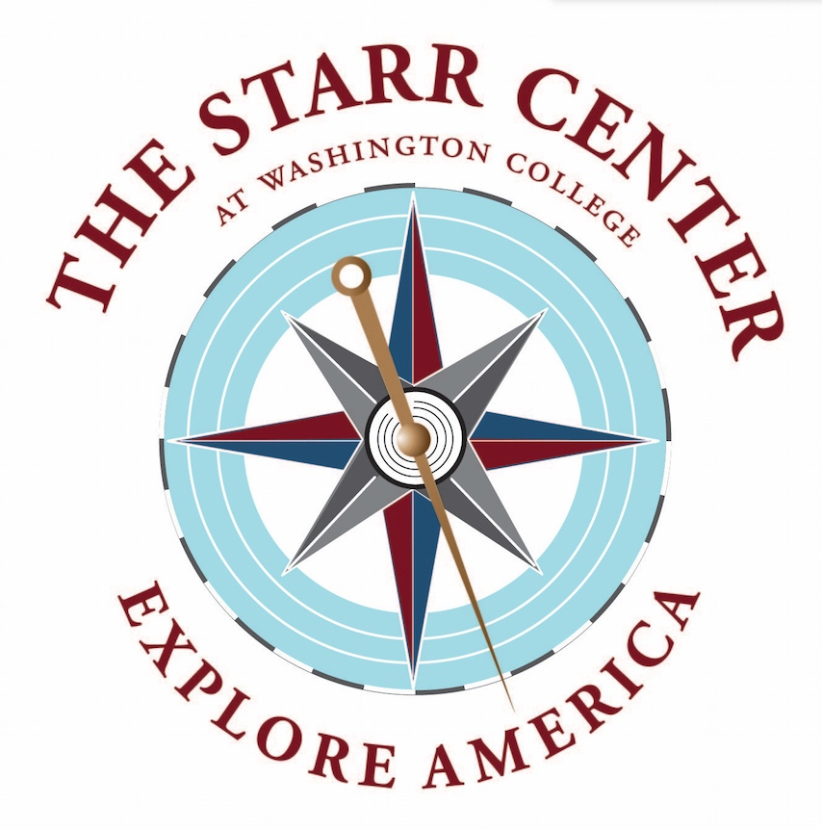

Hodson Trust-John Carter Brown Library Fellowship
The Starr Center for the Study of the American Experience and the John Carter Brown Library invite applications for the Hodson Trust - John Carter Brown Fellowship, a unique research and writing fellowship. The deadline to apply for the 2023-24 Hodson Trust - John Carter Brown Fellowship is February 1, 2023.
The Hodson Trust - John Carter Brown Fellowship supports work by academics, independent scholars and writers working on significant projects relating to the literature, history, culture, or art of the Americas before 1830. Candidates with a U.S. history topic are strongly encouraged to concentrate on the period prior to 1801. The fellowship is also open to filmmakers, novelists, creative and performing artists, and others working on projects that draw on this period of history.
The 2023-24 fellowship award supports two months of research and two months of writing. The stipend is $5,000 per month for a total of $20,000, plus housing and university privileges.
The research is conducted at the John Carter Brown Library on the campus of Brown University in Providence, R.I., which has one of the world’s richest collections of books, maps and documents related to North and South America and the Caribbean between 1492 and 1830. The research must be completed within the academic year (September to May). Every effort will be made to provide housing convenient to the library.
The writing period of the fellowship will be at the Starr Center at Washington College in Chestertown, Md. The Starr Center is dedicated to innovative approaches to the nation’s past and present, and to fostering outstanding writing on American history and culture. The two-month writing term will be during the summer following the research term (June-August). The Hodson Trust - John Carter Brown Fellow will be provided with an office in the Starr Center’s c. 1745 waterfront Custom House, as well as exclusive use of its Fellows’ Residence in Chestertown’s historic district. (The house is large enough to accommodate a family.)

Applications should include the following (submitted in a single PDF document):
1. A cover letter.
2. The applicant’s curriculum vitae, including a list of past publications or other relevant projects, as well as the names and telephone numbers of at least three references. Letters of reference are not required.
3. At least one substantial sample of the candidate’s writing (published or unpublished) or other past work. (No more than 50 pages in total, please.)
4. A brief narrative description of the work-in-progress, its potential contributions to history, literature, the arts, or our understanding of the present, and the candidate’s plan for their fellowship terms in Providence and Chestertown.
cont.
Candidates are encouraged to consult the John Carter Brown Library’s collections online prior to submitting an application. Special consideration will be given to proposals discussing specific resources at the JCBL that will be useful to the project.
Questions may be directed to Katy Shenk – kshenk2@washcoll.edu
Deadline for applications is February 1, 2023. Applications may be submitted via email to applications_starrcenter@washcoll.edu. Please submit your application in a single PDF document.
For more information on the fellowships and the sponsor institutions, please visit The Starr Center for the Study of the American Experience at Washington College and The John Carter Brown Library at Brown University.

