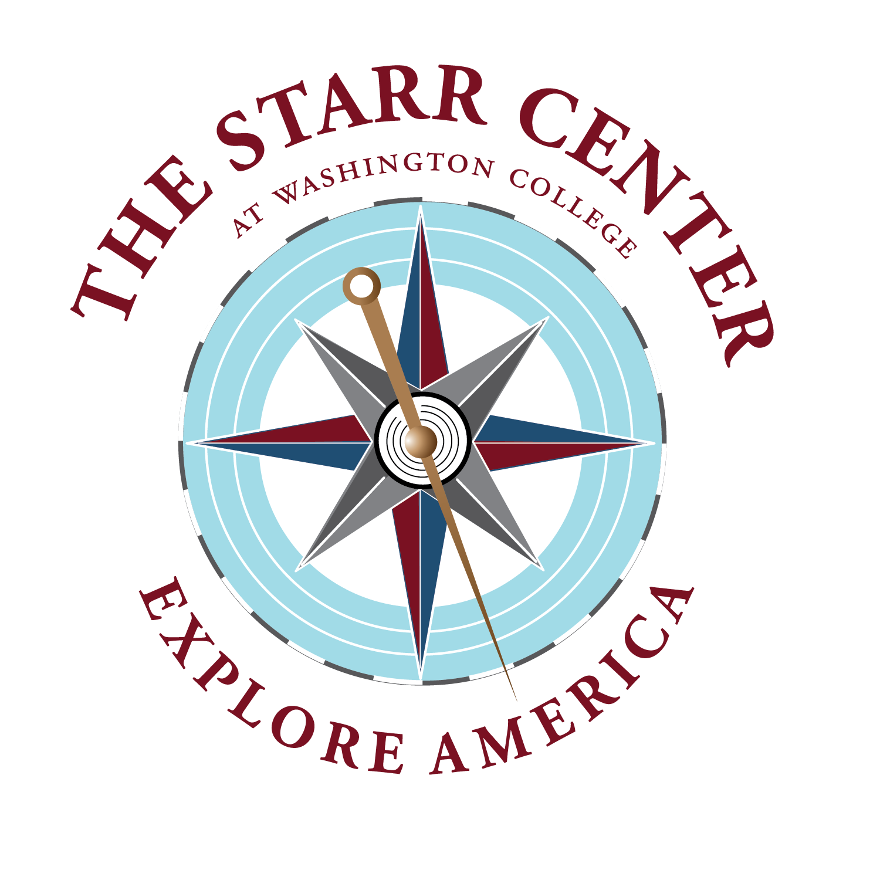

Explore America Summer Internship Info Sheet – 2022

Your application must also include a letter of interest, a résumé, and copies of your academic transcript. More details about the application are available on our website. Please email your completed application in a single PDF or Word document to: applications_starrcenter@washcoll.edu.

Applicant’s name:

Applicant’s phone number:

Applicant’s student ID #:

Washington College Current Class Year:

Major(s)/Minor(s):

Will you be pursuing this internship for credit?

☐Yes

☐No

Names of three references whom we can contact. At least two must be Washington College faculty. For non-WAC references, please also provide the person’s professional title. (Letters of recommendation/reference are NOT required.)

1.
Name/email/phone:

2.
Name/email/phone:

3.
Name/email/phone:

Desired internships (selected from here), ranked in order of preference. You may be considered for multiple positions. You may list as many as you wish, and we encourage you to list several.

