FOUNDED 1782
300 WASHINGTON AVENUE CHESTERTOWN, MARYLAND 21620-1197

STANDARD OPERATING PROCEDURE NO. 12
RADIAL ARM AND MORRIS WATER MAZE SPATIAL MEMORY PROTOCOLS

Spatial learning and memory assists in efficient navigation within the environment and has been found to be dependent upon neural pathways that include the hippocampus. Animal investigators that assess spatial learning, memory and the function of what have been called “cognitive maps” have utilized numerous types of mazes. Among these are the Morris Water Maze (MWM) Task and the Radial Arm Maze (RAM). In the former, laboratory rodent must learn to employ various landmarks surrounding the maze to swim toward the location of a small platform that is submerged just below the surface of the water. In the RAM the rodent must learn to obtain a small food reward at the ends of specific arms of the maze and to avoid others that are never baited.

Note on the Morris Water Maze: An attendant is always present in the room when the rat is in the water. Also available is a wooden paddle to rescue the rat in case of difficulty swimming. Rats are dried with towels and allowed to rest in a heated cage between trials.

Basic Protocol:

The basic MWM and RAM protocols for use with rodent species that have been approved by the WC IACUC are described in:

Wenk, G.L. (2004) Assessment of spatial memory using the radial arm maze and Morris Water Maze, In Gerfen C., Holmes, A., Sibley D., Skolnick, P., Wray, S. (Eds.) Current Protocols in Neuroscience, pp. 8.5A.1-8.5A.12. Wiley & Sons, Inc.: New York. http://onlinelibrary.wiley.com/book/10.1002/0471142301

Any differences or modification from this protocol must be reviewed by the IACUC. January 2013

Assessment of Spatial Memory Using the
Radial Arm Maze and Morris Water Maze

Behavioral tasks must be evaluated in terms of the cognitive functions they require in order to be performed. Each task is a tool that allows the researcher to achieve a specific goal—i.e., to determine the consequences of manipulations of specific brain regions. These manipulations usually fall into one of four categories: stimulation of a single brain region by drugs or small electrical current, impairment of normal function by production of a lesion or administration of appropriate pharmacological agents, recording of brain activity during the performance of a specific behavioral task, or behavioral phenotyping of transgenic and knockout mice for genes expressed in specific brain regions. All of the tasks described in this chapter can be used with each of these four experimental manipu- lations.

Performance of the radial arm maze task (see Basic Protocol 1 and Alternate Protocol 1) requires intact spatial memory abilities. Normal performance is sensitive to the effects of hippocampal damage, normal aging, and a variety of pharmacological agents. Perform- ance of the water maze task (see Basic Protocol 2 and Alternate Protocols 2 and 3) also requires intact spatial memory abilities and is particularly sensitive to the effects of aging. The major advantage of the water maze task over the radial arm maze task is that the rats do not need to be water or food deprived; they are quite motivated to escape from the water. The task is also free from errors of omission or abortive choices—i.e., the rat makes an attempt to find the platform on every trial.

Rats are generally used in research employing these four behavioral tasks because a considerable amount is known about their brain anatomy and chemistry. Previous experi- mental studies have clearly shown that rats can be used to investigate the structure/func- tion relationships between selected brain regions and learning or memory. Eight to ten rats are included in each experimental group, a number that is sufficient for statistical analyses (e.g., an analysis of variance, ANOVA) of the behavioral data and any neuro- chemical assays or histopathological studies that might be performed for confirmation of the manipulations.

UNIT 8.5A

USE OF RADIAL ARM MAZE TASK TO TEST BASIC WORKING MEMORY

The radial arm maze task has been most extensively used to investigate specific aspects of spatial working and reference memory. This task is based upon the premise that animals have evolved an optimal strategy to explore their environment and obtain food with the minimum amount of effort.

A radial arm maze can easily be built by the investigator, so the cost for this equipment can be quite low compared to other behavioral testing equipment. Using the maze, however, is quite labor-intensive and requires that a tester be present throughout the task.
The maze is typically used for rats, but it can be scaled down in size (by ∼75%) for use
with mice.

Materials
Rats
Food reward (e.g., 10-mg pellet of chow or sweetened breakfast cereal; see
Critical Parameters)
Radial arm maze (Fig. 8.5A.1), handmade or fully automated (Coulbourn
Instruments or Columbus Instruments)

Contributed by Gary L. Wenk
Current Protocols in Neuroscience (2004) 8.5A.1-8.5A.12
BASIC PROTOCOL 1

Behavioral
Neuroscience

8.5A.1

Assessment of Spatial Memory Using the Radial Arm and Morris Water Mazes

8.5A.2
Figure 8.5A.1 8-arm radial maze. For rats, the central platform should be ≥45 cm in diameter to
accommodate the animal and allow it to turn easily between arms. A Plexiglas wall, 25 cm high,
surrounds the central platform. The arms are 87 cm long and 10 cm wide, radiating from the central platform at equal angles. For mice, use shorter (35-cm), narrower (5-cm) arms and a smaller (20-cm) central platform. Each arm has a 5-mm-deep hole 1 cm from the end, which is used as a food cup, and each arm is separated from the center platform by a transparent Plexiglas guillotine door that covers a hole in the Plexiglas wall. The guillotine door can be raised or lowered to allow or prevent entry. The guillotine doors are connected by individual strings to a pulley system that allows the experimenter to open any door from one location within the testing room. Short walls (2 cm high) along the edge of the maze arms prevent the animal from falling off the maze.

Train rats
1. Weigh each rat daily throughout training and testing to monitor health and degree of food deprivation.

2. Restrict food available to rat so that its body weight attains 85% of that prior to training. During testing and training, allow rat to gain ∼5 g body weight per week.

3. Allow rat to become comfortable with the experimenter (see Critical Parameters, discussion of rat handling).

4. Give food reward in home cage for a few days prior to training in order to acclimate the rat to the reward in a familiar environment.
The food reward is typically a small piece (10 mg) of normal chow or a flavored (chocolate is a favorite) or sweetened breakfast cereal. Liquid rewards, such as chocolate milk or water, can also be used. Liquid rewards are preferred if the rat will be given a drug, e.g., scopolamine, that might make swallowing dry food uncomfortable.
5. Set up radial arm maze (see Fig. 8.5A.1).
The wooden or Plexiglas maze is set up ∼1 m above the floor for easy access to the rat and
food cups. It is composed of a central octagonal platform with eight arms extending from
it like the spokes of a wheel. Guillotine doors that can be opened and closed individually separate the central platform from the arms. The maze should be placed in a room that contains various external cues that are visible to the rat while it is on the maze—e.g., a doorway, overhead lights, a noisy radio, and large simple designs on the walls. The maze can be handmade or a fully automated setup purchased commercially. The latter, including data analysis software, can be obtained from either Coulbourn Instruments or Columbus Instruments.

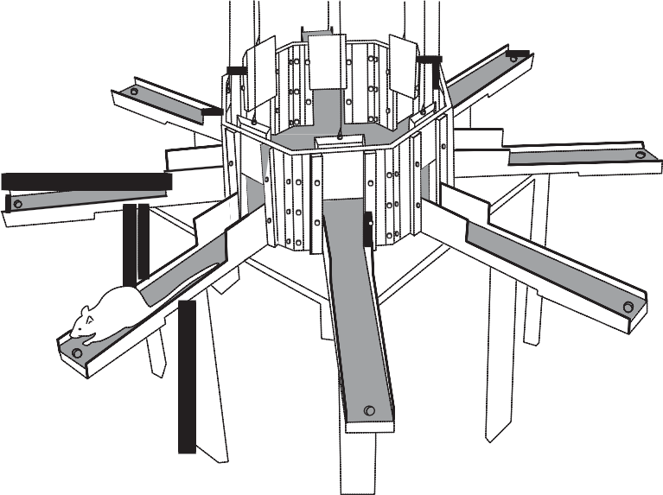
Supplement 26 Current Protocols in Neuroscience

6. Place a well-handled pair of rats (preferably cagemates) on the maze at the same time.

Using two rats reduces the time it takes for each to acclimate to the maze.

7. Spread food rewards around the entire maze to encourage exploration.

Acclimation should require only 1 or 2 days.

8. On subsequent days, place food only on the arms, then only at the ends of the arms.

9. Finally, place rat alone on maze and food only in the food cup at end of arms. Testing can begin when rat is comfortable being picked up by the experimenter and, when placed alone on the maze, explores without hesitation and without excessive defeca- tion or urination.

A typical rat will be ready for testing—i.e., food-restricted and acclimated to the maze—
within ∼7 days. Rats should be run in the maze once a day every day (including weekends,
ideally) during training and testing.

Test rats
10. Place food reward at end of each arm before each test session.

11. Place rat on central platform with all guillotine doors closed.

12. Raise all doors simultaneously. Allow rat to enter an arm. Close doors to all other arms.

13. Allow rat time to eat food and to return to central platform.

14. Close door to that arm and confine rat to the central platform area for a set time (from
0 sec to many minutes; 5 sec is ideal to begin).

Longer waits make the task more difficult to solve—i.e., increase the length of time for which the rat must remember which arms it has entered.

15. Repeat steps 12 to 14 until all food pellets have been retrieved or until a predetermined length of time has elapsed.

16. Record the following data:

Which arm the rat entered each time and whether it received a food reward. Time elapsed between the beginning of the test session and the rat’s
obtaining all eight food rewards.
Number of correct arm choices: i.e., those that are chosen the first time. Number of incorrect arm choices: i.e., visitations to the same arm more
than once during a single test session.

Time elapsed since the beginning of the session is considered in order to determine how fast the rat is making choices and finding the food rewards. This is also an indirect indication of motivation.

Visitation to a previously chosen arm is considered a working memory error. Normal healthy young rats will perform this task almost perfectly every time.

A healthy, happy, and motivated rat should learn this task, such that working memory errors are <15%, within 15 days.

17. Perform data analysis. Performance for all groups is typically expressed as either:

a. The percentage of correct choices made in each test session in relation to the total number of arms entered,
b. The absolute number of correct choices made in the first eight to twelve choices of each test session, or

Behavioral
Neuroscience

8.5A.3

Current Protocols in Neuroscience Supplement 26

c. The percentage of correct choices made in relation to the number of incorrect choices.

The data are best presented as a line drawing comparing a performance measure for each group versus daily test sessions. Data from two or four days of testing can also be averaged into blocks.

18. When performance is stable and choice accuracy is >85%, begin studies with pharmacological agents or lesions.

Alternatively, one can study the effects of drugs or lesions upon the acquisition of performance of this task. Drugs can be administered (or lesions produced) either prior to training to assess their effects upon acquisition, or after acquisition in order to assess their effects upon performance.

ALTERNATE PROTOCOL 1

Assessment of Spatial Memory Using the Radial Arm and Morris Water Mazes

8.5A.4
USE OF RADIAL ARM MAZE TASK TO TEST WORKING VERSUS REFERENCE MEMORY

This protocol allows a disassociation to be achieved between working and reference types of memory, whereas the previous protocol is primarily sensitive to impairments in working memory. Working memory is operationally defined as information that is only useful to a rat during the current experience with the task, whereas reference memory is information that is useful across all exposures to the task—i.e., on any day of testing. This protocol should be performed after initial training of rats (Basic Protocol 1) has been completed.

1. Train rats in radial arm maze (see Basic Protocol 1, steps 1 to 9).

2. Place food reward at the end of only four arms of the radial arm maze before each test session.

The arms chosen to be baited must be the same for a given rat but should vary between rats. For example, bait arms 1, 3, 6, and 8 every time that rat #1 is on the maze, bait arms
1, 4, 5, and 7 every time that rat #2 is on the maze, and so on. This task can be conducted on mazes with more or fewer arms in much the same way.

3. Place rat on maze with all doors raised and allow it to explore the maze completely and retrieve all food rewards.

4. Remove the rat from the maze for a set period of time (1 hr to 1 day).

Longer delays make the task more difficult for the rat.

5. Bait appropriate four arms of maze for rat.

In the example discussed above, bait arms 1, 3, 6, and 8 for rat #1.

6. Repeat step 3.

7. Record the following data:

Number of correct entries into baited arms. Number of entries into unbaited arms. Number of reentries into baited arms.
Time elapsed between the beginning of the test session and the rat’s obtaining all available food rewards.

Entries into unbaited arms are reference memory errors; reentries into baited arms are working memory errors.

8. Repeat steps 2 to 7 until performance is stable and choice accuracy is high (>85%).

Supplement 26 Current Protocols in Neuroscience

9. Perform data analysis. Performance for all groups is typically expressed as:
a. The percentage of correct entries into baited arms in relation to the total number of arms originally baited (working memory performance), and
b. The percentage of entries into arms that are never baited in relation to the number of unbaited arms (reference memory performance).

The data are best presented as a line drawing comparing working and reference performance for each group versus daily test sessions. Data from two or four days of testing can be averaged into blocks.

10. Once the rat makes few, or no, reference or working memory errors, begin studies with pharmacological challenges or lesions.

Normal healthy young rats will perform this task almost perfectly every time. A healthy, happy, and motivated rat should learn this version of the task, such that working and reference memory errors are <15%, within 10 days.

USE OF MORRIS WATER MAZE TASK TO TEST SPATIAL MEMORY

The water maze task has been most extensively used to investigate specific aspects of spatial memory. This task is based upon the premise that animals have evolved an optimal strategy to explore their environment and escape from the water with a minimum amount of effort—i.e., swimming the shortest distance possible. The time it takes a rat to find a hidden platform in a water pool after previous exposure to the setup, using only available external cues, is determined as a measure of spatial memory. Studies with pharmacologi- cal agents or lesions are initiated when performance is stable; the water maze task is particularly sensitive to the effects of aging (Brandeis et al., 1991). Alternatively, one can study the effects of drugs or lesions upon the acquisition of performance of this task. Drugs can be administered (or lesions produced) prior to training to assess their effects upon acquisition, or after acquisition in order to assess their effects upon performance. A water maze (Fig 8.5A.2) can easily be built or purchased by the investigator, so the cost for this equipment can be quite low. Using the maze is quite labor-intensive and requires that a tester be present, or nearby, throughout the task. This maze is typically used for
rats, but it can be scaled down in size (by ∼50%) for use with mice.

Materials
Rats
Water maze apparatus
Tracking system and software (Columbus Instruments, HVS Image, San Diego
Instruments, or CPL Systems)

Set up apparatus and begin acquisition testing
1. Set up water maze (see Fig. 8.5A.2).

A water-tight pool, painted white, should be positioned in a room with various external cues that are visible to a rat swimming in the pool, e.g., a doorway, overhead lights and camera (if desired), and large simple designs on the walls. Make water opaque by adding powdered milk or nontoxic white paint to the water. The pool should be designed so that it can be easily drained on a regular basis.

2. Insert platform into one quadrant of the pool.

3. Place rat into water with its head pointed towards the side of pool.
The starting position should be at a different, and randomized, location each day of testing, e.g., north, south, etc.
BASIC PROTOCOL 2

Behavioral
Neuroscience

8.5A.5

Current Protocols in Neuroscience Supplement 26

Figure 8.5A.2 Morris water maze. The pool should be watertight, 200 cm in diameter and 75 cm deep, and filled with 50 cm water. The actual dimensions of the pool can be varied depending upon the space available to contain it and whether rats or mice are being tested (e.g., for mice, the pool
need only be ∼100 cm in diameter and 30 cm deep). The water is made opaque by adding nontoxic
white paint or powdered milk. A 10-cm circular escape platform should be constructed of a
water-resistant material and covered with material (e.g., cloth) that allows the animal to remain on the top when it is submerged. The platform should be made heavy enough to remain upright when submerged or may be attached to the bottom of the pool. The platform should be 48 to 49 cm in height so that it is submerged 1 to 2 cm below the surface. A chair can be positioned near the pool to allow the experimenter easy access and provide an additional cue for the animal. The water
temperature should be maintained at ∼20°C. It is useful to have an ample supply of towels nearby
to dry animals between trials. Also, an incubator can be used to keep them warm between trials.

4. Record time (in seconds) it takes the rat to find the submerged platform. Guide rat to platform on first few trials if it requires >120 sec.
A tracking camera, positioned ∼200 cm above the center of the pool, can be used to quantify
the distance swam on each trial and thereby determine swimming speed when combined
with latency measurements. The tracking system can also display swim path and distance and provide additional information on search efficiency and exploration patterns during acquisition and probe trials. This equipment and associated computer software can be obtained from several commercial manufacturers.

5. Allow rat to remain on platform for 10 to 15 sec.
This allows the experimenter time to return to an appropriate place at the side of the water pool in order to be ready for step 6.

6. Remove rat from pool. Wait 5 min.

7. Release rat into pool (from the same location) with platform in same location. Record time for rat to find platform.

8. Give each rat four trials on the first day.

Assessment of Spatial Memory Using the Radial Arm and Morris Water Mazes

8.5A.6
Perform trials
9. On second day, insert platform in same location as on the first day.

10. Release rat with its head pointed towards the side of the water pool.

11. Record time it takes rat to find platform.

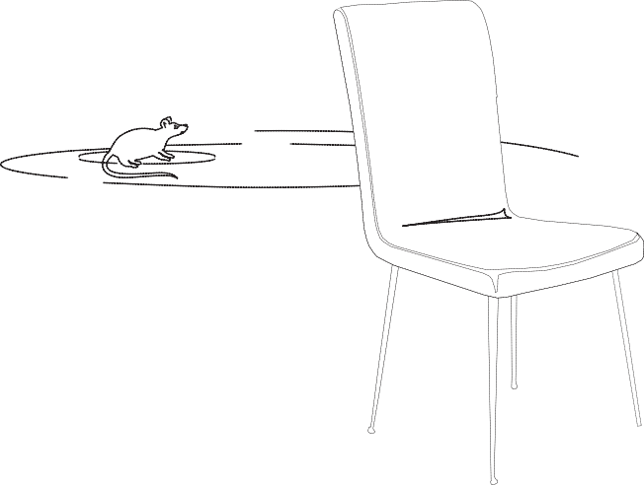
Supplement 26 Current Protocols in Neuroscience

12. Give rat eight to ten trials per day with 5-min intertrial intervals for several days until performance is stable and latency to find the platform is low (<5 to 7 sec).

13. Perform data analysis. Performance is expressed as the average time it takes each rat to find the submerged platform. The data are best presented as a line drawing comparing the latency to find the platform for each group versus daily test sessions. Data from 2 or 4 days of testing can be averaged into blocks.

Additional analyses utilizing sophisticated computer tracking programs can classify the spatial location of the animal with regard to the platform in order to provide information on the spatial pattern of the rat’s search during both the training and testing phases, as well as during the probe trial (see Alternate Protocol 2).

14. Begin studies with pharmacological agents or lesions.

USE OF WATER MAZE TASK FOR SPATIAL PROBE TRIAL
This alternate protocol should be performed after the acquisition phase of testing in Basic Protocol 2 has been completed. It is important that the rats know the location of the hidden platform before beginning this protocol. This knowledge is demonstrated by the rat swimming quickly and directly to the hidden platform. The spatial probe trial is used to test the rat’s knowledge of the precise location of the platform. An accurate direction of the swimming behavior provides evidence that the rat has learned the spatial location of the platform relative to the available external cues (Sutherland et al., 1982). Although the spatial probe trial is typically performed only after performance has stabilized, some researchers perform a spatial probe trial at the end of each day of training throughout the acquisition phase, and average performance across trials.

1. Train rats in water maze (see Basic Protocol 2, steps 1 to 12).

2. Set up water pool without platform.

3. Release rat with its head pointed towards the side of the water pool.

4. Remove rat after 90 sec.

5. Record time rat spent in the quadrant that previously contained the platform and calculate as a percentage of total time in pool. If possible (i.e., if using a computer tracking system), also record the percentage of time spent in the other quadrants.

6. Perform data analysis. The data can be expressed as either:
a. A histogram showing the average amount of time that the rats in each group spent exploring each quadrant of the pool (most typically), or
b. The percentage of time the rat spent exploring the quadrant that had contained the platform in relation to the total time spent exploring the entire pool.
ALTERNATE PROTOCOL 2

USE OF WATER MAZE TASK TO TEST WORKING MEMORY

This alternate protocol can be performed after the acquisition phase of testing in Basic Protocol 2 has been completed. It is important that the rats have demonstrated that they know the location of the hidden platform before this next protocol is begun. This protocol has also been referred to as a “reversal test.”

1. Train rats in water maze (see Basic Protocol 2, steps 1 to 12).
2. Release rat with its head pointed towards the side of the water pool.
Start position should be at same location each day.
ALTERNATE PROTOCOL 3

Behavioral
Neuroscience

8.5A.7

Current Protocols in Neuroscience Supplement 26

3. Record time it takes rat to find submerged platform. Allow rat to remain on platform for 10 sec. Remove rat from pool and place in holding cage for 15 sec.
4. Move submerged platform to new location.
5. Release rat from same location as in step 2.

6. Allow rat to swim for up to 120 sec. Record time it takes for rat to find platform.
Guide rat to platform if necessary.

7. Allow rat to remain on platform for 10 sec. Remove rat from pool and place in holding cage for 15 sec.

8. Repeat steps 5 to 7 until rat swims directly and quickly to the platform. Record time on each attempt.

9. Repeat steps 4 to 8 once per day for 4 days, with the platform in a different quadrant of the pool each day.
Latency to find the platform should decrease with each day of testing.

10. Perform data analysis. Performance is expressed as the average time it takes each rat to find the submerged platform at each new location. The data are best presented as multiple line drawings comparing the latency to find the platform for each group and for each location versus daily test sessions. Data from 2 or 4 days of testing can be averaged into blocks.

Assessment of Spatial Memory Using the Radial Arm and Morris Water Mazes

8.5A.8
COMMENTARY Background Information
Radial arm maze task
The radial arm maze task was introduced and popularized in its present form by Olton and co-workers (Olton and Samuelson, 1976). The task is a logical extension of the multiple, simultaneous choice tasks originally described by Hamilton (1911) and Tolman et al. (1946); it has been used to measure the effects of vari- ous brain manipulations upon specific aspects of memory, such as spatial working and refer- ence memory, and can be adapted for use with rats, mice, and pigeons (Bond et al., 1981; Levy et al., 1983; Wenk et al., 1986). The large number of sequential locations that the rat can visit to obtain a reward makes the task ideal for investigating the effects of drugs or lesions upon serial order memory—i.e., whether loca- tions visited first or last are remembered better (Kesner and Novak, 1982). The task is sensitive to the effects of brain lesions (Becker et al.,
1980) and to numerous drugs (for review see Levin, 1988) that either impair or enhance per- formance, including inebriants such as ethanol (Devenport et al., 1983), endogenous neuro- peptides such as vasopressin (Buresova and Skopkova, 1982), amnestic drugs such as sco- polamine (Stevens, 1981; Watts et al., 1981;

Okaichi and Jarrard, 1982), and neurotoxins such as trimethyltin (Walsh et al., 1982).

Water maze task
The water maze task was designed to ad- dress theoretical controversies that arose from using the radial arm maze task (Brandeis et al.,
1989): i.e., the concept that memories about spatial information are handled by the brain quite differently than information on other forms of learning. The water maze task is not a better or more sensitive task than the radial arm maze task, it simply asks many of the same questions of the animal under different circum- stances. Differences between the two tasks in- clude the nature of the locomotion, walking versus swimming; the nature of the motivation, food deprivation versus avoidance of drown- ing; the location of available cues for finding the reward, local and distant cues versus distant cues only; and the visibility of the location of the reward, a visible food cup on the radial arm maze versus a submerged platform in the water maze task. Sometimes asking the same ques- tion in a different way has allowed researchers to discover subtle differences in the contribu- tions of different brain regions or the effects of specific lesions or drugs. The water maze task was introduced by Morris (1981) and col- leagues as a spatial localization or navigation

Supplement 26 Current Protocols in Neuroscience

task. The task has been extensively used to study the neurobiological mechanisms that un- derlie spatial learning and memory, age-asso- ciated changes in spatial navigation (Gage et al., 1984; Rapp et al., 1987; Pitsikas et al., 1990; Gallagher et al., 1993), and the ability of psy- chopharmacological agents (Sutherland et al.,
1982; Hagan et al., 1983, 1986; McNaughton and Morris, 1987; Brandeis et al., 1991; McNamara and Skelton, 1991), lesions (Morris et al., 1982; Kolb et al., 1983), or gene muta- tions (Tsien et al., 1996; Crawley et al., 1997) to influence specific cognitive processes.

Critical Parameters

Essence of rat handling
Remain relaxed. The rat can sense your nervousness. Be consistent with your treatment and handling. Use the rat’s native intelligence and your skills to provide him with the specific knowledge that he needs to perform the task. Take the rat’s point of view. Handle the rat the way that you would like King Kong to handle you! Go slowly and be gentle. Do not approach the rat from behind and above; this is how a predator would attack the rat. Do not grab the rat tightly around the abdomen, as its internal organs have very little protection. Support the rat from underneath its body and hold it against yours. Run rats on the maze at the same time every day; rats are like people in that they grow accustomed to a particular schedule. Allow the
rat to gain ∼5 g each week during testing and
training, even though it is food-restricted. Pay
attention to how well groomed the animal is; a well-groomed rat is a healthy rat. If the rat is undernourished, it will feel cold to the touch. Sick rats do not provide useful data and may be in danger of dying. Find out why the rat is sick and correct the problem.

Radial arm maze task
Rats will use whatever sensory cues are available to solve the radial arm maze task and obtain a reward. Removing these cues will make performance difficult and impair choice accuracy. Reducing the salience of stimuli around the maze—e.g., completely enclosing the arms or placing the maze in a homogeneous environment—can greatly influence perform- ance. This may force the rat to use other, more egocentric, information to solve the task, such as a sequence of left turns after every arm choice, or to depend upon intramaze cues, such as odor trails.
The guillotine doors are a critical feature of the maze in that they confine the rat to the central platform area between choices. Other- wise, the rat may develop a biased response pattern, which makes interpretation of the per- formance difficult: i.e., it becomes impossible to determine whether the rat remembered the correct choice or a response habit. For example, without temporary confinement between each arm choice, the rat could successfully solve this task by simply always turning right after each choice and entering the first arm away from the previously chosen one. This simple strategy does not require an accurate knowledge of the spatial environment or memory for a specific location. Unless the experimenter is primarily interested in studying response patterns, it is best to have the rat confined to the central platform prior to making each arm choice.
The number of arms the maze contains can vary depending upon the goals of the experi- menter. For example, having fewer arms re- quires that the animal remember fewer visited places on each trial. Increasing the number of arms increases the mnemonic demands of the task by increasing the list of spatial locations in memory. In addition, an increased number of arms introduces considerably more proactive interference, i.e., interference of previous learning on current memory. Most researchers choose to use eight arms in order to minimize proactive interference (if that is desired) or to shorten the length of time it takes to test each rat. Numerous variations have been introduced in order to automate the task, reduce testing time, or provide alternative interpretations of the psychological processes that underlie nor- mal performance (Bond et al., 1981; Okaichi and Jarrard, 1982).
Most rats are quite fearful of exploring the arms during the initial training periods. Some- times it is better to have somewhat taller sides (6 to 8 cm) along the edges of the arms to offer more support to the rat. A taller barrier may be attached along the edges of the arms near the central platform. This prevents the rat from jumping from one arm to another and forces the rat into the central platform area between choices. The guillotine doors should be at- tached by strings to an overhead pulley system that allows all doors, or individual doors, to be raised and lowered by one experimenter from a single location. Alternatively, individual elec- tronic mechanisms could also be installed at a greater cost.
The food reward is typically a small piece
(10 mg) of normal chow or a flavored (choco-

Behavioral
Neuroscience

8.5A.9

Current Protocols in Neuroscience Supplement 26

Assessment of Spatial Memory Using the Radial Arm and Morris Water Mazes

8.5A.10
late is a favorite) or sweetened breakfast cereal. Liquid rewards, such as chocolate milk or water, can also be used. Liquid rewards are preferred if the rat will be given a drug, such as scopolamine, that might make swallowing dry food uncomfortable.

Water maze task
Rats will use whatever sensory cues are available to solve this task and escape from the water. Indeed, animals can take advantage of celestial cues if the pool is placed out of doors (Kavaliers and Galea, 1994). Removing exter- nal cues around the pool will make finding the submerged platform more difficult and increase the latency to escape. Reducing the salience of stimuli around the pool may force the rat to use other, more egocentric, information to solve the task. Rats will use a search strategy to find the platform when it is moved. They will swim close to the wall for a few laps then move further away and continue swimming in concentric circles until they bump into the platform. La- tency to find the platform and swimming dis- tance will then decrease quickly thereafter. The greatest advantage of this task over food-moti- vated tasks is that most rats are more highly motivated to escape from the water. In addition, food restriction is unnecessary, which is a great advantage when testing aged animals, to which such restriction is more stressful.
Performance in the water maze task can be influenced by many factors that should be con- sidered carefully when comparing the results of one study with another. For example, the sex and strain of the rats, the dimensions of the pool and temperature of the water, and the particular training schedule can all affect performance. One should also take into account factors that affect swim speeds, which include body weight, muscle development, and age. See Brandeis et al. (1989) for a thorough discussion of the role of these factors in performance of the Morris water maze task.
Finally, because older rats or mice are fre- quently tested in the water maze, it is important to be sure that they can swim adequately and have sufficient visual acuity to use distant cues. To test this, place rat into the pool and allow it to swim to a platform that is supported above the water level. To assist rat, suspend a large visible cue above the platform. If the rat can swim directly to the visible platform without difficulty, it is ready to begin testing using the protocols outlined in this unit.
Troubleshooting

Radial maze task
The major problems associated with testing rats in open mazes are usually related to two competing factors for the rat: its fear of the maze (or experimenter) versus its motivation to explore and find the food that it knows is on the maze. Excessive levels of fear will prevent the rat from performing. It will usually remain frozen in one place on the maze and not explore. In addition, if it is frightened it will usually defecate and urinate on the maze and squeal when being picked up. If the rat is not making choices on the maze it is impossible to know whether its mnemonic abilities are normal or impaired. Fear can be overcome by considering some of the issues presented in the discussion of rat handling above (see Critical Parameters). The most important thing the experimenter can do is simply handle the animal more often. Also, higher barriers can be installed along the arms of the maze to provide the rat a better sense of security from falling.
A lack of motivation will produce similar results—i.e., the rat will make little or no at- tempt to explore the maze and find food. Moti- vation can be increased by a slightly greater restriction of food intake. The rat’s weight and general health must be carefully monitored during food restriction. Usually the rat’s weight should not drop below 80% of its free-feeding weight. For most rats, it is only necessary to reduce their weight by 15%. If the rat is aware that a safe food source exists on the maze, they will usually explore the maze to find it.

Water maze task
There are only two problems that are typi- cally associated with this task. First, immersion of the animal into the water may cause signifi- cant stress and subsequent endocrinological changes that may interfere with the purpose of the study. These problems are usually resolved with continued exposure to the pool. However, for aged animals this stress can be sufficient to induce cardiovascular system collapse leading to death or stroke. Second, the method by which the water is made opaque can produce prob- lems. If powdered milk is added to the water, the pool must be drained regularly (e.g., daily) to avoid bacterial contamination and odor. If powdered white paint is used, care must be taken to ensure that it is nontoxic to the animal, who may frequently ingest small quantities of water while performing the task.

Supplement 26 Current Protocols in Neuroscience

Anticipated Results and Time
Considerations

Radial arm maze task
A healthy, happy, and motivated rat should learn this task within 15 days: i.e., working and reference memory errors should be <15%. This assumes that the rat is actively making choices and eating the food rewards on the maze. The rat should run quickly down the arms to retrieve the food reward and return to the central plat- form immediately after eating the reward. Dur- ing the confinement period the rat will usually wander around the central area and quickly choose an unvisited arm as soon as the guillo- tine doors are raised. After a control rat has learned the task, a single test session—i.e., eight correct arm choices—should not require more than 5 to 10 min to complete. Rats given drugs or lesions may require two to three times longer to complete the test session. A healthy group of rats, including experimental and con- trol groups, should be able to be trained and tested in Basic Protocol 1 and Alternate Proto-
col 1 in ∼4 weeks. This estimate assumes that
all rats are tested once per day.

Water maze task
Control rats may take ∼30 to 60 sec to find
the platform on the first day of testing. Latency

should decrease significantly with subsequent trials to ∼5 sec. On the probe test, the rats should
spend a greater percentage of time exploring the quadrant that previously contained the plat- form than in the other quadrants. On both the reversal and working memory tests, the rats should first explore the quadrant that pre- viously contained the platform and then inad- vertently find the new location of the platform. On subsequent trials (usually less than five), their latency to find the platform will decrease significantly. All rats should be trained in the Basic Protocol 2 portion of this task within 1 week. The spatial probe trial (Alternate Proto- col 2) can be completed in 1 day, and the reversal test (Alternate Protocol 3) within 5 days. Lesioned rats may require a few addi- tional days of training in Basic Protocol 2 in order to reach an asymptotic level of perform- ance. Drugs can be given each day prior to testing in this protocol; however, this will also extend the amount of time required to reach asymptotic performance. Drug administration will also prolong the number of days spent testing in the spatial probe and reversal trials; the number of days depends upon the number of doses to be tested. It is important to have
drug-free and saline injection days interspersed between the drug testing days. Obviously, this will prolong the time required to complete this task.

Literature Cited
Becker, J.T., Walker, J.A., and Olton, D.S. 1980.
Neuroanatomical bases of spatial memory. Brain
Res. 200:307-320.
Bond, A.B., Cook, R.B., and Lamb, M.R. 1981.
Spatial memory and the performance of rats and pigeons in the radial-arm maze. Anim. Learn. & Behav. 9:575-580.
Brandeis, R., Brandys, Y., and Yehuda, S. 1989. The use of the Morris water maze in the study of memory and learning. Int. J. Neurosci. 48:29-
69.
Brandeis, R., Sapir, M., Kapon, Y., and Borelli, G.
1991. Improvement of cognitive function by MAO-B inhibitor L-deprenyl in aged rats. Phar- macol. Biochem. Behav. 39:297-304.
Buresova, O. and Skopkova, J. 1982. Vasopressin analogues and spatial working memory in the
24-arm radial maze. Peptides 3:725-727.
Crawley, J.N., Belknap, J.K., Collins, A., Crabbe, J.C., Frankel, W., Henderson, N., Hitzemann, R.J., Maxson, S.C., Miner, L.L., Silva, A.J., Wehner, J.M. Wynshaw-Boris, A., and Paylor, R.
1997. Behavioral phenotypes of inbred mouse strains: Implications and recommendations for
m o le c ula r st u d i e s . Psychopharmacology
132:107-124.
Devenport, L.D., Merriman, V.J., and Devenport, J.A. 1983. Effects of ethanol on enforced spatial variability in the 8-arm radial maze. Pharmacol. Biochem. Behav. 18:55-59.
Gage, F.H., Dunnett, S.B., and Bjorklund, A. 1984.
Spatial learning and motor deficits in aged rats.
Neurobiol. Aging 5:43-48.
Gallagher, M., Burwell, R., and Burchinal, M. 1993.
Severity of spatial learning impairment in aging:
development of a learning index for performance
in the Morris water maze. Behav. Neurosci.
107:618-626.
Hagan, J.J., Alpert, J.E., Morris, R.G., and Iversen, S.D. 1983. The effects of central catecholamine depletions on spatial learning in rats. Behav. Brain Res. 9:83-104.
Hagan, J.J., Tweedie, F., and Morris, R.G. 1986.
Lack of task specificity and absence of posttrain- ing effects of atropine on learning. Behav. Neuro- sci. 100:483-493.
Hamilton, G.V. 1911. A study of trial and error reactions in mammals. J. Anim. Behav. 1:33-66.
Kavaliers, M. and Galea, L.A. 1994. Spatial water maze learning using celestial cues by the meadow vole. Microtus pennsylvanicus. Behav. Brain Res. 61:97-100.
Kesner, R.P. and Novak, J.M. 1982. Serial position curve in rats: Role of the dorsal hippocampus. Science 218:173-175.

Behavioral
Neuroscience

8.5A.11

Current Protocols in Neuroscience Supplement 26

Kolb, B., Sutherland, R.J., and Whishaw, I.Q. 1983.
A comparison of the contributions of the frontal
and parietal association cortex to spatial localiza- tion in rats. Behav. Neurosci. 97:13-27.
Levin, E.D. 1988. Psychopharmacological effects in the radial-arm maze. Neurosci. Biobehav. Rev.
12:169-175.
Levy, A., Kluge, P.B., and Elsmore, T.F. 1983. Ra- dial arm maze performance of mice: Acquisition and atropine effects. Behav. Neural Biol. 39:229-
240.
McNamara, R.K. and Skelton, R.W. 1991. Diaze- pam impairs acquisition but not performance in the Morris water maze. Pharmacol. Biochem. Behav. 38:651-658.
McNaughton, N. and Morris, R.G. 1987. Chlor- diazepoxide, an anxiolytic benzodiazepine, im- pairs place navigation in rats. Behav. Brain Res.
24:39-46.
Morris, R.G.M. 1981. Spatial localisation does not depend on the presence of local cues. Learn. Motiv. 12:239-260.
Morris, R.G., Garrud, J., Rawlins, N.P., and O’Keefe, J. 1982. Place navigation impaired in rats with hippocampal lesions. Nature 297:681-
683.
Okaichi, J. and Jarrard, L.E. 1982. Scopolamine impairs performance of a place and cue task in rats. Behav. Neural Biol. 35:319-325.
Olton, D.S. and Samuelson, R.J. 1976. Remem- brance of places passed: Spatial memory in rats. Exp. Psychol. [Anim. Behav.] 2:97-116.
Pitsikas, N., Carli, M., Fidecka, S., and Algeri, S.
1990. Effect of life-long hypocaloric diet on age-related changes in motor and cognitive be-
havior in a rat population. Neurobiol. Aging
11:417-423.
Rapp, P.R., Rosenberg, R.A., and Gallagher, M.
1987. An evaluation of spatial information pro- cessing in aged rats. Behav. Neurosci. 10:3-12.
Stevens, R. 1981. Scopolamine impairs spatial maze performance in rats. Physiol. & Behav. 27:385-386.
Sutherland, R.J., Whishaw, I.Q., and Regehr, J.C.
1982. Cholinergic receptor blockade impairs
spatial localization by use of distal cues in the rat. J. Comp. Physiol. Psychol. 96:563-573.
Tolman, E.C., Ritchie, F.B., and Kalish, D. 1946.
Studies in spatial learning. I. Orientation and the short cut. J. Exp. Psychol. 36:13-24.
Tsien, J.Z., Huerta, P.T., and Tonegawa, S. 1996. The essential role of hippocampal CA1 NMDA re- ceptor-dependent synaptic plasticity in spatial memory. Cell. 87:1327-1338.
Walsh, T.J., Miller, D.B., and Dyer, R.S. 1982.
Trimethyltin, a selective limbic system neuro- toxicant, impairs radial arm maze performance. Neurobehav. Toxicol. Teratol. 4:177-183.
Watts, J., Stevens, R., and Clare, R. 1981. Effects of scopolamine on radial maze performance, male rats, implications for hippocampal role in spatial memory. Physiol. & Behav. 26:845-851.
Wenk, G., Sweeney, J., Hughey, D., Carson, J., and Olton, D. 1986. Choline acetyltransferase inhi- bition does not impair radial maze performance in rats. Pharmacol. Biochem. Behav. 25:521-526.

Key References
Brandeis et al., 1989. See above.
Provides a general review of the many ways this water maze task has been used to study brain func- tion and the general theoretical principles that un- derlie its use.

Olton, D.S. 1985. The radial arm maze as a tool in behavioral pharmacology. Physiol. & Behav.
40:793-797.
Reviews the many ways in which the radial arm maze task has been and can be used to investigate the effects of lesions or drugs upon the function of specific brain regions.

Contributed by Gary L. Wenk
University of Arizona
Tucson, Arizona

Assessment of Spatial Memory Using the Radial Arm and Morris Water Mazes

8.5A.12

Supplement 26 Current Protocols in Neuroscience

How to use EthoVision with the

morris water maz

Since its initial description by Prof. Richard Morris, the Morris water maze has become a very popular paradigm for the study of learning and memory in rodents [1]. The test apparatus consists of a round pool of water in which a platform is submerged just below the water’s surface. Typically, an animal learns to escape from the water by locating the hidden platform with the help of visual cues around the pool. This leaﬂet shows how accurate and reliable results can be obtained from the test, by use of automated tracking and analysis with EthoVision®.

Design your test
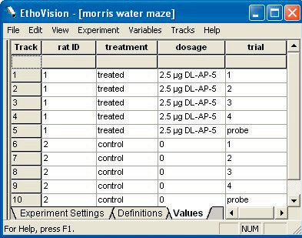
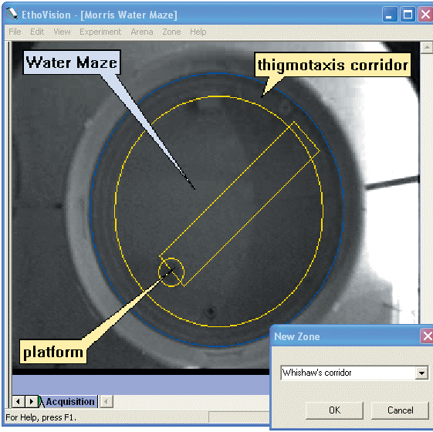
With EthoVision you can deﬁne independent variables such as animal code, treatment, trial number, platform location, or any other factor beforehand. Your analysis can later be based on these independent variables.

Figure 1. Deﬁning independent variables and zones.

Zones of any shape can be deﬁned directly over the video image of your water maze. This allows you to analyze the behavior of animals in relation to a platform, annulus, quadrant zones, thigmotaxis corridor, and Whishaw’s corridor (a narrow lane from release point to platform [2]).
Track your animals
Release an animal in your water maze and EthoVision will automatically track its swim path. Tracking can be done live from camera input, from videotape or from digital video ﬁles. You can instruct EthoVision to start and/or stop tracking when user-deﬁned conditions are met. For instance, tracking could stop automatically after 2 minutes have passed or when the animal has been on the platform for a few seconds.

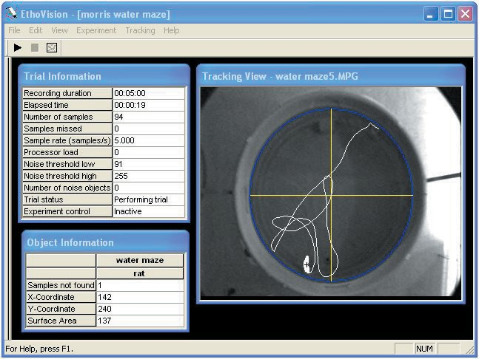
Figure 2. Tracking the swim path of a rat during a probe trial.

Analyze your data Time and distance related parameters can be measured for the independent variables and zones of your choice. This allows you, for instance, to measure the latency to reach the platform, length of the swim path, and Gallagher’s proximity (the cumulative distance to the platform [3]) for treated and non-treated animals. Although the latency to reach the platform may be the same for two different animals, the strategy used may differ considerably. To ﬁnd out more on how the animals searched for the platform, EthoVision provides a number of parameters related to the shape and speed of movement. This allows you to acquire an almost complete description of the animals’ behavior. You can visualize and replay the swim paths covered by your animals on your screen. Visualized paths and calcu- lated parameters can be copied to other programs (e.g. PowerPoint) for report and presentation purposes.

In addition, for inferential statistics and hypothesis testing or computation of endpoints not provided by EthoVision, a number of export formats are provided to analyze your data with spreadsheet and statistics
programs (e.g. Excel, SPSS, Wintrack [4] for advanced path analysis, and Theme™ [5] for spatial pattern detection).

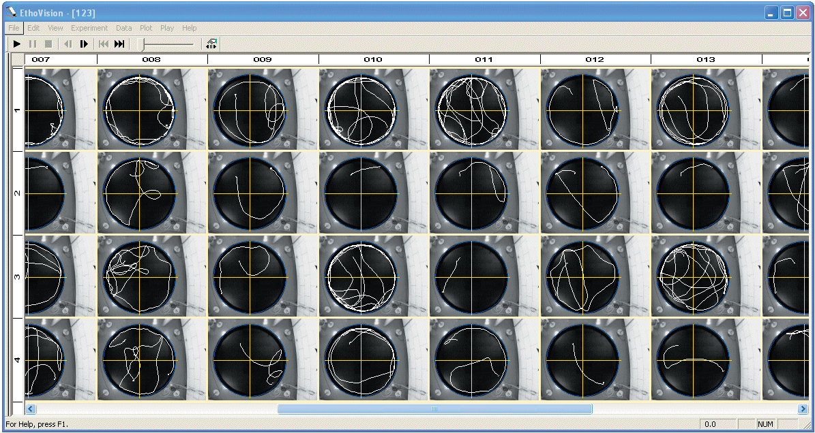

Figure 3. Visualizing recorded swim paths: Trial number and rat ID are displayed on the rows and columns, respectively.

Research articles illustrating the use of EthoVision with the morris water maze test
Evers, M.R.; Salmen, B.; Bukalo, O.; Rollenhagen, A.; Bösl, M.R.; Morellini, F.; Bartsch, U.; Dityatev, A.; Schachner, M. (2002). Impairment of L-type Ca2+ channel-dependent forms of hippocampal synaptic plasticity in mice deﬁcient in the extracellular matrix glycoprotein tenascin-C. The Journal of Neuroscience , 7177-7194. Kamphuis, P.J.G.H.; Gardoni, F.; Kamal, A.; Groiset, G.; Bakker, J.M.; Cattabeni, F.; Gispen, W.H.; Bel, F. van; Di Luca, M.; Wiegant, V.M. (2003). Long-lasting effects of neonatal dexamethasone treatment on spatial learning and hippocam- pal synaptic plasticity: involvement of the NMDA receptor complex. FASEB Journal 17, 911-913. Roubertoux, P.L.; Sluyter, F.; Carlier, M.; Marcet, B.; Maarouf-Veray, F.; Chérif, C.; Marican, C.; Arrechi, P.; Godin, F.; Jamon, M.; Verrier, B.; Cohen-Salmon, C. (2003). Mitochondrial DNA modiﬁes cognition in interaction with the nuclear genome and age in mice. Nature Genetics 35, 65-69.

Feel free to contact us or one of our local representatives for more references, clients lists, or more detailed information about EthoVision.

[1] D’Hooge, R. & De Deyn, P.P. (2001). Applications of the Morris water maze in the study of learning and memory. Brain Res. Rev 36, 60-90. [2] Gallagher, M., Burwell, R. & Burchinal, M. (1993). Behav. Neurosci 107, 618–626.
[3] Whishaw, I. Q. (1985). Behav. Neurosci 99, 979-1005.
[4] Wolfer, D.P.; Madani, R.; Valenti, P.; Lipp, H.P. (2001). Extended analysis of path data from mutant mice using the public domain software
Wintrack. Physiology & Behavior 73, 745-753.
[5] Magnusson, M.S. (2000). Discovering hidden time patterns in behavior: T-patterns and their detection. Behavior Research Methods, Instruments & Computers, 32, 93-110

