Womens Iridescent Performance Halter Top
Manufacturer: Ingenue
Item #: ING 128
Source: Discountdance.com

Inventory
Color | Size | Quantity | Notes
Gold | S | 3
Gold | M | 8
Gold | L | 3
Gold | XL | 2
Recital Magic Convertible Dance Dress
Manufacturer: Body Wrappers
Item #:7895
Source: Bodywrappers.com
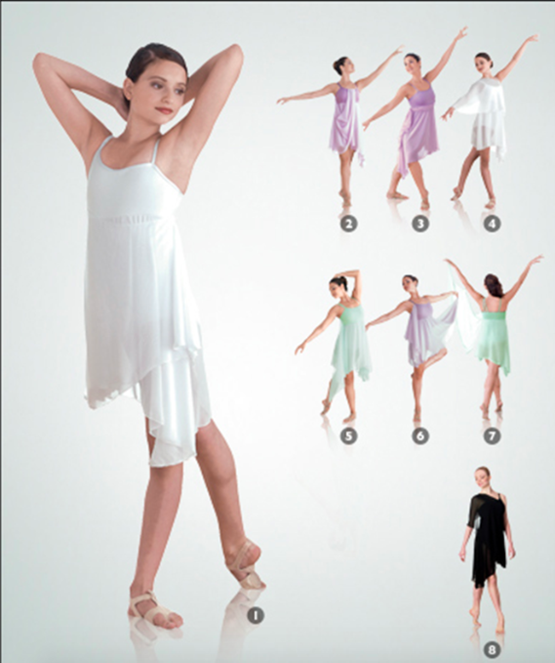

Inventory
Color | Size | Quantity | Notes
Mint | S | 1
Mint | M | 1

Adult Hand Painted Asymmetrical Side Drape Tank Lyrical Dress
Manufacturer: Watercolour
Item #: WC233
Source: Discountdance.com
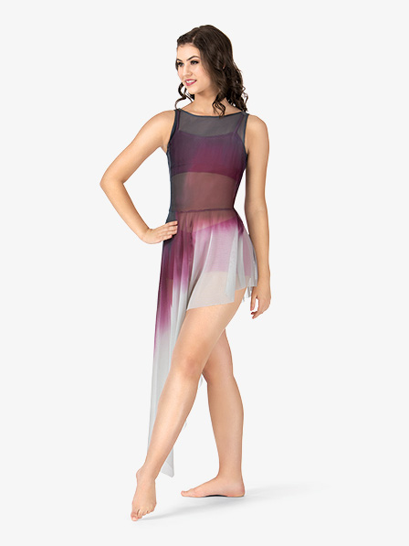

Inventory
Color | Size | Quantity | Notes
Navy/Burgundy/Light Grey | M | 3
Navy/Burgundy/Light Grey | L | 1
Navy/Burgundy/Light Grey | XL | 1

Twinkle Mock Neck Halter Bra
Manufacturer: Body Wrappers
Item #: TW600
Source: bodywrappers.com

Inventory
Color | Size | Quantity | Notes
Royal | M | 4
Royal | L | 1

Buffalo Plaid Flannel Shirt
Manufacturer: Balera
Item #: AH3623
Source: dancewearsolutions.com
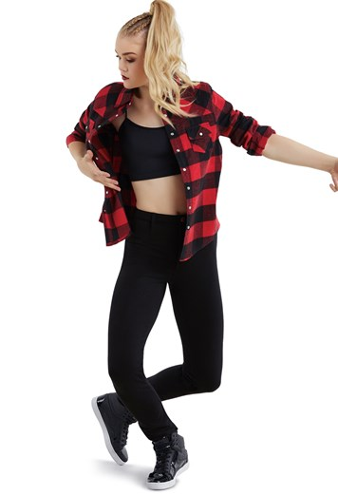

Inventory
Color | Size | Quantity | Notes
Red | SA | 1
Red | MA | 7
Red | LA | 3

High Waist Metallic Shorts
Manufacturer: Balera
Item #: ML7009
Source: dancewearsolutions.com

Inventory
Color | Size | Quantity | Notes
Black | SA | 5
Black | MA | 6
Black | LA | 2

ASMAX HaoDuoYi Womens Sparkly Sequin Spaghetti Strap Crop Top
Manufacturer: ASMAX
Item #:
Source: Amazon.com

Inventory
Color | Size | Quantity | Notes
Green | M | 1
Green | L | 2

Sequin Lace & Mesh Maxi Dress
Manufacturer: Balera
Item #: D9692
Source: weissmans.com
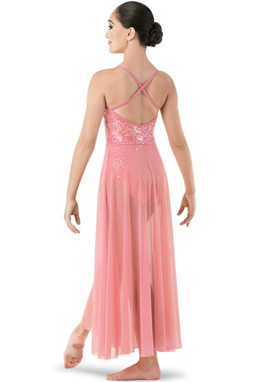

Inventory
Color | Size | Quantity | Notes
Pink | M | 3
Pink | L | 2
Pink | XL | 1

Natural Rise Metallic Leggings
Manufacturer: Balera
Item #: ML9756
Source: dancewearsolutions.com

Inventory
Color | Size | Quantity | Notes
Gold | SA | 6
Gold | MA | 1
Gold | LA | 3
Gold | XLA | 1

Balera Dance Crop Top With Lace Sleeve
Manufacturer: Balera
Item #: SL9087
Source: Amazon.com
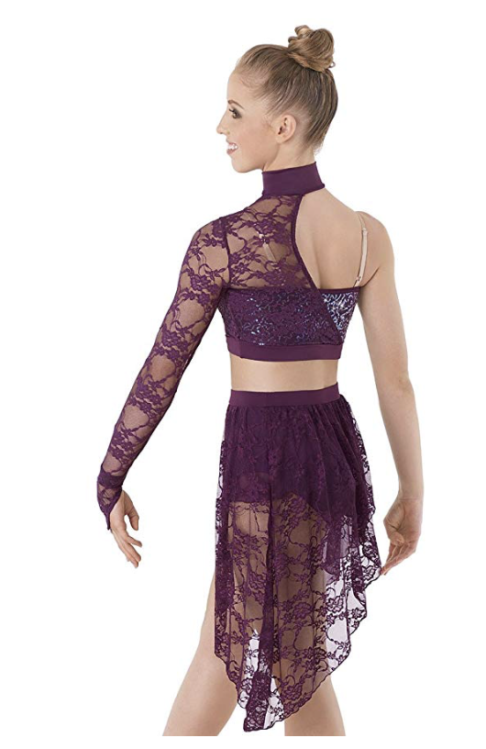

Inventory
Color | Size | Quantity | Notes
Burgundy/Purple | S | 3
Burgundy/Purple | M | 4
Burgundy/Purple | L | 2

Balera Dance Wrap Skirt Mesh High-Low Hemline With Built-In Brief
Manufacturer: Balera
Item #: S9086
Source: Amazon.com
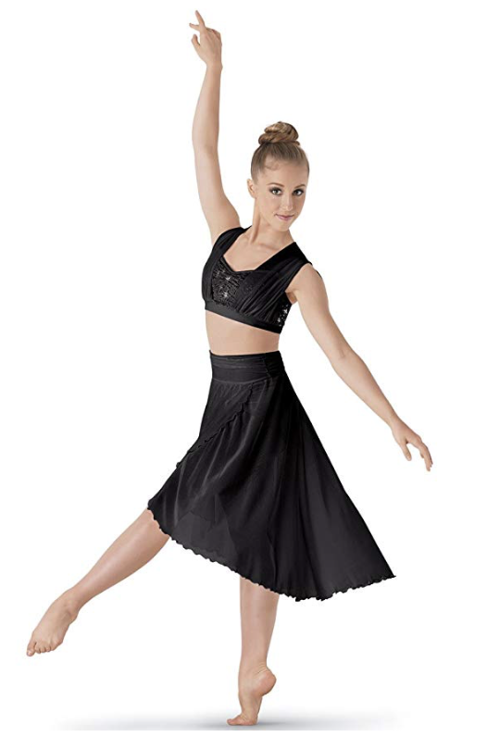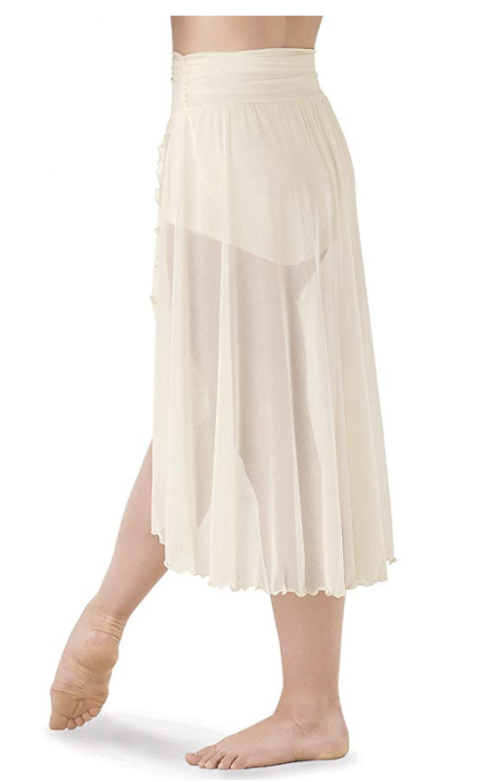

Inventory
Color | Size | Quantity | Notes
Burgundy/Purple | S | 3
Burgundy/Purple | M | 4
Burgundy/Purple | L | 2

Triple Color Block Harem Pants
Manufacturer: Balera
Item #: AH9838
Source: dancewearsolutions.com
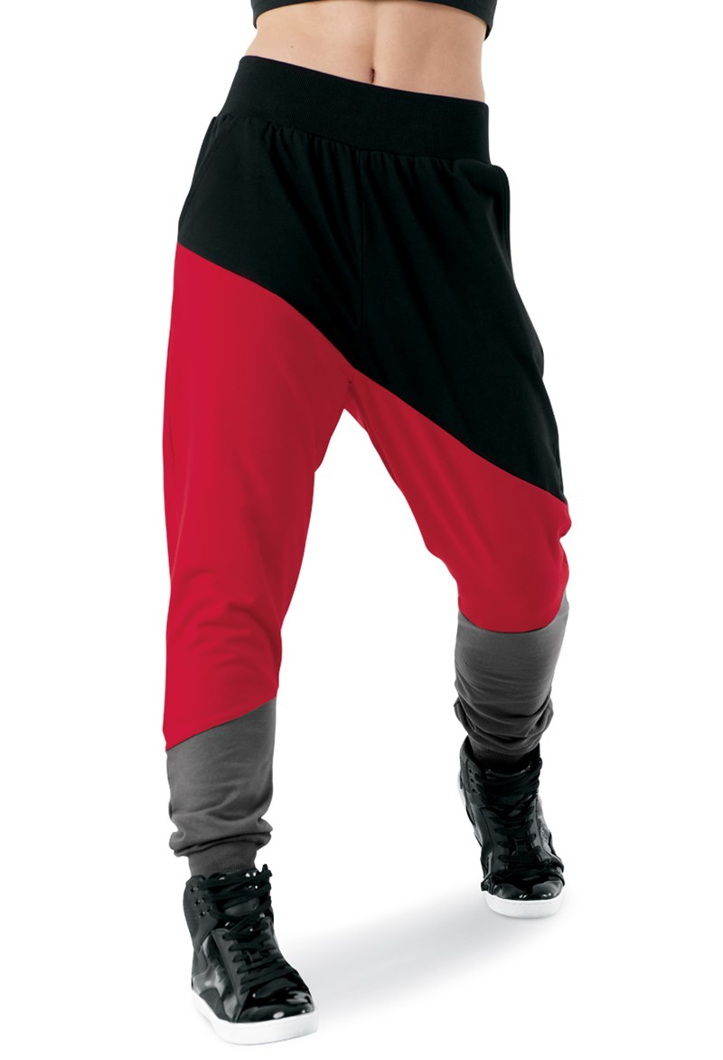
Inventory
Color | Size | Quantity | Notes
Black/Red | MA | 6

Hologram Sequin Mesh Bra Top
Manufacturer: Balera
Item #: SQ8436
Source: dancewearsolutions.com
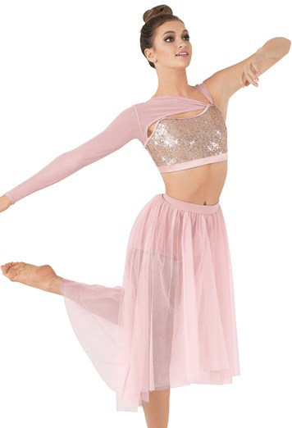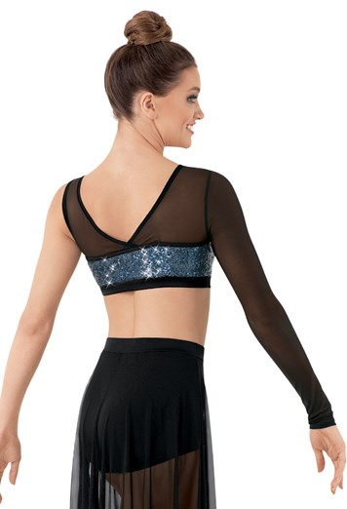

Inventory
Color | Size | Quantity | Notes
Black/Navy | MA | 5
Black/Navy | LA | 1

Shadow Stripe Leotard
Manufacturer: Balera
Item #: MT10480
Source: dancewearsolutions.com

Inventory
Color | Size | Quantity | Notes
Black | SA | 5
Black | MA | 1
Black | LA | 2
Black | XLA | 1

Crisscross Back Bra Top
Manufacturer: Balera
Item #: MT7766
Source: dancewearsolutions.com
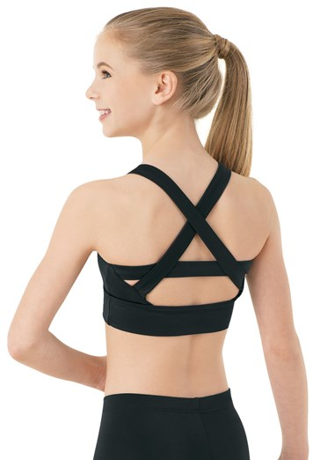

Inventory
Color | Size | Quantity | Notes
Black | SA | 5
Black | MA | 2
Black | LA | 2
Black | XLA | 1

Pleated High-Low Skirt
Manufacturer: Balera
Item #: S10259
Source: weissmans.com
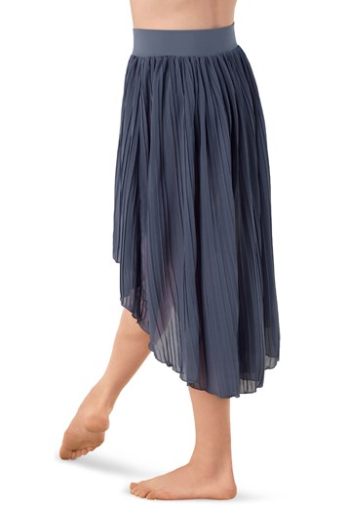

Inventory
Color | Size | Quantity | Notes
Periwinkle | SA | 1
Periwinkle | MA | 1
Periwinkle | LA | 2
Periwinkle | XLA

Sleeveless Mock Neck Crop Top
Manufacturer: Balera
Item #: MT6707
Source: dancewearsolutions.com

Inventory
Color | Size | Quantity | Notes
Black | LC | 1
Black | SA | 6
Black | MA | 9
Black | LA | 2

Skinny Cotton Harem Pant
Manufacturer: Balera/ Urban Groove
Item #: AH6773
Source: dancewearsolutions.com
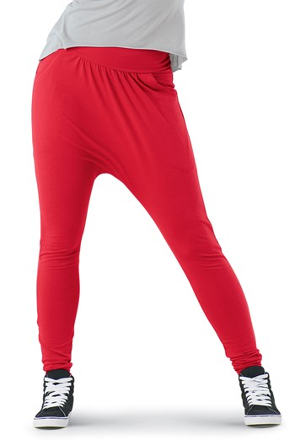

Inventory
Color | Size | Quantity | Notes
Purple | LA | 2
Purple | MA | 7
Red | MA | 3
Purple | XL | 1
Black | XL | 1

Alexander + David Womens Casual Flared Slvless Jersey Knit Shirt Tank Top
Manufacturer: Alexander + David
Style#: 8106 Cut#: 462
Source: amazon.com

Inventory
Color | Size | Quantity | Notes
Black | S | 7
Black | M | 2
Black | Large | 3

High Neck Halter Bra Top
Manufacturer: Balera
Item #: MT7478
Source: dancewearsolutions.com

Inventory
Color | Size | Quantity | Notes
Black | SA | 1
Black | MA
Black | LA
Black | XLA

Double Platinum Adult Asymmetrical One-Sleeve Spliced Leotard
Manufacturer: Natalie Dance Wear
Item #: N7071
Source: allaboutdance.com

Inventory
Color | Size | Quantity | Notes
Black | S | 3
Black | M | 6
Black | L | 5
Black | XL | 2

Womens Long Sleeve Ballet Cut Leotard
Manufacturer: Body Wrappers
Item #: BWC326
Source: discountdance.com

Inventory
Color | Size | Quantity | Notes
Navy | S | 2
Navy | M | 1
Navy | L | 2
Black | M | 1

VOGVOG Fedie Women Boatneck Sleeveless Vintage Tea Cocktail Dress with Belt
Manufacturer: Fedie
Item #:
Source: amazon.com
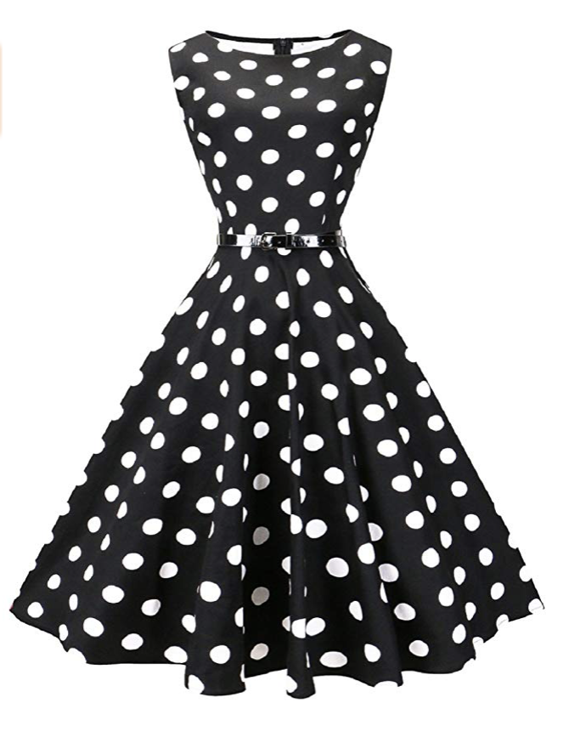

Inventory
Color | Size | Quantity | Notes
Black | S | 2
Black | M | 5

Whitewed Roaring 1920s 20s Sequin Tassel Paisley Flapper Girl Costume Dress
Manufacturer: Whitewed
Item #:
Source: amazon.com

Inventory
Color | Size | Quantity | Notes
Black/Gold | S | 1 | 7 headpieces
Black/Gold | M | 2
Black/Gold | L | 2
Black/Gold | XL | 2

Body Wrappers Asymmetrical Chiffon Cowl Back Dress
Manufacturer: Body Wrappers
Item #:
Source: amazon.com
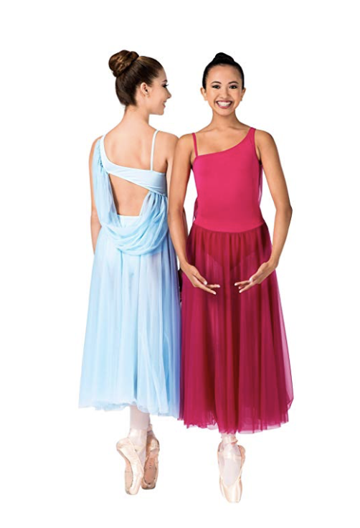

Inventory
Color | Size | Quantity | Notes
Light Blue | S | 3 | Stain on front of 1
Light Blue | M | 3
Light Blue | L | 1
Pink | S | 2
Pink | M | 2
Pink | L | 3

Theatricals Adult Cotton Blend Camisole Dance Leotard
Manufacturer: Theatricals Classwear
Item #: TH5500
Source: allaboutdance.com

Inventory
Color | Size | Quantity | Notes
White | S | 1
White | M | 4
White | L | 2

Mock Neck Long Sleeve Leotard
Manufacturer: ?
Item #: ?
Source: ?
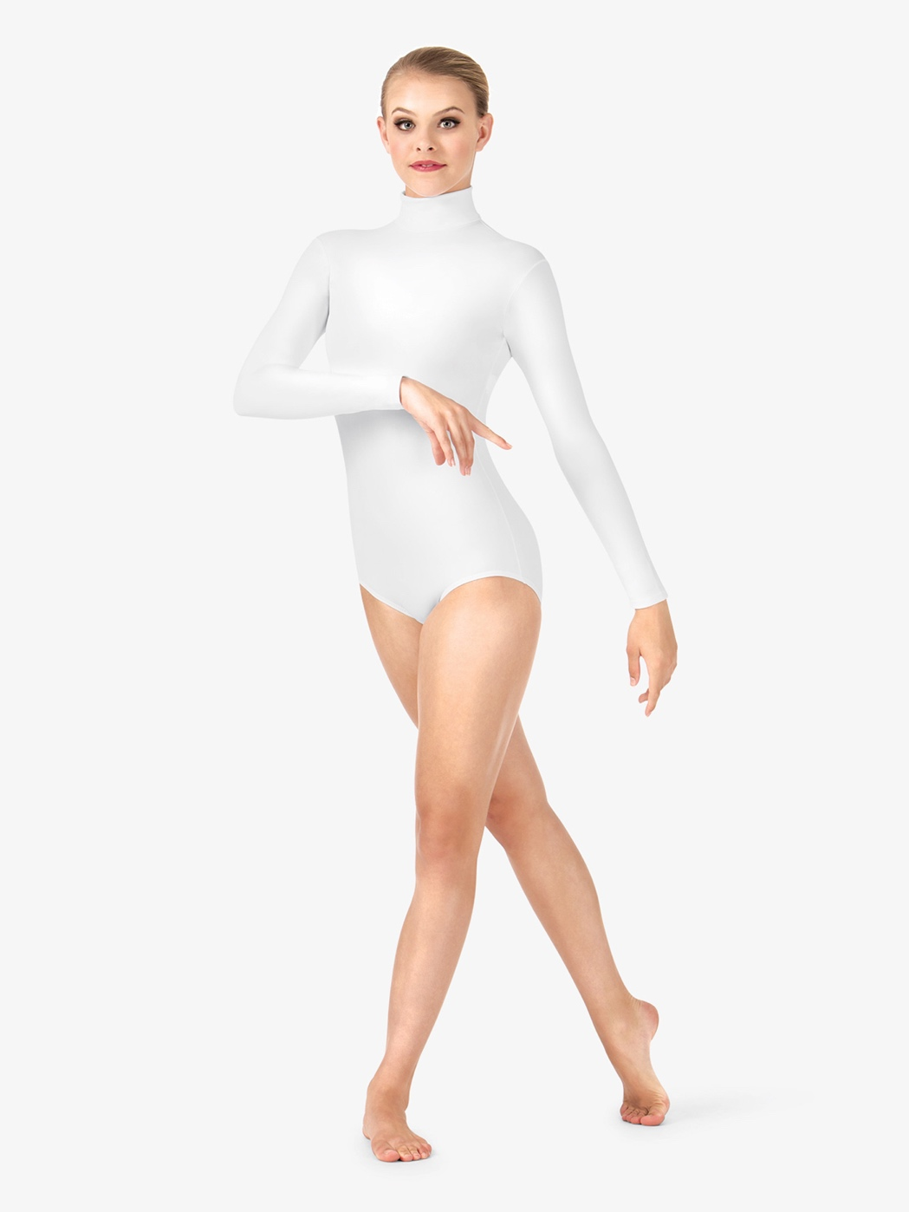

Inventory
Color | Size | Quantity | Notes
Silver/Gray | S | 5
Silver/Gray | M | 4
Silver/Gray | L | 6
Silver/Gray | XL | 1

Oversized Baseball Jersey
Manufacturer: Balera
Item #: AH9224
Source: dancewearsolutions.com
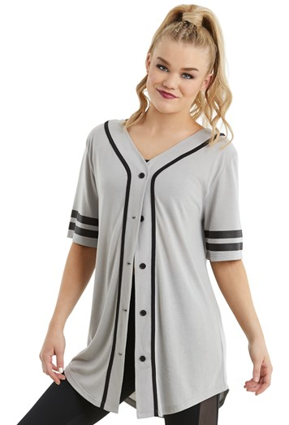

Inventory
Color | Size | Quantity | Notes
Gray | SA | 1 | There should be more of these somewhere

Luxe Scoop-Neck Swing Tank for Women
Manufacturer: Old Navy
Item #:
Source: oldnavy.gap.com

Inventory
Color | Size | Quantity | Notes
Just Peachy | S | 3
Just Peachy | M | 4
Just Peachy | XL | 1

Adult Long Sleeve Leotard with Lace Sleeve and Insert
Manufacturer: Natalie
Item #: N8650
Source: discountdance.com

Inventory
Color | Size | Quantity | Notes
Black | M | 4
Black | L | 2

Adult Turtleneck Long Sleeve Top
Manufacturer: Capezio
Item #: TB107
Source: discountdance.com

Inventory
Color | Size | Quantity | Notes
Black | S | 1
Black | M | 1
Black | L | 2

Adult Dance Shorts With Attached Bustle
Manufacturer: Natalie Dancewear
Item #: N8595
Source: amazon.com
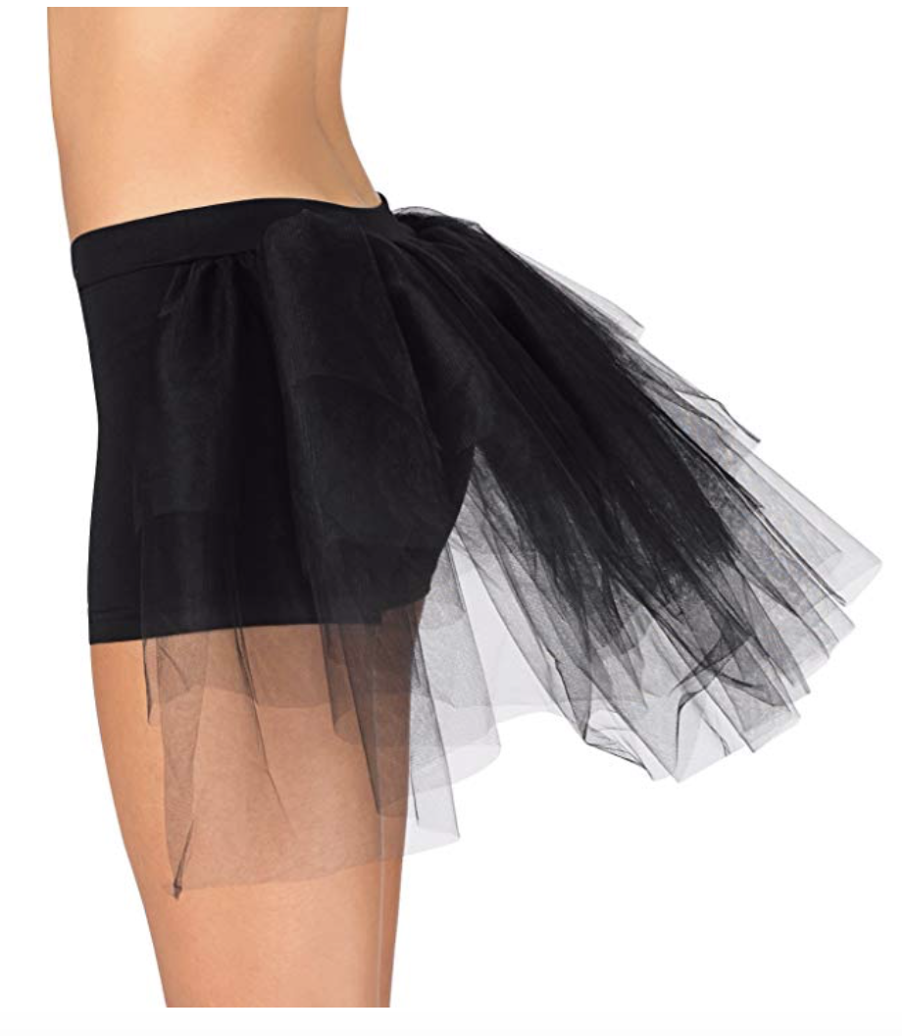

Inventory
Color | Size | Quantity | Notes
Black | S | 1
Black | M | 3
Black | L | 2

Oversized Favorite Tee Dress
Manufacturer: Balera
Item #: D10565
Source: dancewearsolutions.com

Inventory
Color | Size | Quantity | Notes
Mocha | S | 5
Mocha | M | 4
Mocha | L | 3

Color-Block T-Shirt With Pocket
Manufacturer: Shein
SKU #: RTSH160112160
Source: us.shein.com
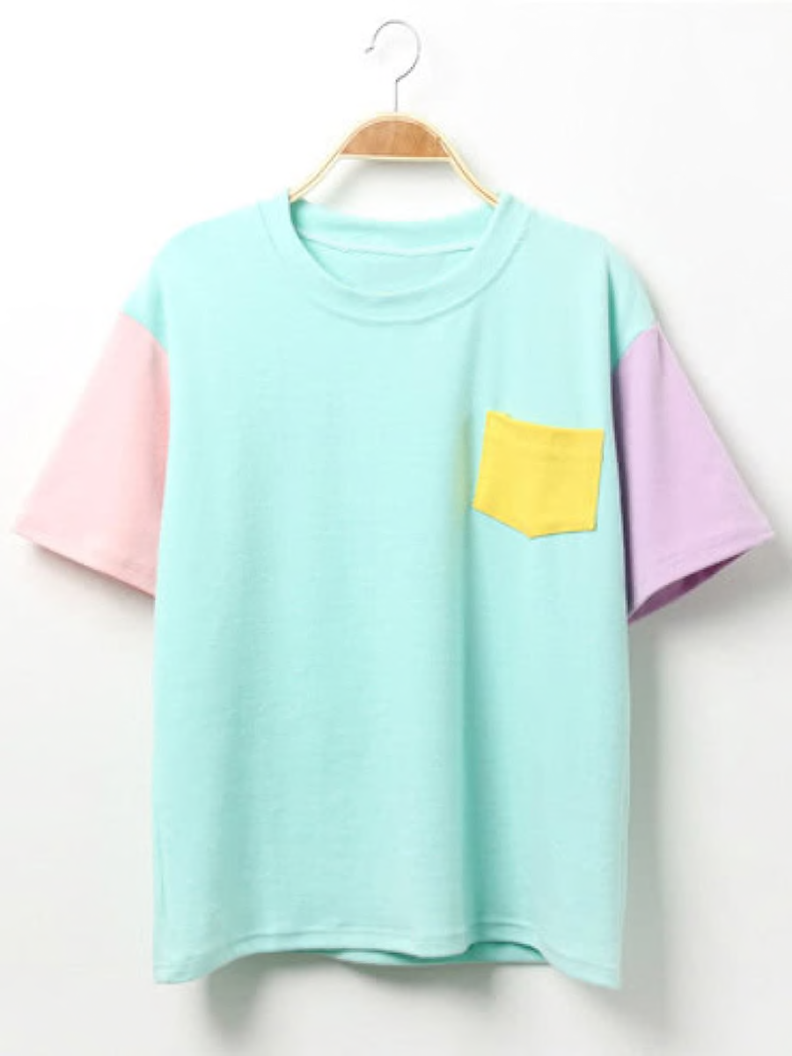

Inventory
Color | Size | Quantity | Notes
Green | One Size | 5
Pink | One Size | 5

Yiyuan Xiwo Gold Sequin Top
Manufacturer: yiyuanxiwo
Item #:
Source: poshmark.com
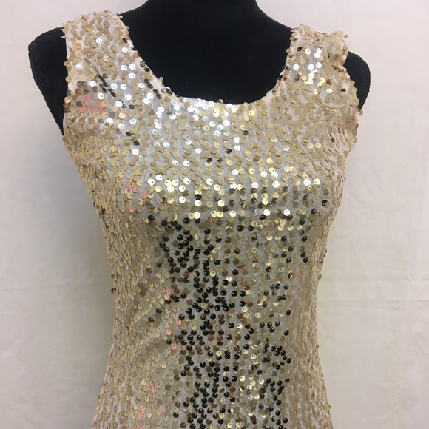

Inventory
Color | Size | Quantity | Notes
Gold | XL | 1

Balera Ballerina Dance Skirt High Waist Tulle and Satin
Manufacturer: Balera
Item #:
Source: amazon.com
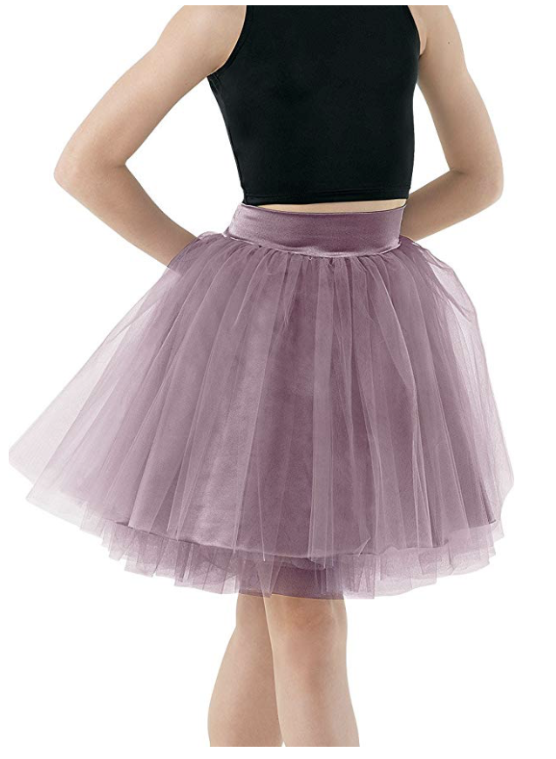

Inventory
Color | Size | Quantity | Notes
French Mauve | SA | 1

Tunic Side Slit Overdress
Manufacturer: Balera
Item #: D10177
Source: dancewearsolutions.com
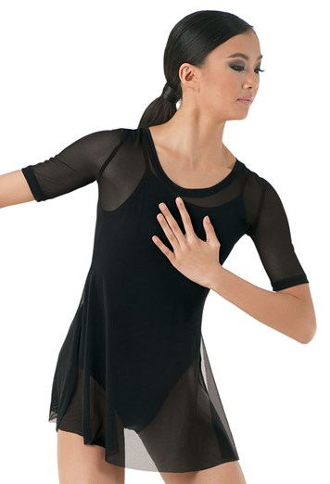

Inventory
Color | Size | Quantity | Notes
Black | L | 6
Black | XL | 2

Skinny Racerback Tank Top
Manufacturer: Urban Groove
Item #: MJ9425
Source: Urban Groove
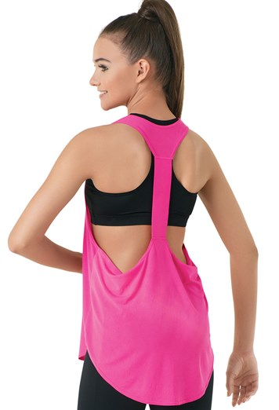

Inventory
Color | Size | Quantity | Notes
Red | M | 1
Purple | L | 1

Eyelet Sleeve Leotard
Manufacturer: ?
Item #: ?
Source: ?
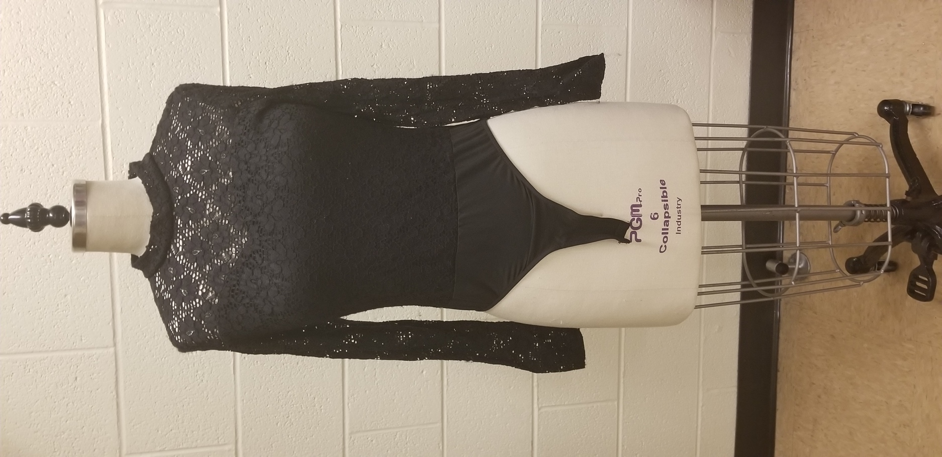

Inventory
Color | Size | Quantity | Notes
Black | S | 1
Black | M | 3
Black | L | 2
Black | XL | 1 | Jury-rigged

Mesh Wrap Dress
Manufacturer: Balera
Item #: D8423
Source: dancewearsolutions.com

Inventory
Color | Size | Quantity | Notes
Red | L | 1

HaiYiuDuo White Sheer Stipe Dress
Manufacturer: HaoYuoDuo
Item #:
Source: poshmark.com
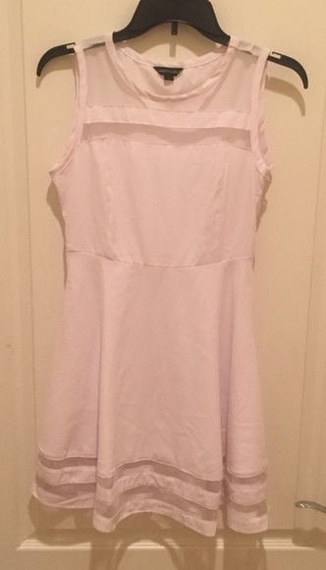

Inventory
Color | Size | Quantity | Notes
White | XL | 1

FENSACE Women’s Sleeveless Aline Waistline Midi Dress Casual Flared Tank Dress
Manufacturer: FENSACE
Item #:
Source: amazon.com
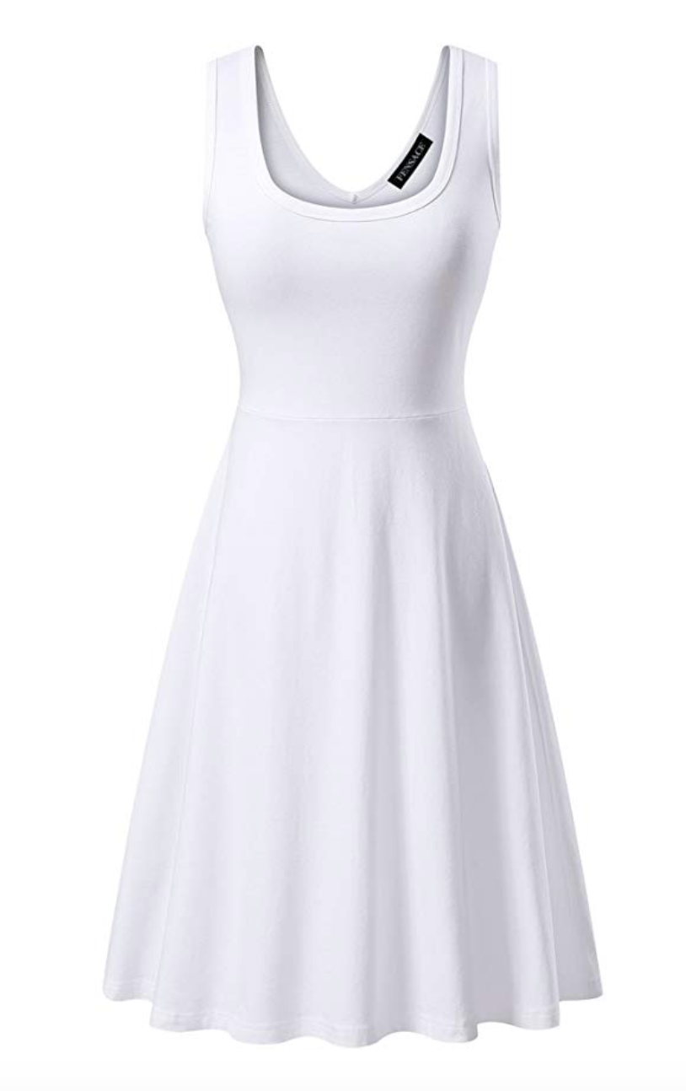

Inventory
Color | Size | Quantity | Notes
White | M | 1

Long Black Vest
Manufacturer:
Item #:
Source:
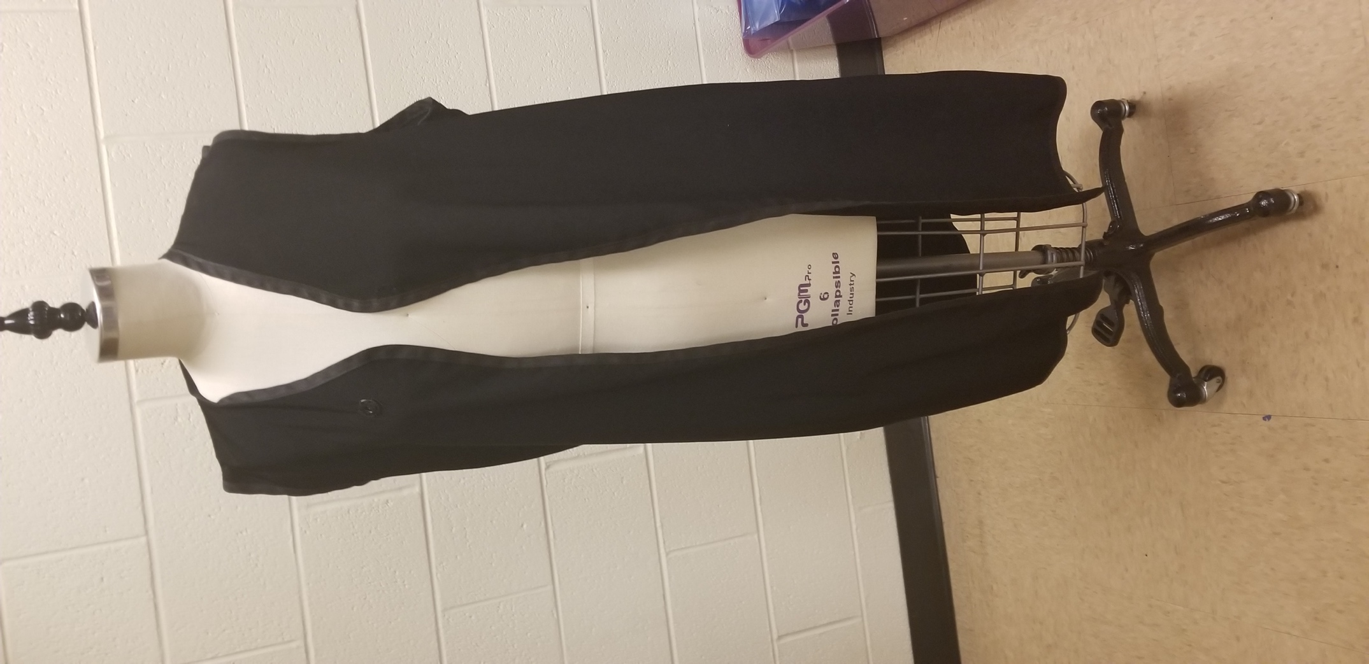

Inventory
Color | Size | Quantity | Notes
Black | ? | 1

Gray V-Neck Holed T-shirt
Manufacturer:
Item #:
Source:
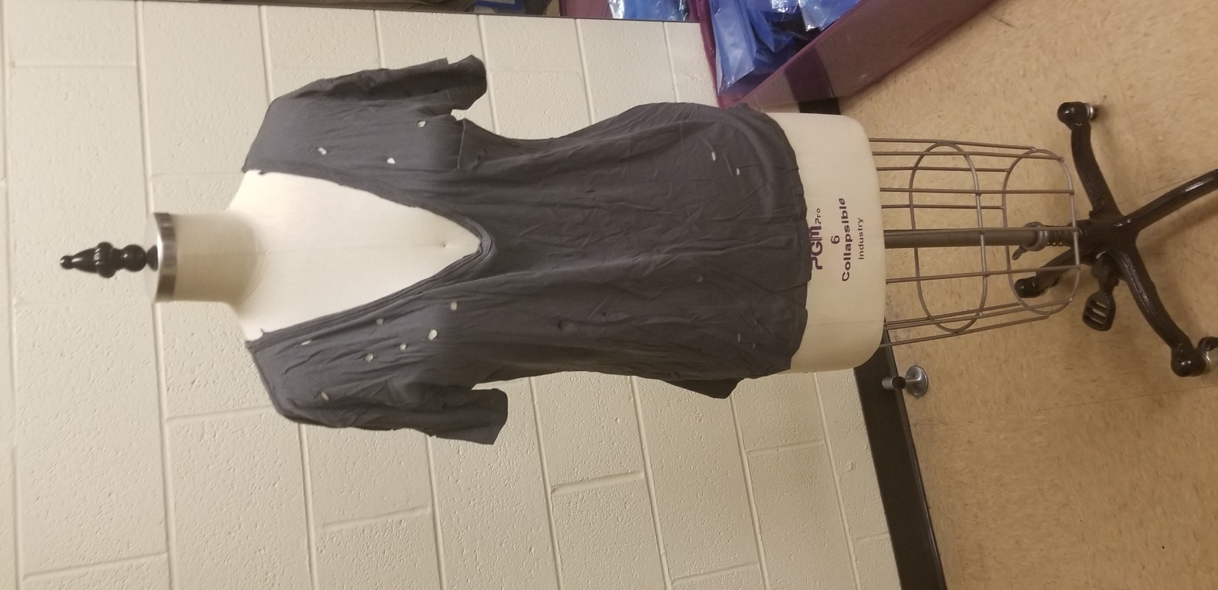

Inventory
Color | Size | Quantity | Notes

Red Sparkly Corset
Manufacturer:
Item #:
Source:
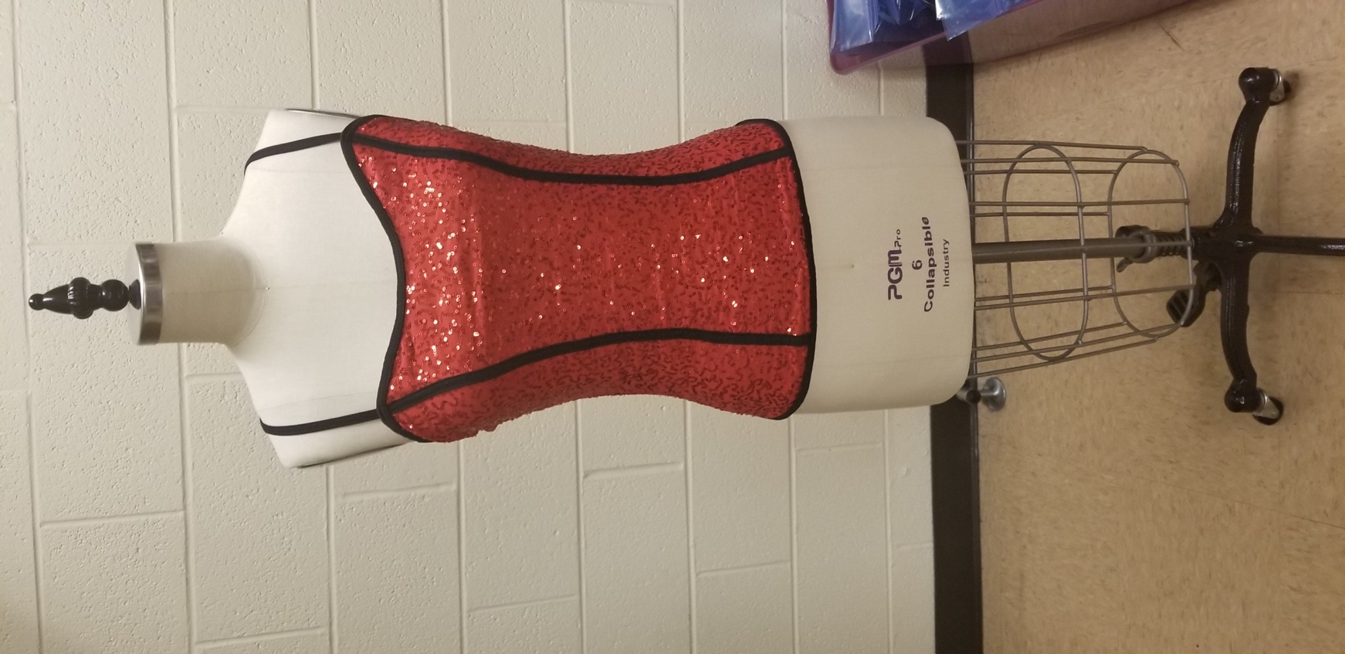

Inventory
Color | Size | Quantity | Notes
Red | Small | 1
Red | Medium | 1
Red | Large | 0
Red | X-Large | 1

Gold/ Blue Sparkle Mini Dress
Manufacturer:
Item #:
Source:
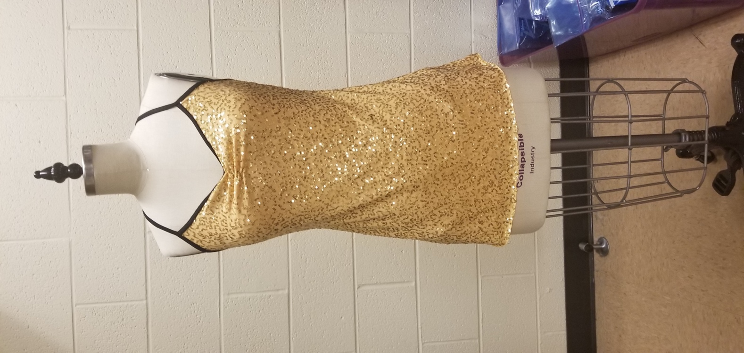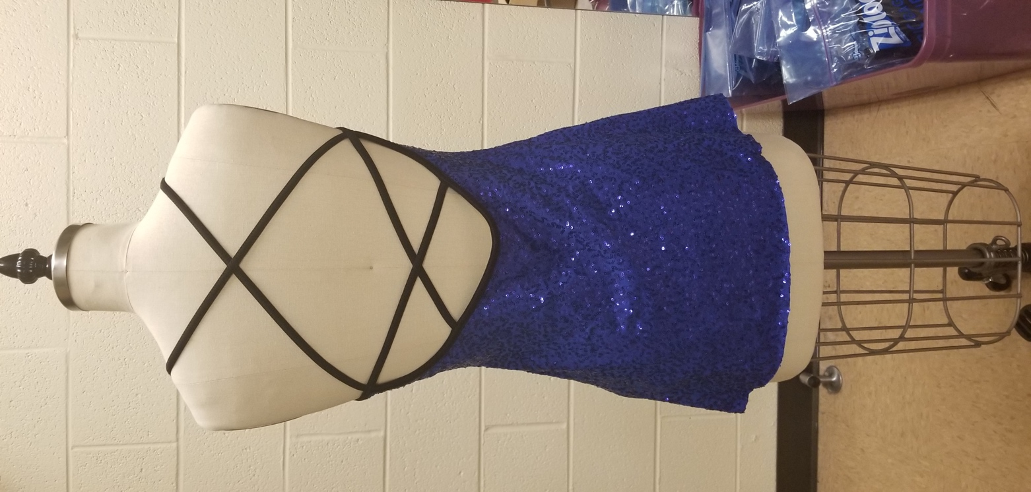
Inventory
Color | Size | Quantity | Notes
Gold/Blue | Small | 2/1
Gold/Blue | Medium | 2/2
Gold/Blue | Large | 1/1
Gold | X-Large | 2

Black Silky Sports Jacket
Manufacturer:
Item #:
Source:
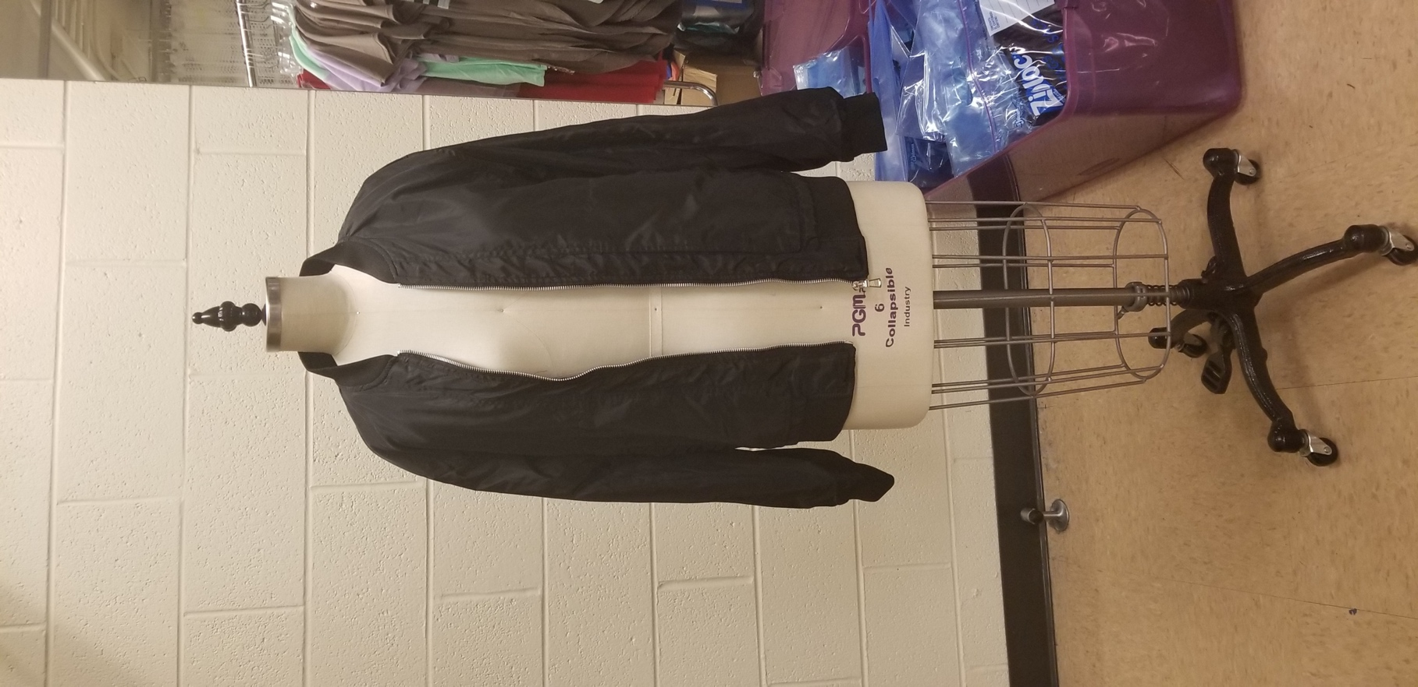

Inventory
Color | Size | Quantity | Notes

Black and White Striped Long Sleeve High Neck Shirt
Manufacturer:
Item #:
Source:

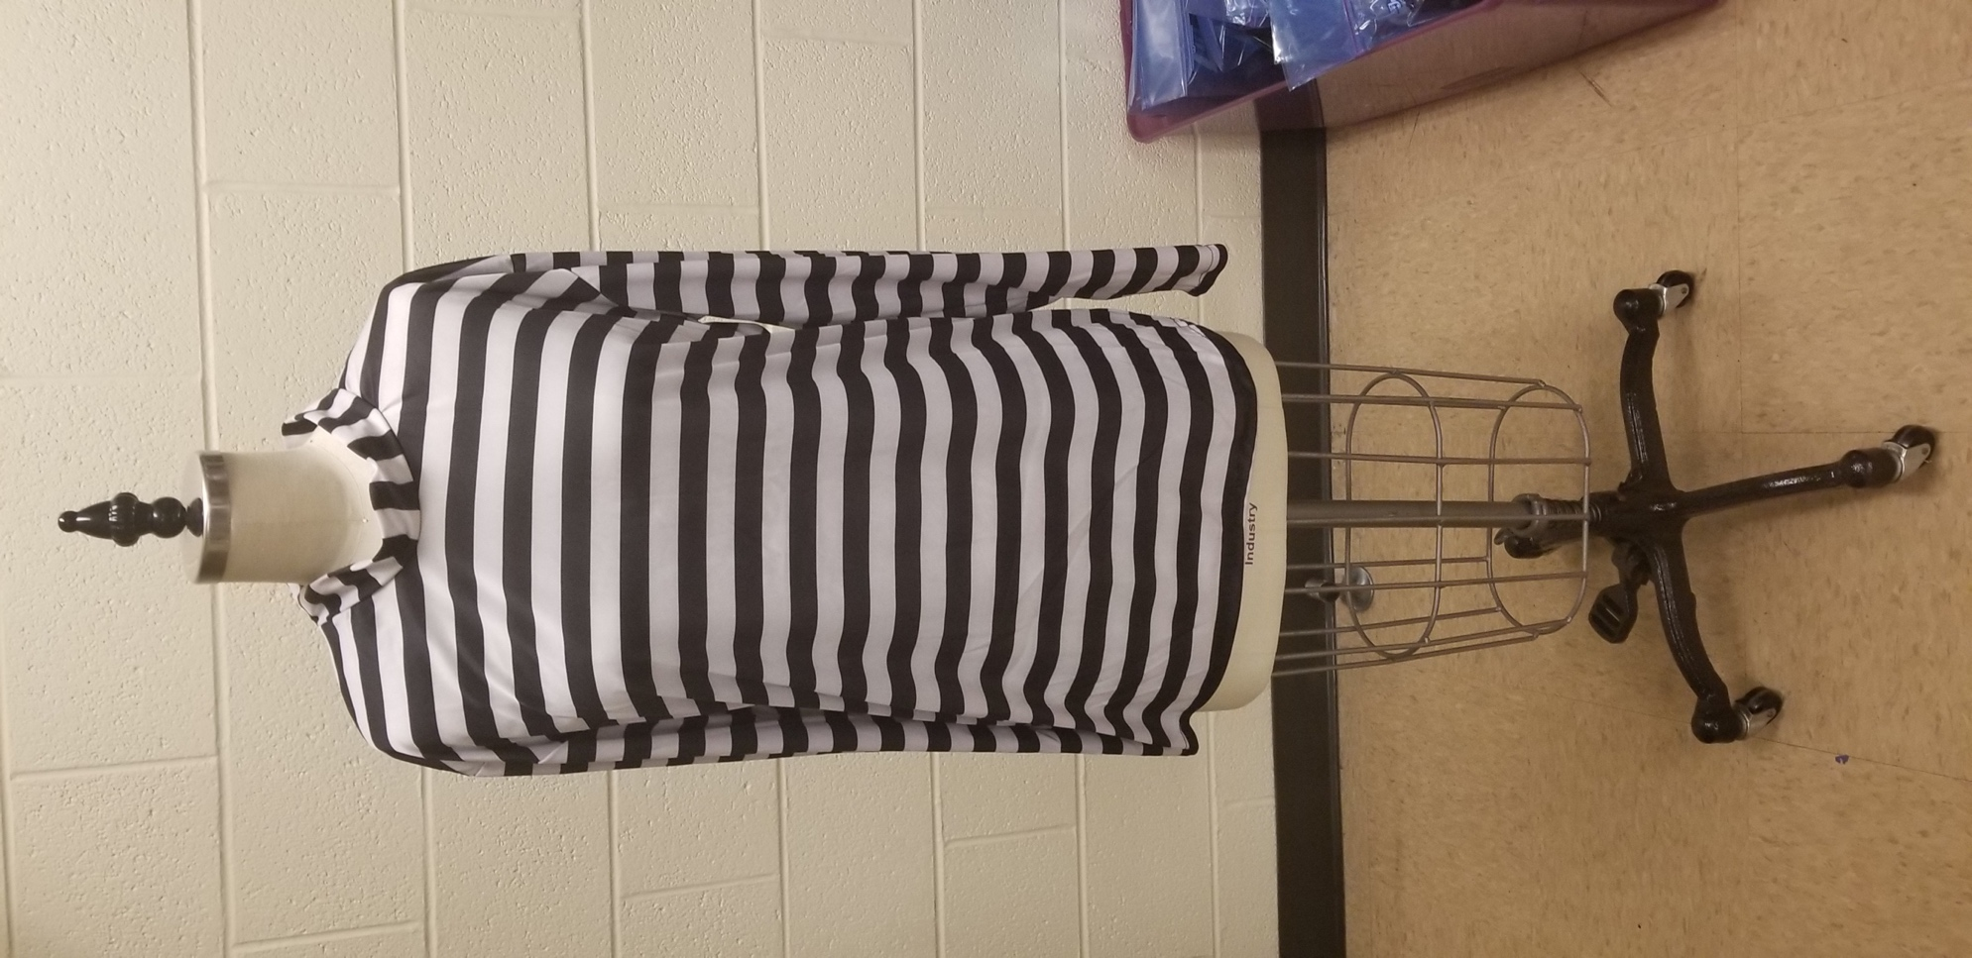
Inventory
Color | Size | Quantity | Notes

Black and White Striped Half Sleeve V-Neck Shirt
Manufacturer:
Item #:
Source:
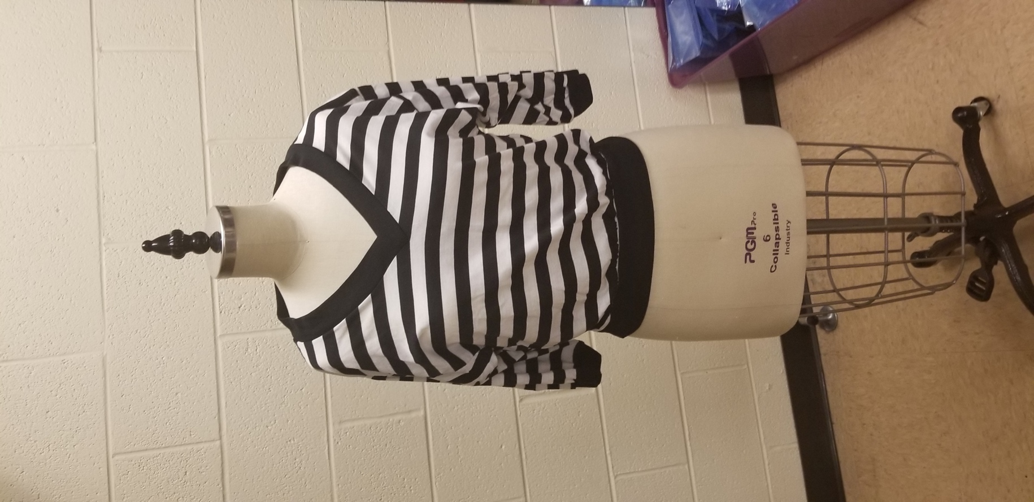

Inventory
Color | Size | Quantity | Notes

Black Cold Shoulder Backless Long Sleeve Shirt
Manufacturer:
Item #:
Source:
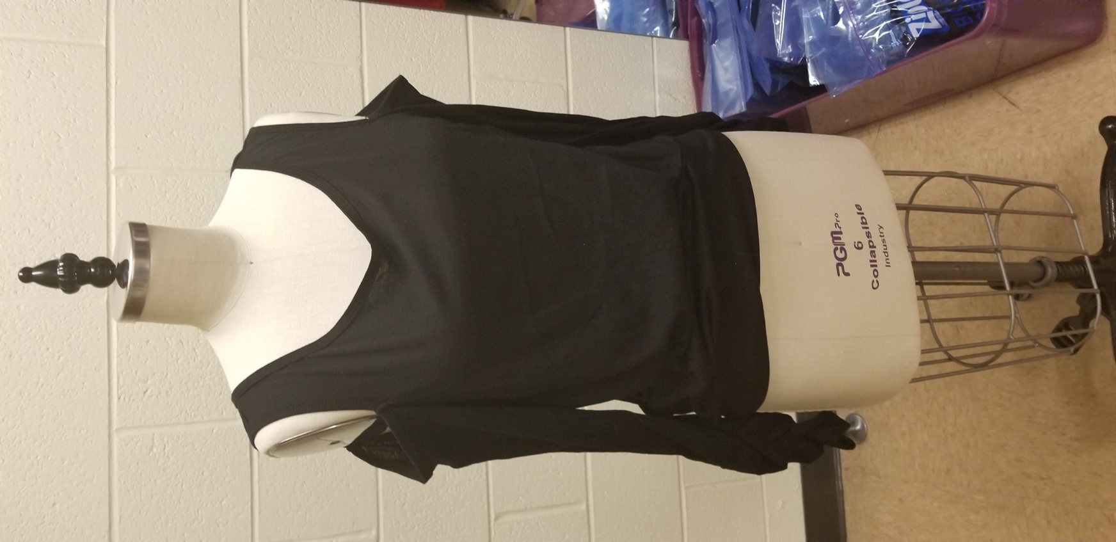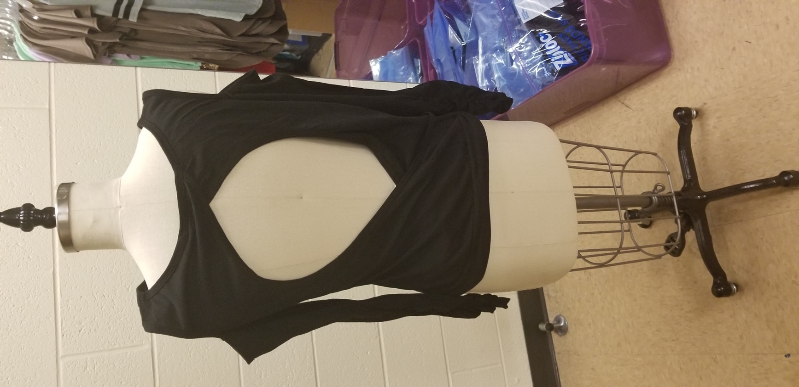
Inventory
Color | Size | Quantity | Notes
Black | Small | 5
Black | Medium | 7
Black | Large | 2

Red Sparkly Sheer Neckline Peplum Top
Manufacturer:
Item #:
Source:
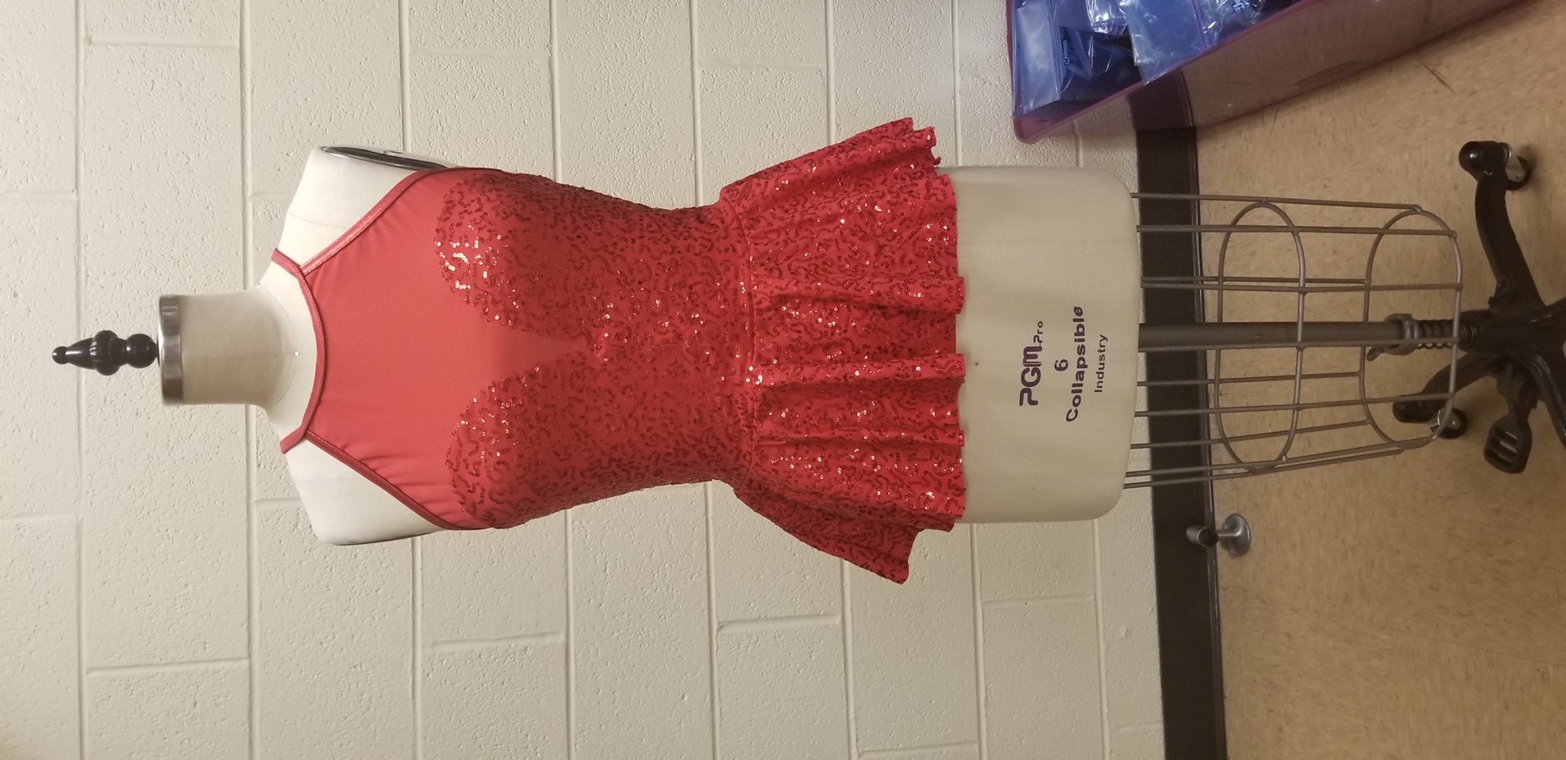

Inventory
Color | Size | Quantity | Notes
Red | Small | 2
Red | Medium | 2
Red | Large | 2
Red | X-Large | 1

Black Cage Mesh Cutout Sheer Skirt Dress
Manufacturer:
Item #:
Source:
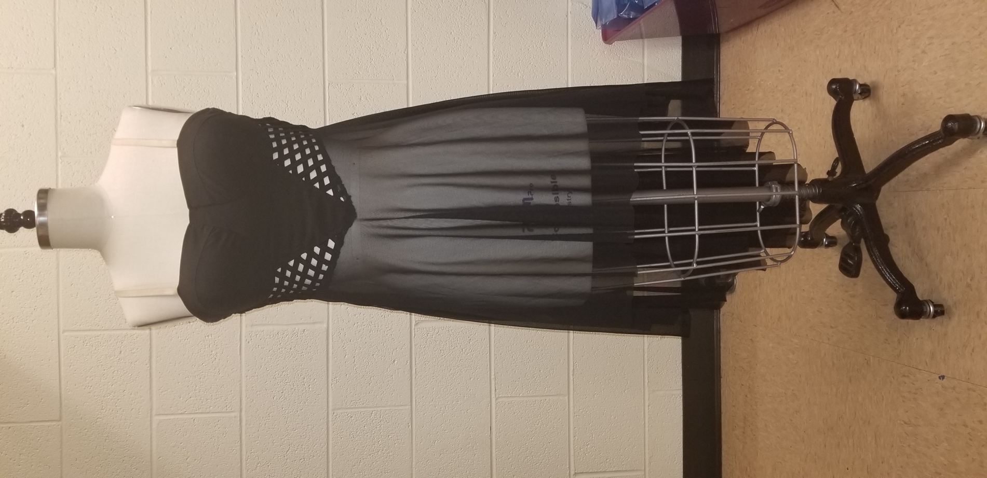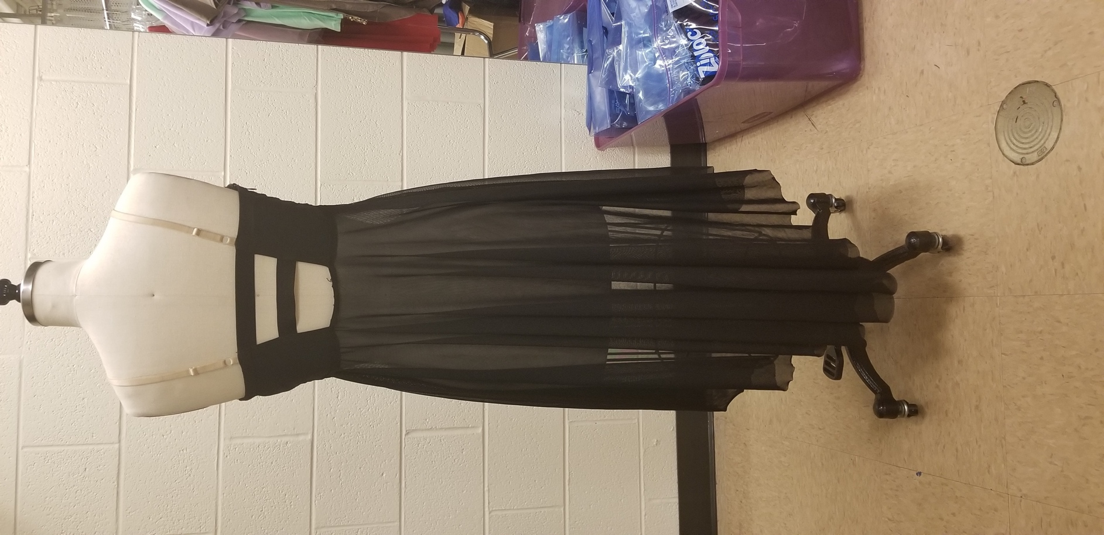

Inventory
Color | Size | Quantity | Notes
Black | Medium | 9
Black | Large | 4
Black

Gray Dress with Sheer Overlay
Manufacturer:
Item #:
Source:
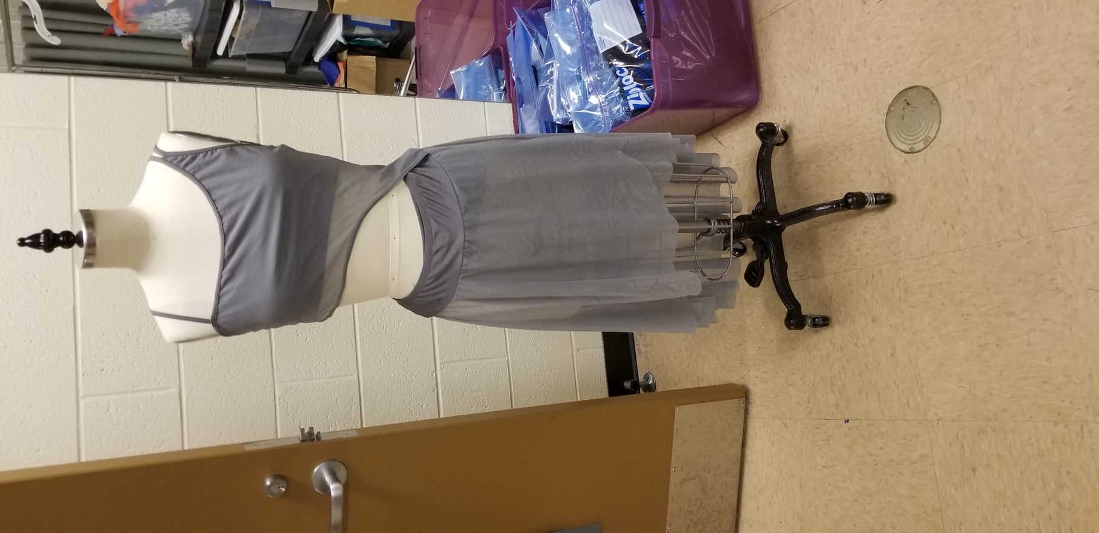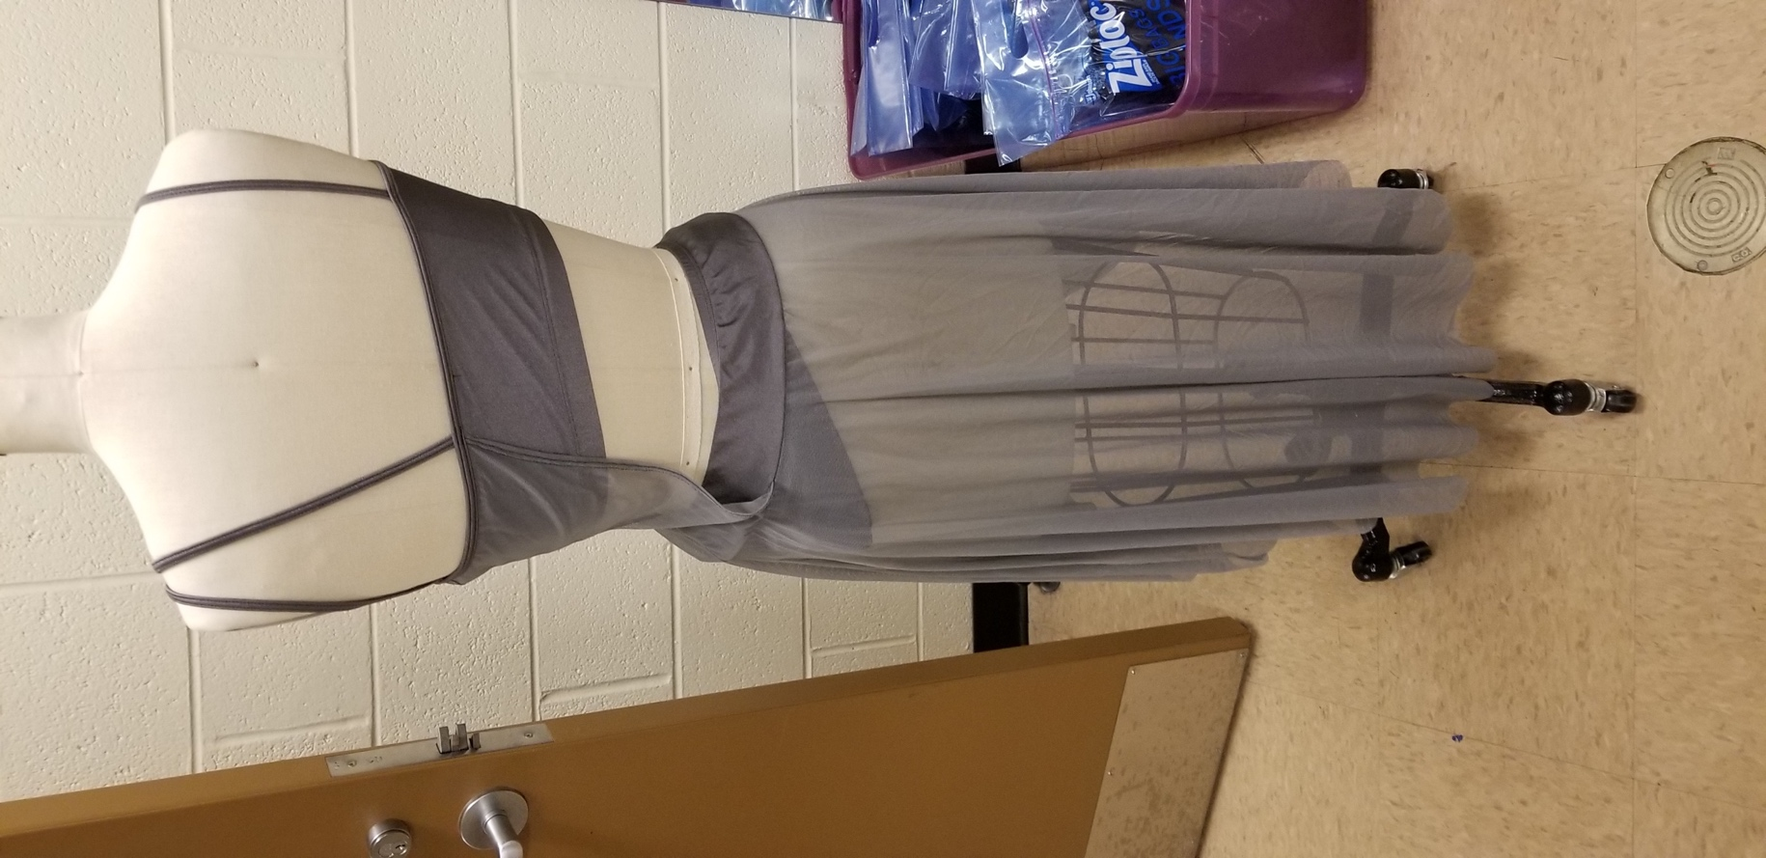

Inventory
Color | Size | Quantity | Notes
Gray | Small | 1
Gray | Medium | 1
Gray | X-Large | 2

Drape Tank
Manufacturer:
Item #:
Source:
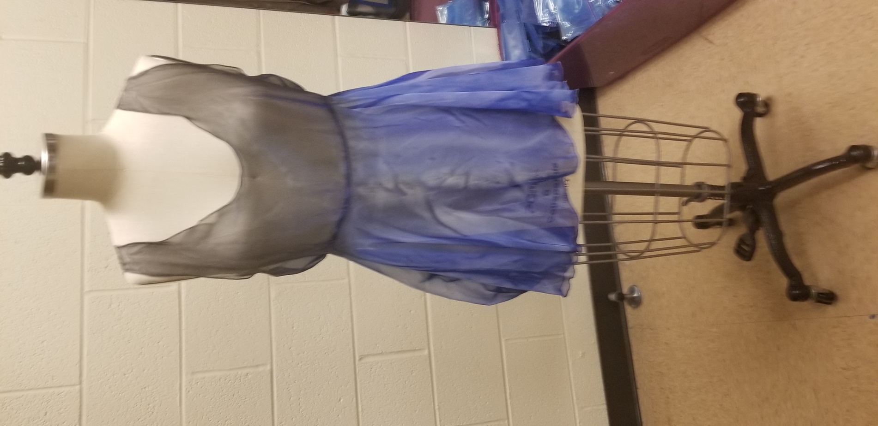

Inventory
Color | Size | Quantity | Notes
Blue Gray | One Size | 5

Gray High-Waist Green Flower Bottoms
Manufacturer:
Item #:
Source:
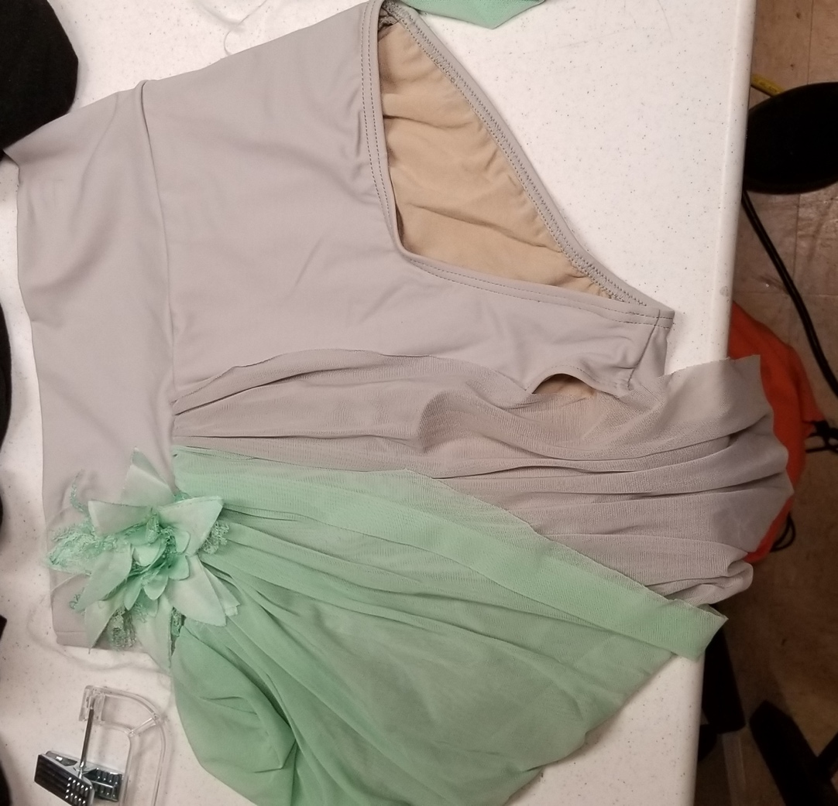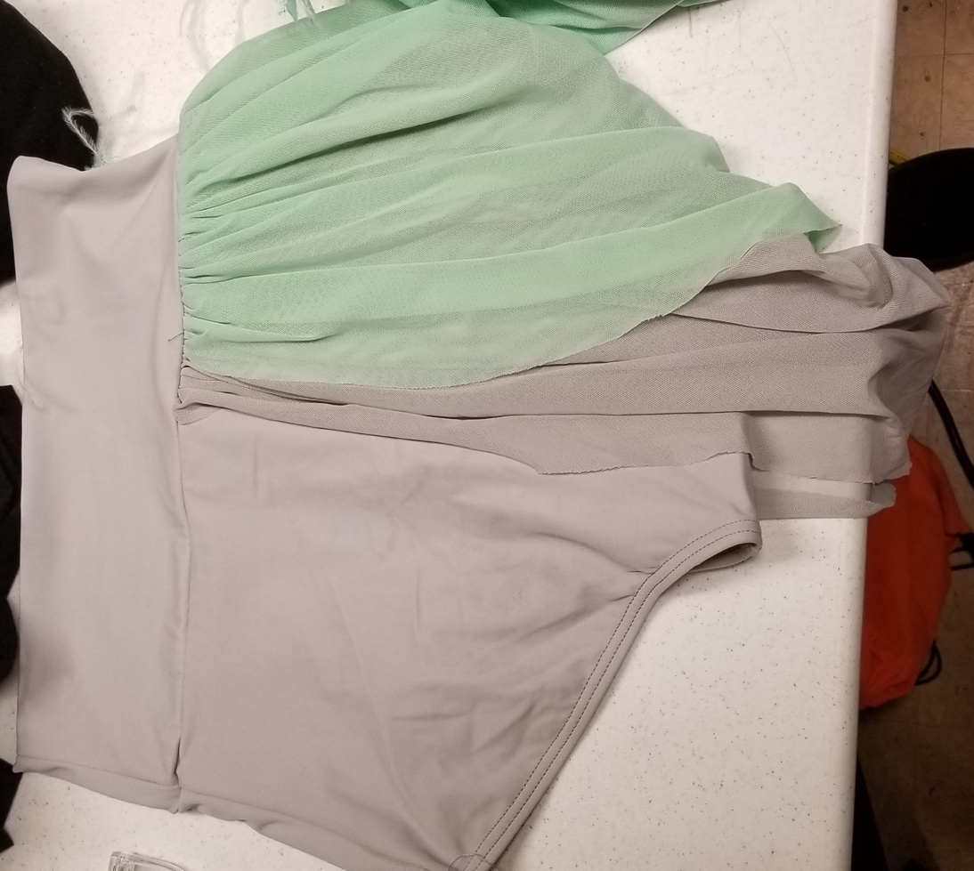

Inventory
Color | Size | Quantity | Notes
Gray Mint Green | Small | 3
Gray Mint Green | Medium | 9
Gray Mint Green | Large | 4

Black Sheer Sleeve Front Cutout Crop Top
Manufacturer:
Item #:
Source:
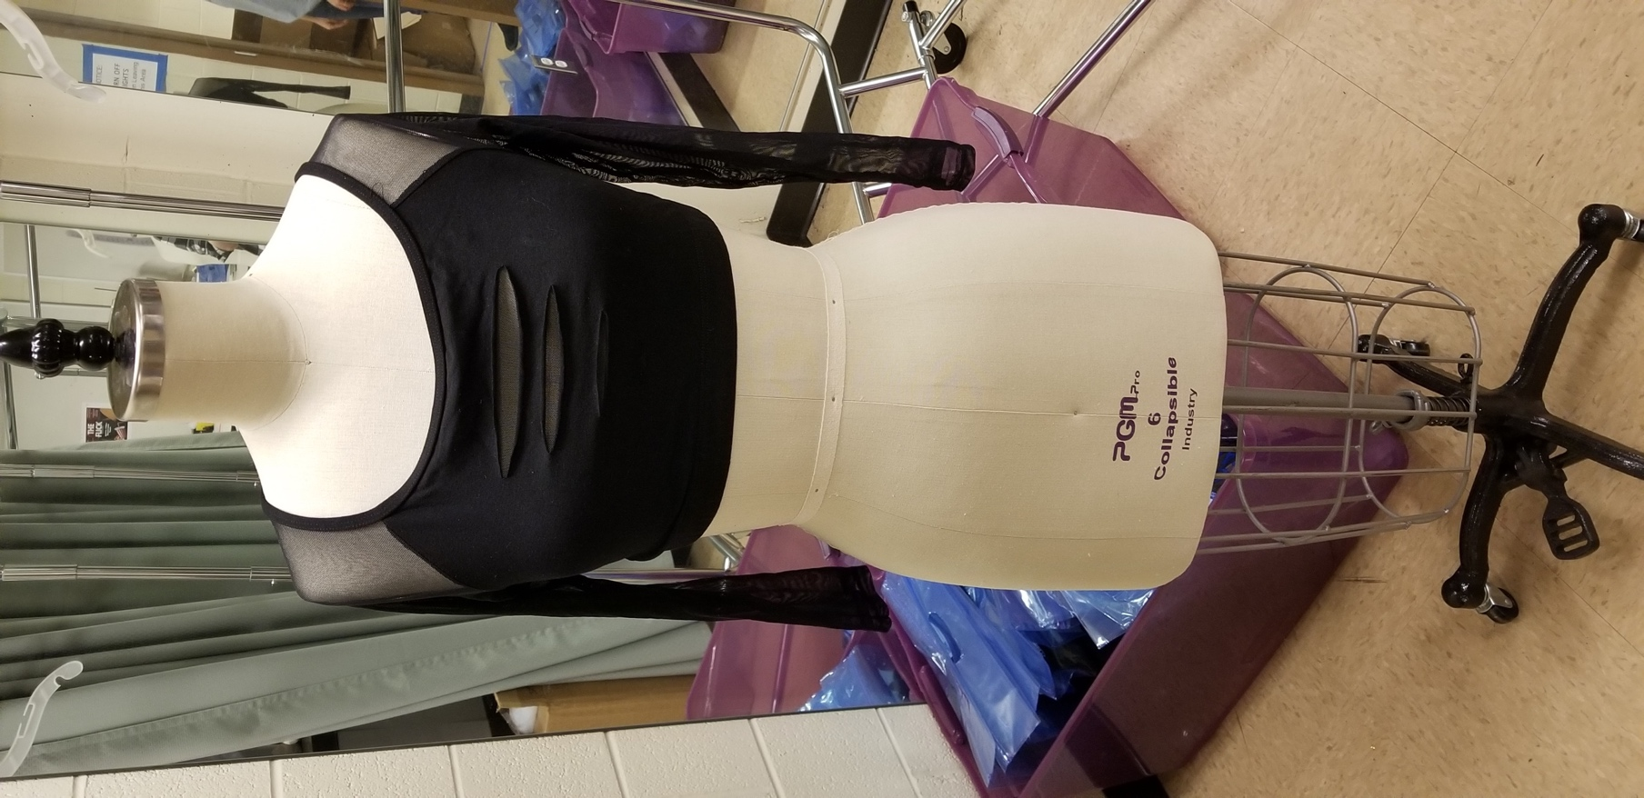

Inventory
Color | Size | Quantity | Notes
Black | Petite | 1
Black | Small | 1
Black | Large | 3

Red High-Waist Booty Short
Manufacturer:
Item #:
Source:
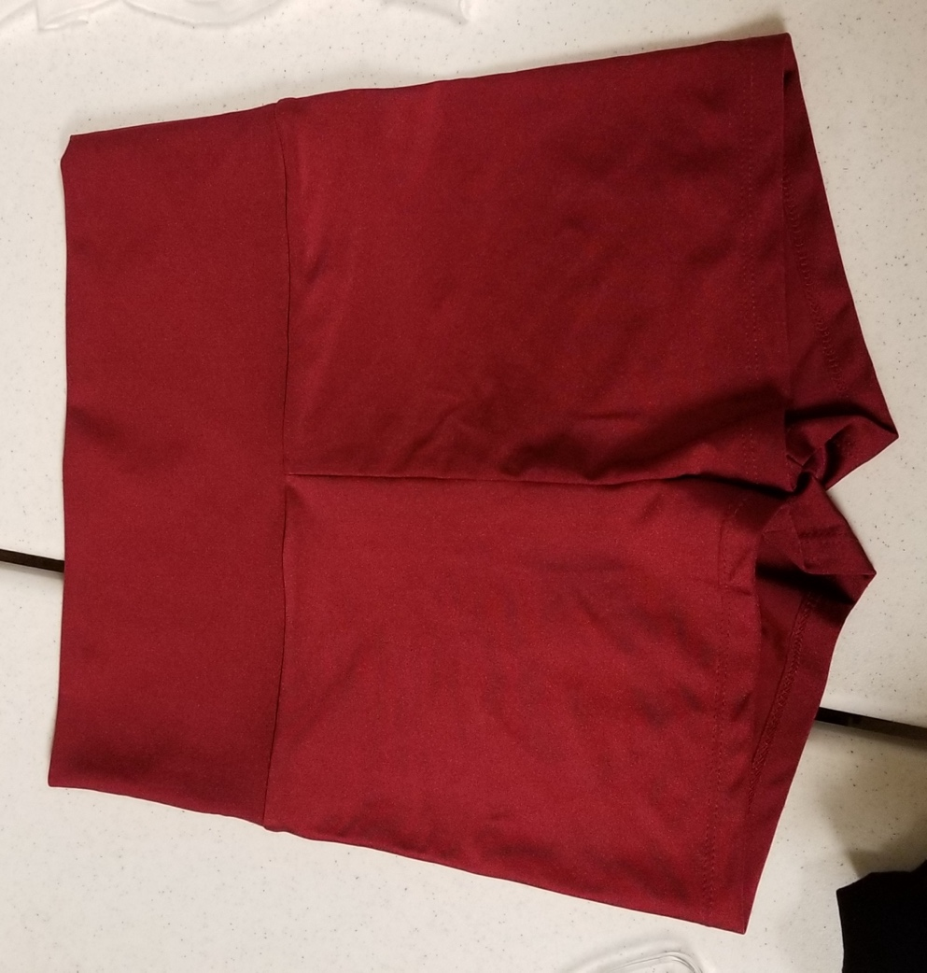

Inventory
Color | Size | Quantity | Notes
Red | Small | 4
Red | Medium | 8
Red | Large | 1

White Sheer Tie Skirt
Manufacturer:
Item #:
Source:
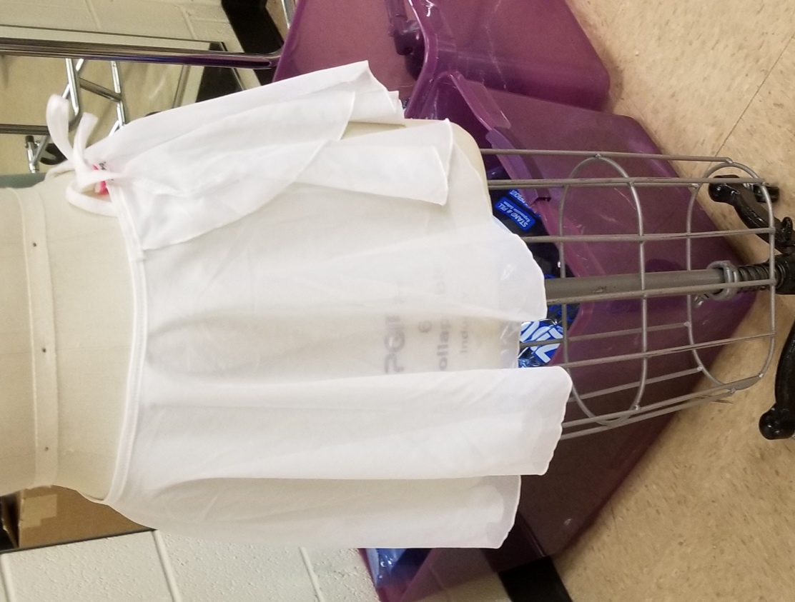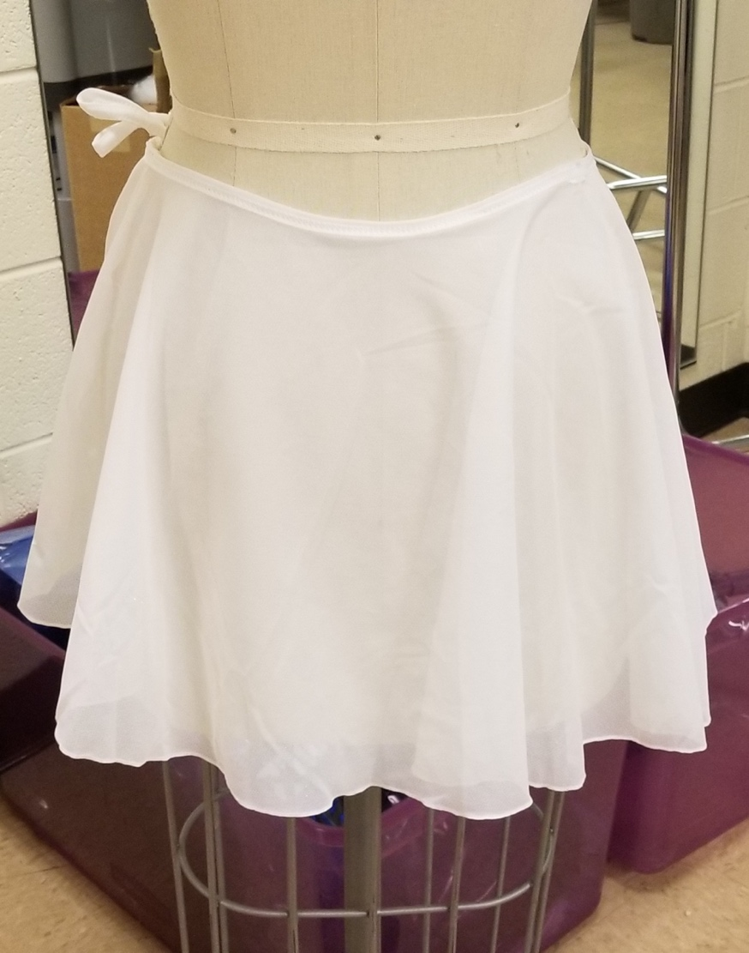

Inventory
Color | Size | Quantity | Notes
White | Small | 5
White | Medium | 3
White | Large | 1

Dark Green Leotard
Manufacturer:
Item #:
Source:
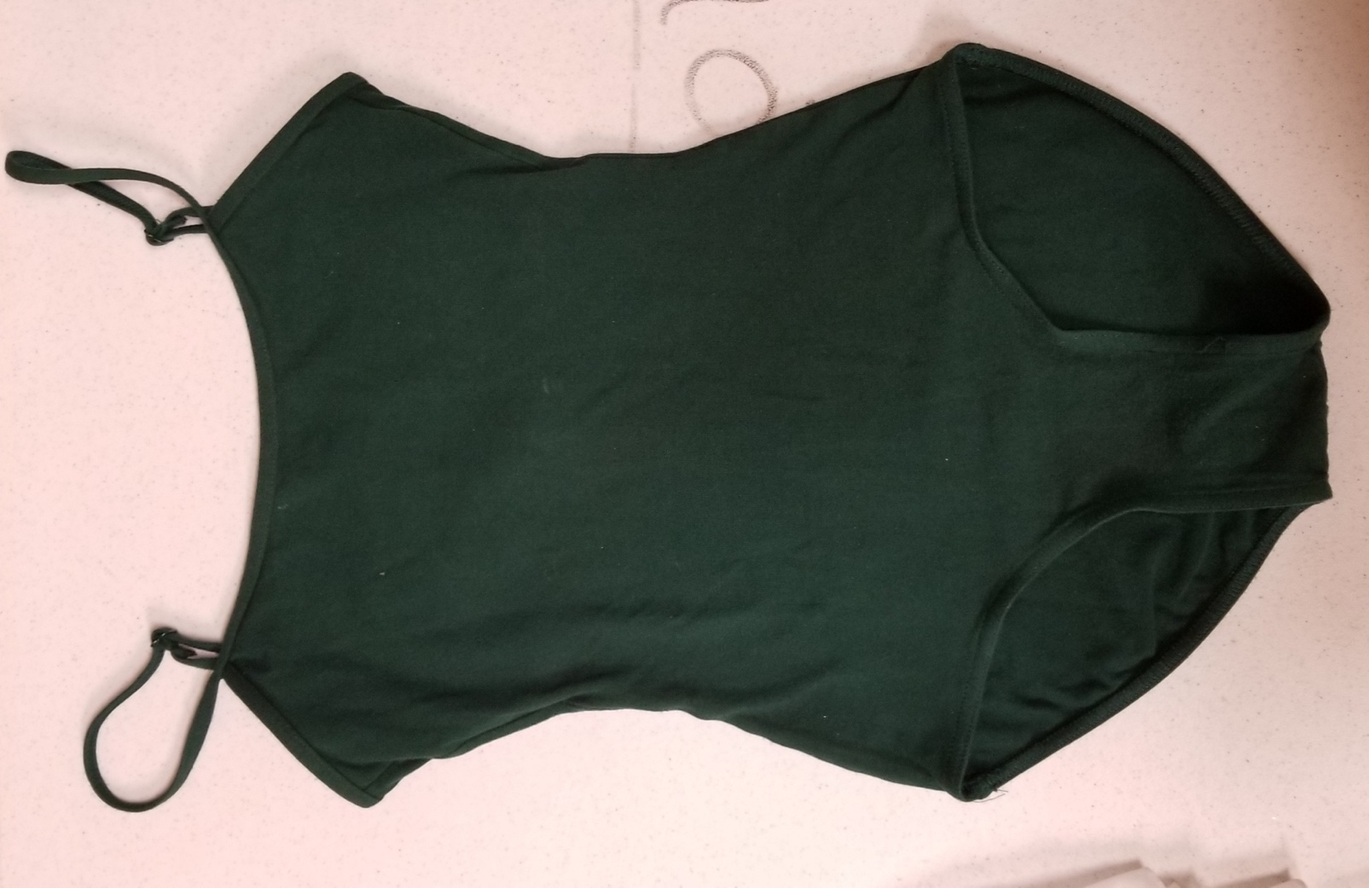

Inventory
Color | Size | Quantity | Notes
Dark Green | Medium | 12

Black Sheer Rose Embroidered Long Sleeve Crop Top
Manufacturer:
Item #:
Source:
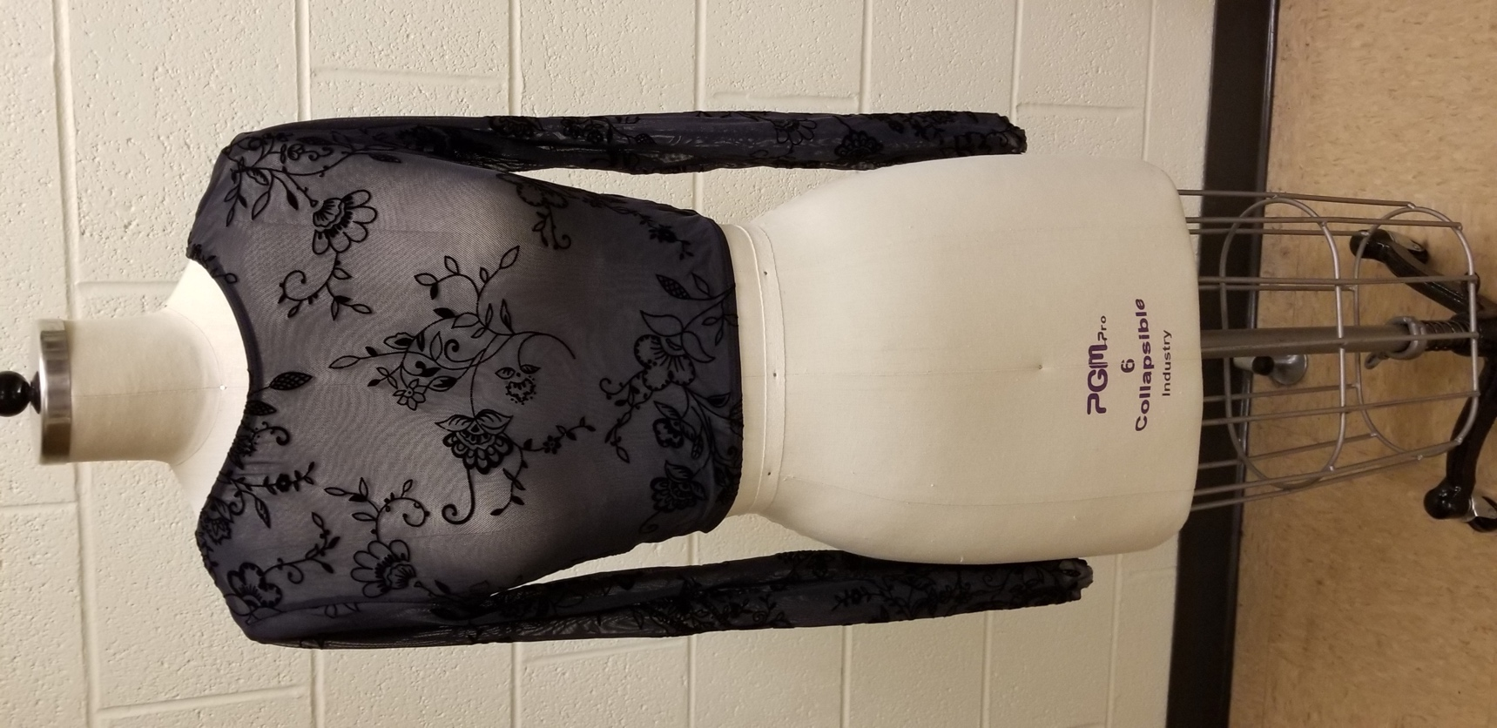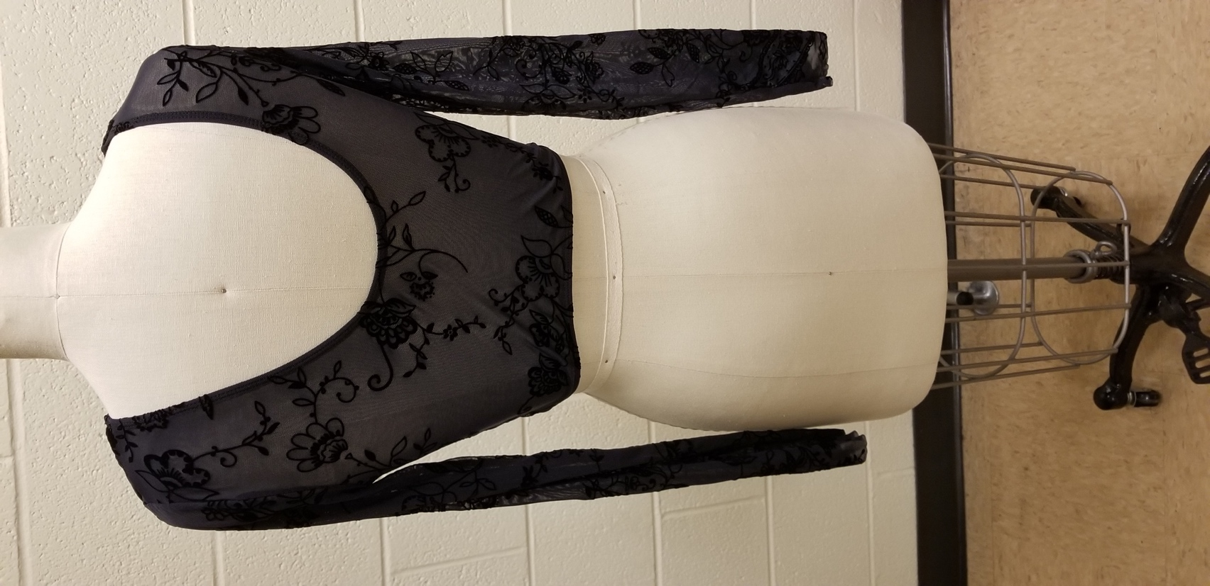

Inventory
Color | Size | Quantity | Notes
Black | Medium | 4
Black | Large | 1
Black | X-Large | 1

Silver Long Sleeved High Neck Leotard
Manufacturer:
Item #:
Source:
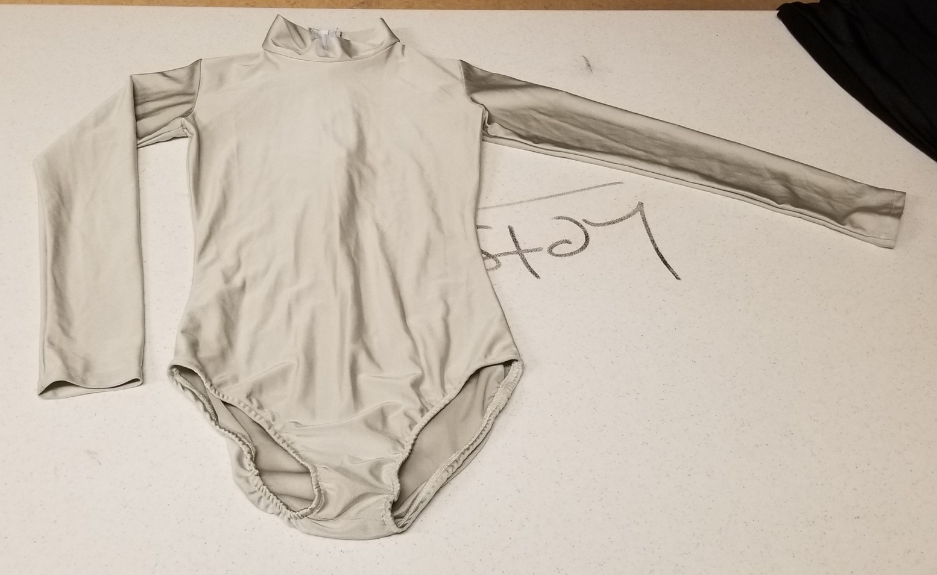

Inventory
Color | Size | Quantity | Notes
Silver | Small | 5
Silver | Medium | 4
Silver | Large | 6
Silver | X-Large | 1

Blue Spaghetti Strap Bra Top
Manufacturer:
Item #:
Source:
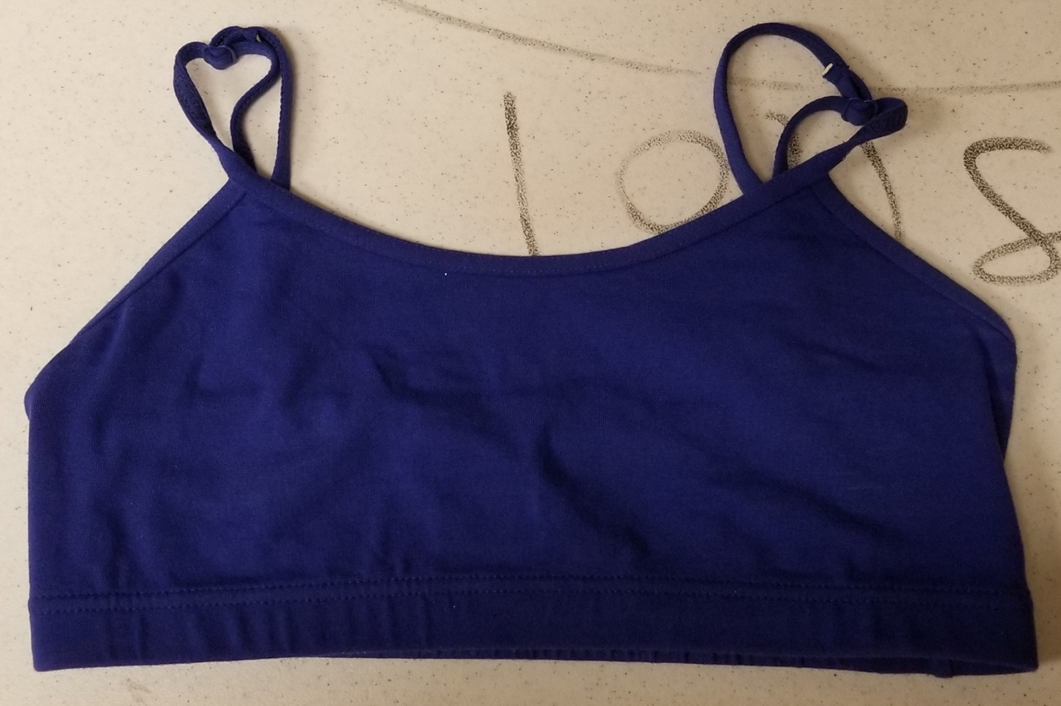

Inventory
Color | Size | Quantity | Notes
Blue | Small | 3
Blue | Medium | 3
Blue | Large | 2

Black Leotard
Manufacturer:
Item #:
Source:
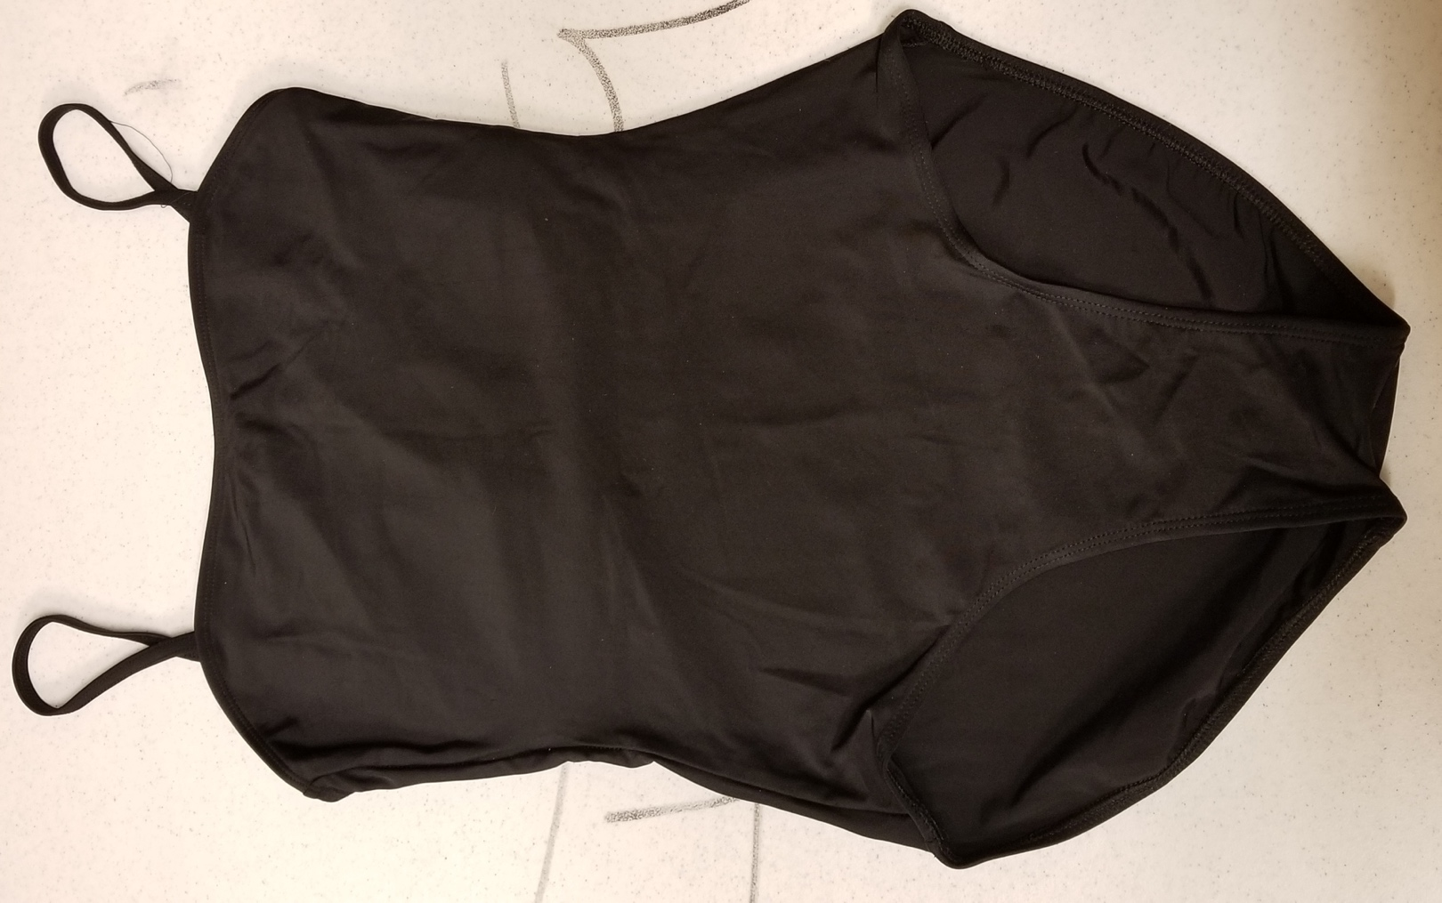

Inventory
Color | Size | Quantity | Notes
Black | Small | 1
Black | Medium | 1
Black | Large | 5
Black | X-Large | 1

Tank Sleeve Black Full-Length Romper
Manufacturer:
Item #:
Source:
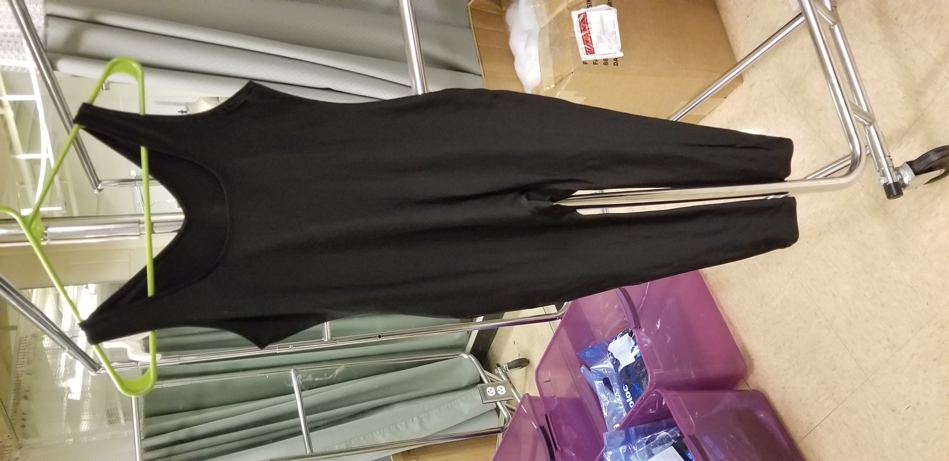

Inventory
Color | Size | Quantity | Notes
Black | Small | 7
Black | Medium | 6
Black | Large | 1
Black | X-Large | 1

Gold High-Waist Booty Short
Manufacturer:
Item #:
Source:
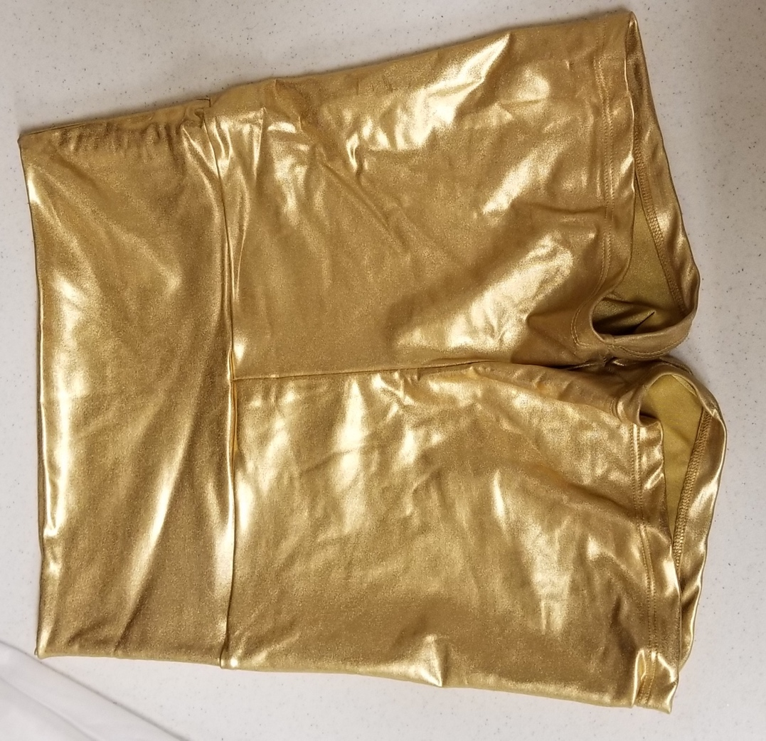

Inventory
Color | Size | Quantity | Notes
Gold | Medium | 1
Gold | Large | 1

Off-White Sheer Drop Waist Dress
Manufacturer:
Item #:
Source:

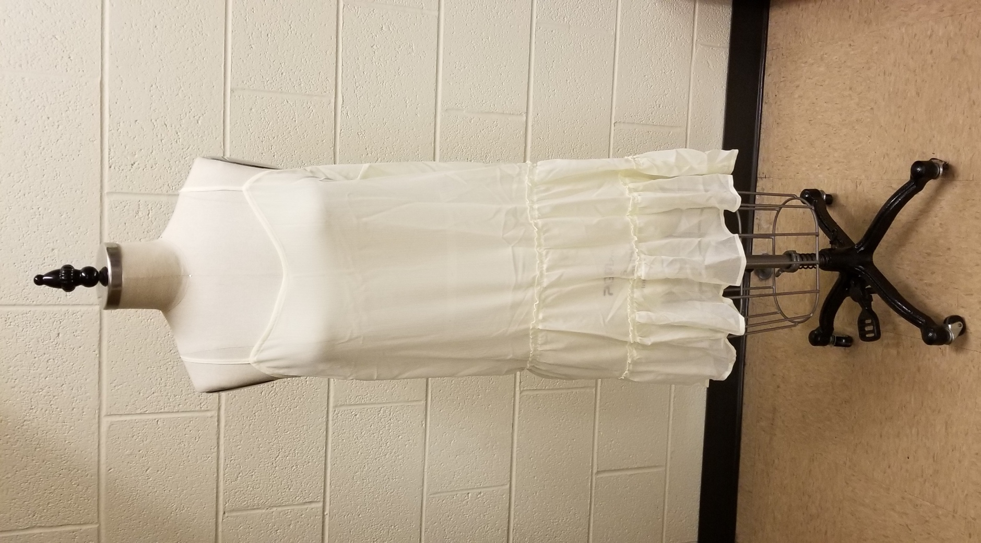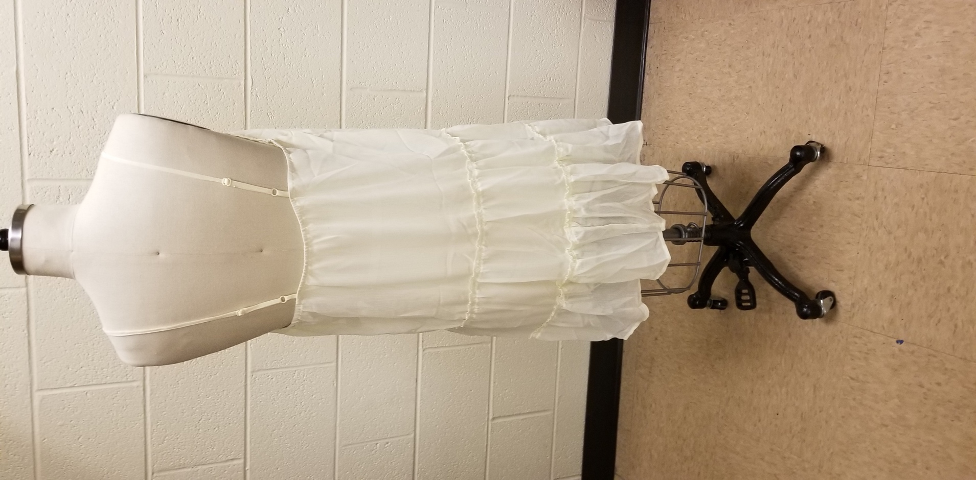
Inventory
Color | Size | Quantity | Notes
White | Large | 8

Metallic Gold Men’s T-shirt
Manufacturer: Performancewear
Item #:
Source:
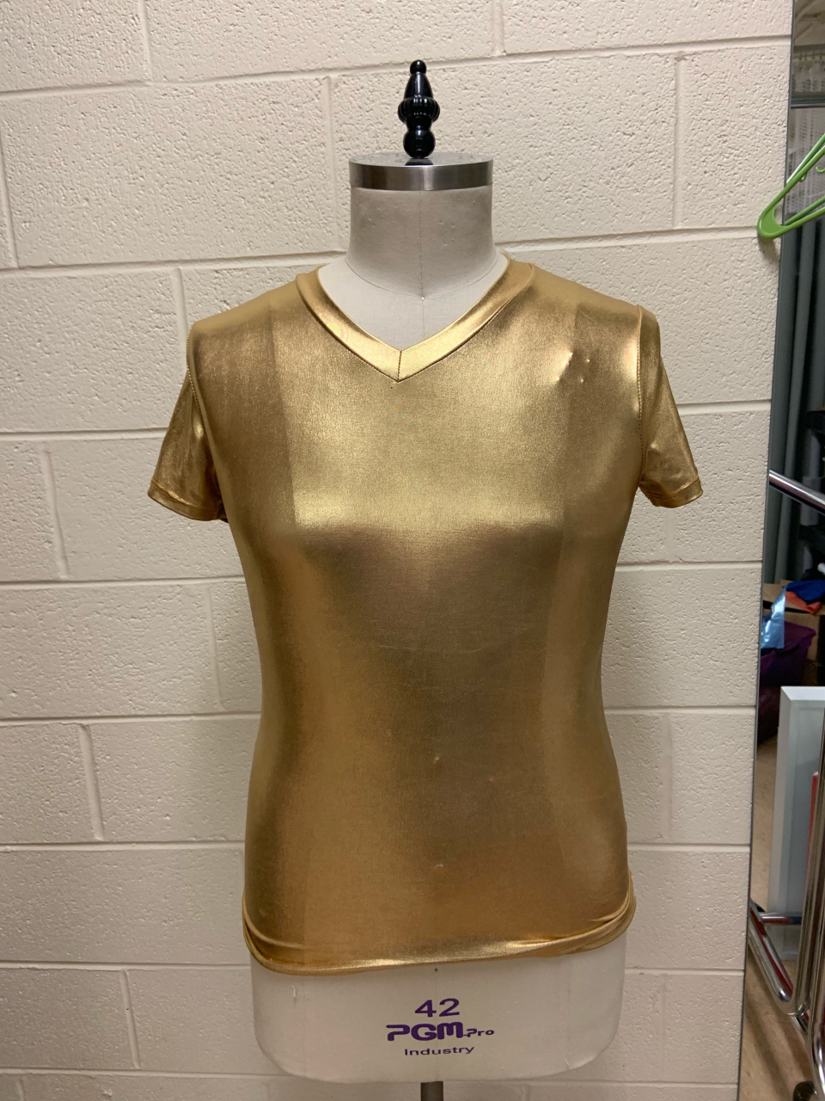

Inventory
Color | Size | Quantity | Notes
Gold | Large | 1

Black Full Length Sheer Skirt
Manufacturer:
Item #:
Source:
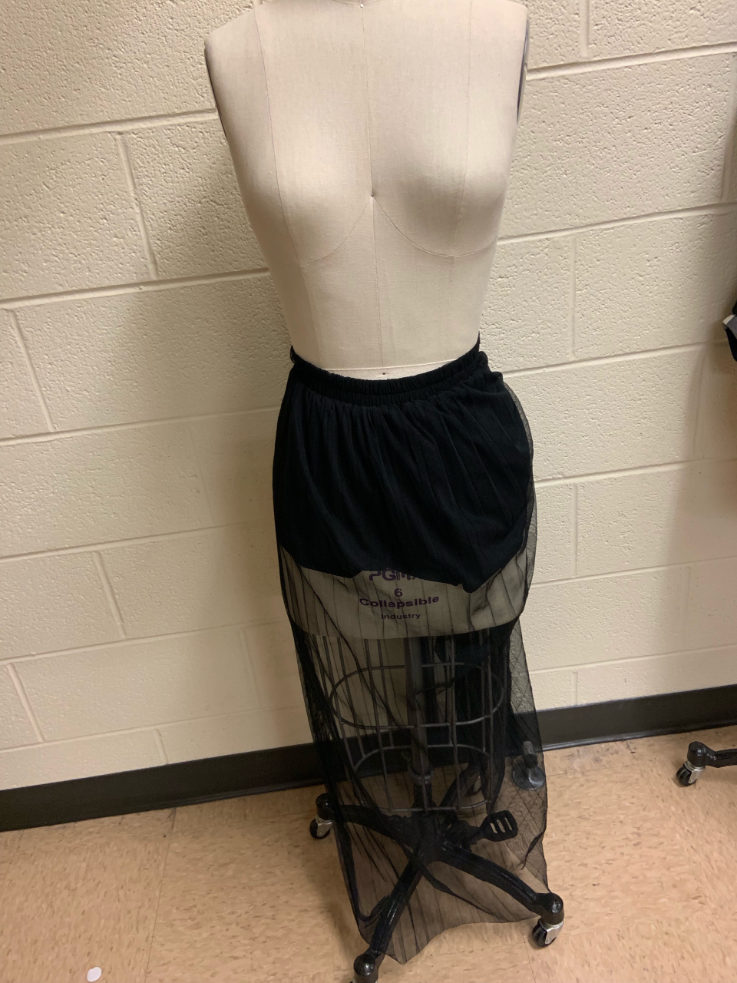

Inventory
Color | Size | Quantity | Notes
Black | 6 | 1 | Very stretched out elastic, would require altering to make it a 6 again

White Jogger Pants
Manufacturer:
Item #:
Source:
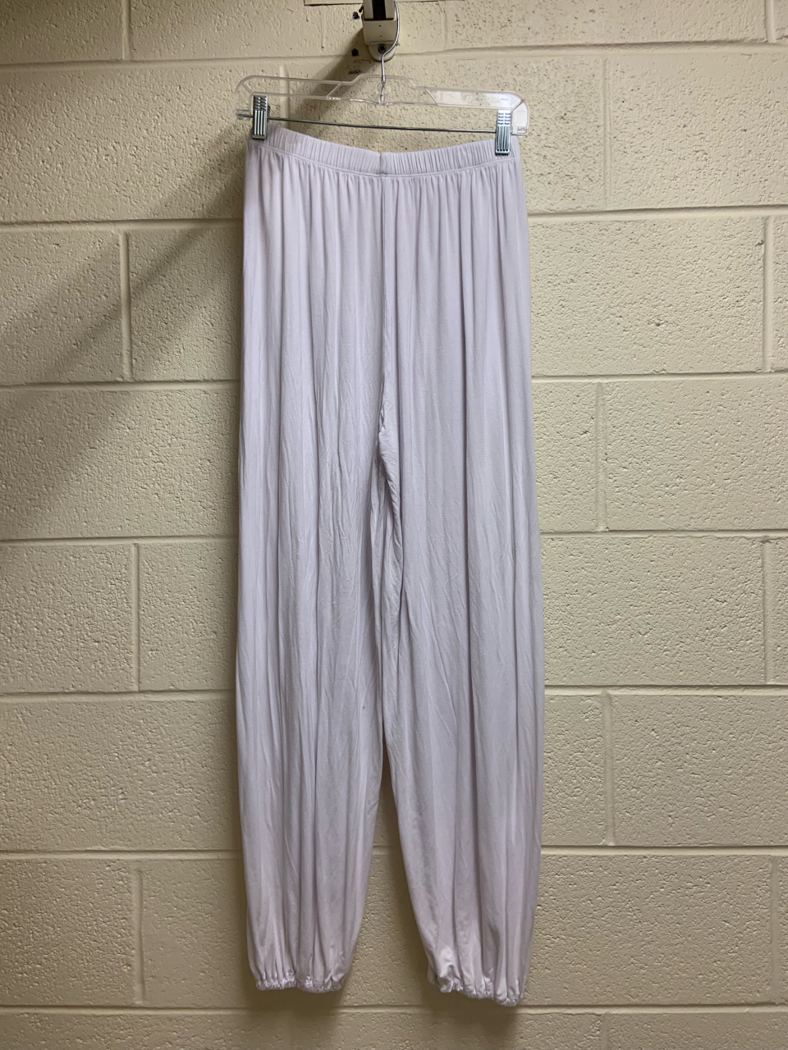

Inventory
Color | Size | Quantity | Notes
White | Unknown | 1

Full-Length White Skirt
Manufacturer:
Item #:
Source:
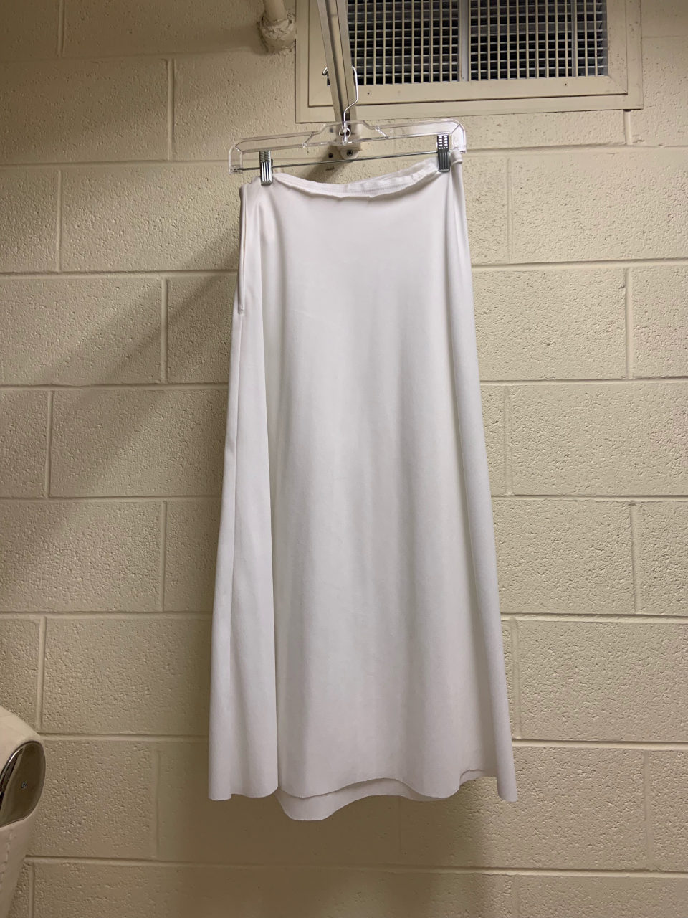

Inventory
Color | Size | Quantity | Notes
White | Unknown | 1 | Home-made, zipper on one side

White Full-Length Capri Pants
Manufacturer:
Item #:
Source:
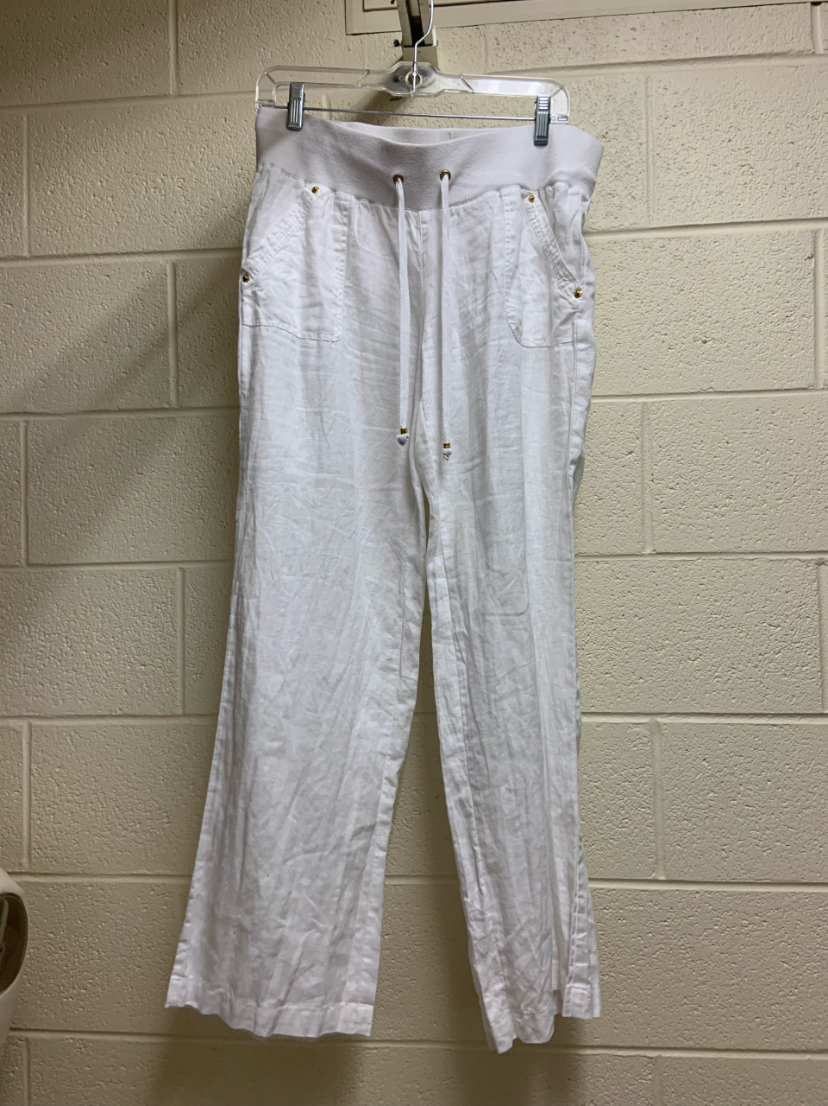

Inventory
Color | Size | Quantity | Notes
White | Unknown | 1

Black Crossed Back Sleeveless Leotard
Manufacturer:
Item #:
Source:

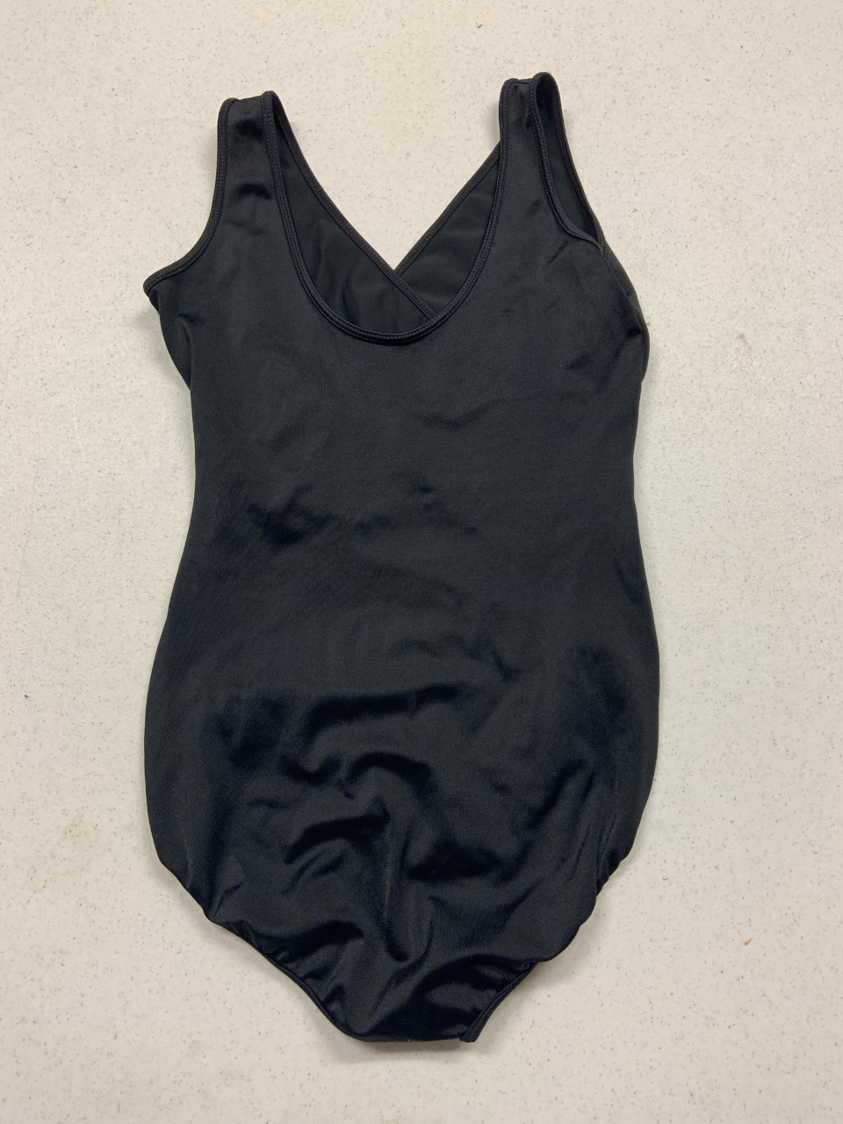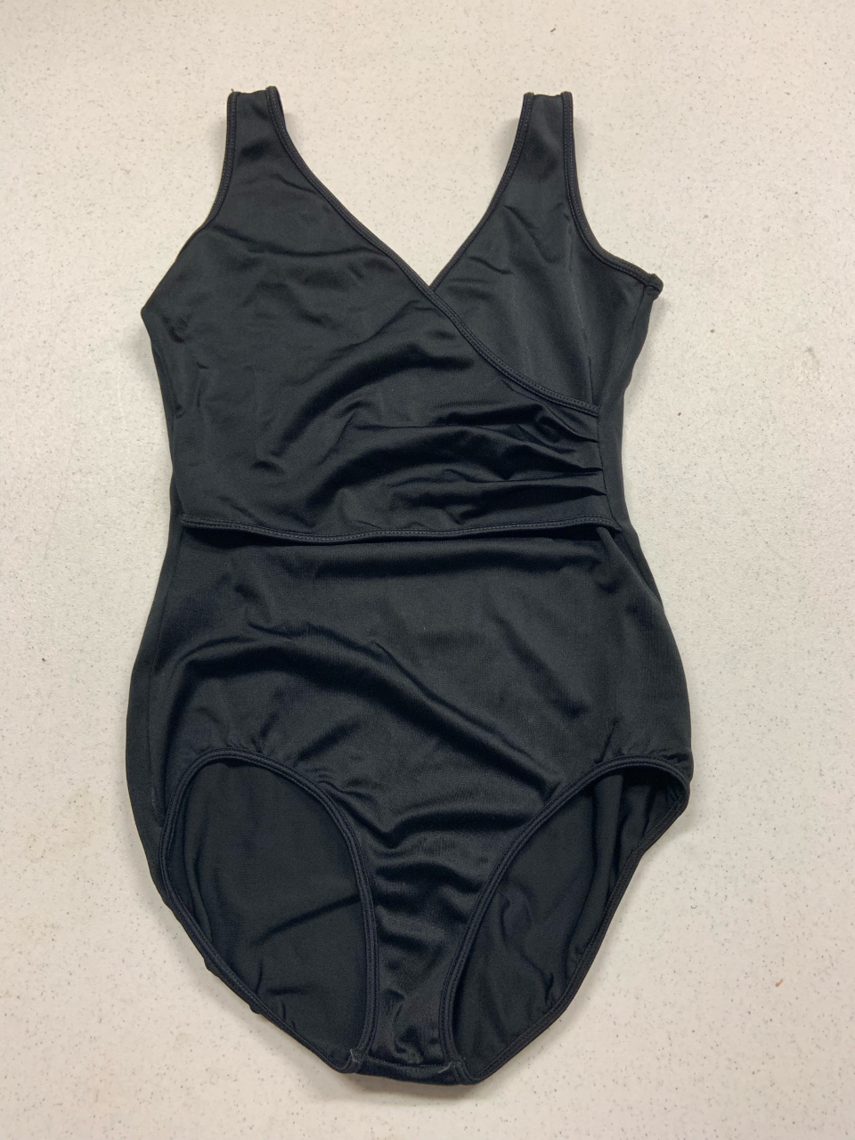
Inventory
Color | Size | Quantity | Notes
Black | Medium | 1

Gray Racerback Men’s Tank Top
Manufacturer:
Item #:
Source:
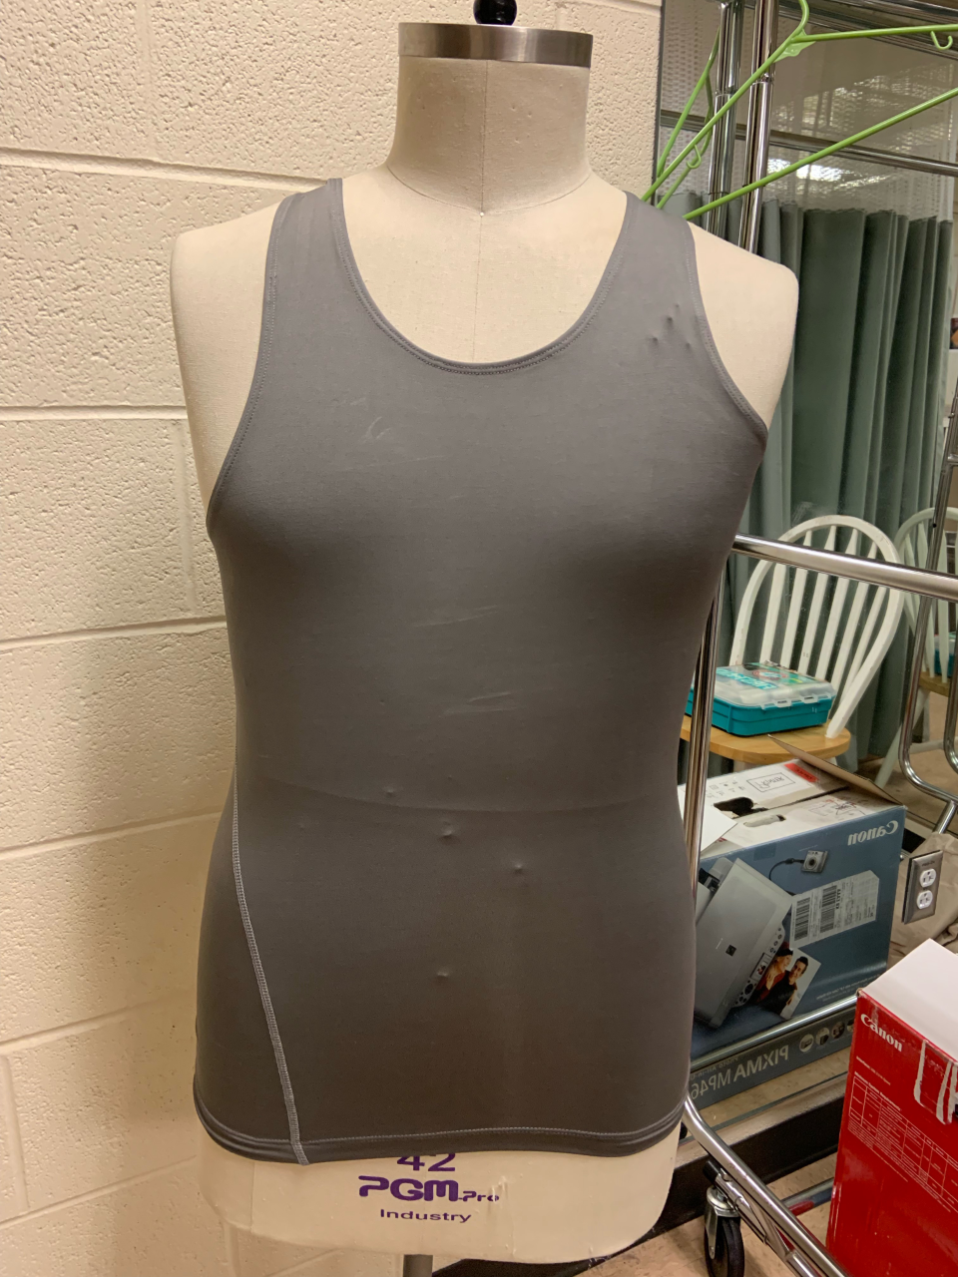

Inventory
Color | Size | Quantity | Notes
Gray | Unknown | 1

Black Sheer Striped Skirt
Manufacturer:
Item #:
Source:

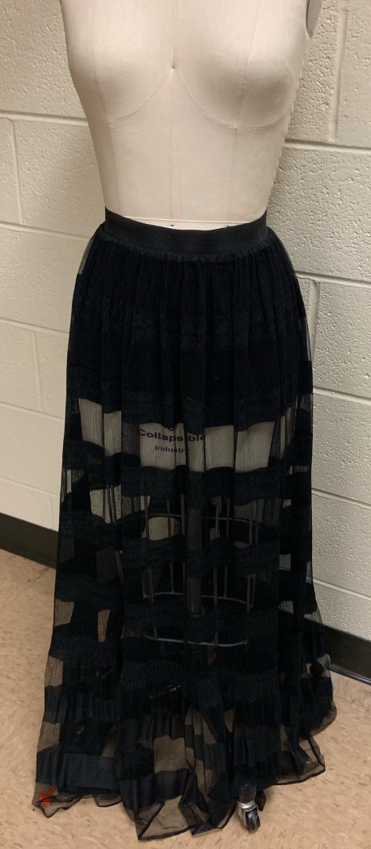
Inventory
Color | Size | Quantity | Notes
Black | Unknown | 1

