The Psychology Senior Capstone Experience (SCE) Guide

Included in this part of the Psychology SCE Guide are the guidelines and regulations for SCE research in the Psychology Department at Washington College. Should you have any questions regarding Washington College’s guidelines for research in the psychology department please contact your SCE advisor or the Psychology Department Chairperson.

Before beginning research it is important to take the time to review the APA’s Ethical Principles for Psychologists and Code of Conduct (2002). This information can be found here:
https://www.apa.org/ethics/code/index

Please pay special attention to Part 8: Research and Publication, which will provide specific information regarding the ethics and principles relating to doing research.

________________________________________________________________________

Preparing for Your SCE

We encourage students to begin gathering articles to support their SCE during the Statistics and Design II course (PSY 309) and to continue conceptualizing their project ideas during Junior Seminar (PSY 399). Students are matched with SCE advisors during the Junior Seminar course. If you are a Psychology major who has questions about the SCE process or you have not yet been matched with an SCE advisor by the end of your junior year, please talk to the department Chair. If you intend to graduate a semester early, please contact the department Chair to be paired with an SCE advisor during the fall of your junior year.

Be sure to use the 7th edition of the APA Manual (Publication manual of the American Psychological Association) for formatting the body of your paper. You may borrow a copy of the APA Manual from the psychology lobby or refer to it in Miller Library. Accurate and easily accessible information is also available at http://www.apastyle.org/

Seniors will want to regularly refer to the SCE syllabus and the SCE formatting document (both available on the website) as well as the psychology bulletin board adjacent to the atrium area of the Toll Science Center for upcoming SCE deadlines/goals. Any questions can be directed to your SCE advisor.

________________________________________________________________________
Collecting Data from Human Participants or Animals

________________________________________________________________________

If you are working with a human sample you will use the forms for the Review Board for Research on Human Subjects (IRB) and you can find the necessary information and forms here:
https://www.washcoll.edu/learn-by-doing/opportunities-research/student-research/research-policy/human-subjects-research.php

All proposals for research with human participants must go through the Institutional Review Board (IRB). Your IRB proposal must be reviewed and signed by your advisor before submitting it to the IRB. Final proposal should be sent to IRB@washcoll.edu. Information regarding room reservations, experimental credits and other procedures can be found inside this guide.

If your proposal will require full committee review (proposals that involve greater risk; talk this over with your advisor), submit your proposal at least 3-4 weeks before you intend to collect data.
________________________________________________________________________

If you are working with an animal sample you will use the forms for the Institutional Animal Care and Use Committee (IACUC) and you can find the necessary information and forms here:
https://www.washcoll.edu/learn-by-doing/opportunities-research/student-research/research-policy/animal-subjects-research.php

Before submitting the IACUC your advisor must first approve the form. The study cannot be conducted in the absence of the approved IACUC. Following approval you will work closely with your advisor in order to learn how to reserve laboratory space and use equipment properly. The majority of this guide includes information for study with a human sample, so please review the guide for general information, but contact your advisor for more specific guidelines for research with animal samples.

Rules and Regulations for Experimenters using the General Psychology Participant Pool

Obtaining an Experiment Number
Before you may collect any data with participants, you must first have obtained approval from the Institutional Review Board (IRB). When your IRB proposal is approved you will be assigned an experimental ID number.
______________________________________________________________________

In-person Experiments

Experimental Sign-up Sheet
Once you are ready for participants to sign up for your experiment, contact the Student Worker. Let them know that you are a researcher and need access to the experimental sign-up sheet. Provide your IRB experimental number, a description of the study (i.e. what the subjects will be required to do – complete surveys, complete a computerized test, interview with a group of students), a description of the requirements for participation (e.g., only women, only right-handed non-smokers, only individuals with a diagnosed learning disability), the number of potential credits, experiment location, and your gmail address (access cannot be given with washcoll.edu email addresses). Your experiment information will be entered into the “All Studies” tab and you will be assigned an experiment tab where you will fill out the times when you will be conducting experiments for participants to sign up. Be sure to type “Enter ID” under the Student ID column to let potential participants know there are openings.

Sign-up Sheet:

https://docs.google.com/spreadsheets/d/1tPhG0oHVDrYxP1Eu41n2UOt3Dvz3LrlFi3N4xtqQLh8/edit?usp=sharing

Reserving Rooms for Experiments
It is your responsibility to reserve a room where you will run your experiment:
- If your experiment is to be conducted in one of the psychology laboratories you must obtain permission from the faculty member who supervises the laboratory space.
- You can also visit or email Mrs. Bari Lynne Kersey at bkersey2 with requests for the use of NG13 and NG14.
- If you are using a room anywhere else on campus, you must reserve the room through the Registrar’s Office. If you require assistance ask your thesis advisor. It is suggested that you obtain written confirmation that the reservation has been made and retain this for your records in case there is a dispute regarding your authorization to use the room.

Completing and Distributing Experimental Credit
How much credit to give to participants for in-person studies:
- In person studies lasting up to an hour: 1 credit
- In person study lasting between 1-2 hours: 2 credits.
- If you are doing a data-driven project with human participants, please make sure the amount of credits for your study is appropriately communicated in your consent form and the participant sign-up sheet.
You MUST be on time for every experimental session you schedule and notify each participant, if possible, at least 24 hours in advance should you need to cancel an experimental session. If you must cancel your experiment with less than 24 hours notice, try to alert the student worker who might be able to contact the participants (this might not always be feasible). You should also try to leave a note on the door of the experiment room that the experiment (provide experiment number, date, and time) is canceled. Avoid doing this except for dire emergencies. You must alert your advisor if you need to cancel an experimental session.

Positive versus Negative Credits - All students who participate in your experiment should receive positive credit. General Psychology students will be told that it is their responsibility to contact the experimenter via e-mail if they must cancel their reservation. If they do not appear for your experiment at the agreed-upon time and place, and they have not contacted you to reschedule, you MUST give them negative credit.
________________________________________________________________________
Online Surveys
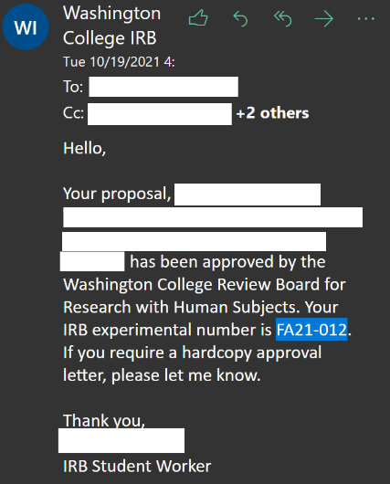
1. Posting Your Survey
After you have received IRB approval for your study (congratulations!), your study is ready to be posted. In order to make filing easy and straightforward, there are a few best practices to keep in mind when sending your survey for posting on the General Psychology Canvas pages. Firstly, make sure to take note of your IRB Experimental Number. The IRB student worker will note this in your approval email (see right).
Now, you can write your email to the Psychology Department Student Worker to have it posted! Format is not strict, but it helps keep things neat and avoids confusion during the credit tracking process further down the line. The things you should include in your email are:
- The Subject: “(IRB #) Title of Survey – Ready for Posting”
- The title of your survey, as it appears in your IRB and on your survey itself. These should be the same title. Keeping this consistent across your records and the General Psychology page, rather than using a shorted title, ensures that studies with similar subjects are still uniquely identifiable.
- The IRB Experimental Number of your survey
- A brief description of your survey:
  - The purpose of this study is to _______.
  - (Optional) Trigger/risk warning for a study if it may contain sensitive information. For instance, if you are posting a survey about eating disorders, you may want to note that questions regarding eating pathology will be included in the survey.
  - This study will take approximately ____ minutes to complete.
  - General Psychology students will receive ____ credit(s) for completion of this survey.
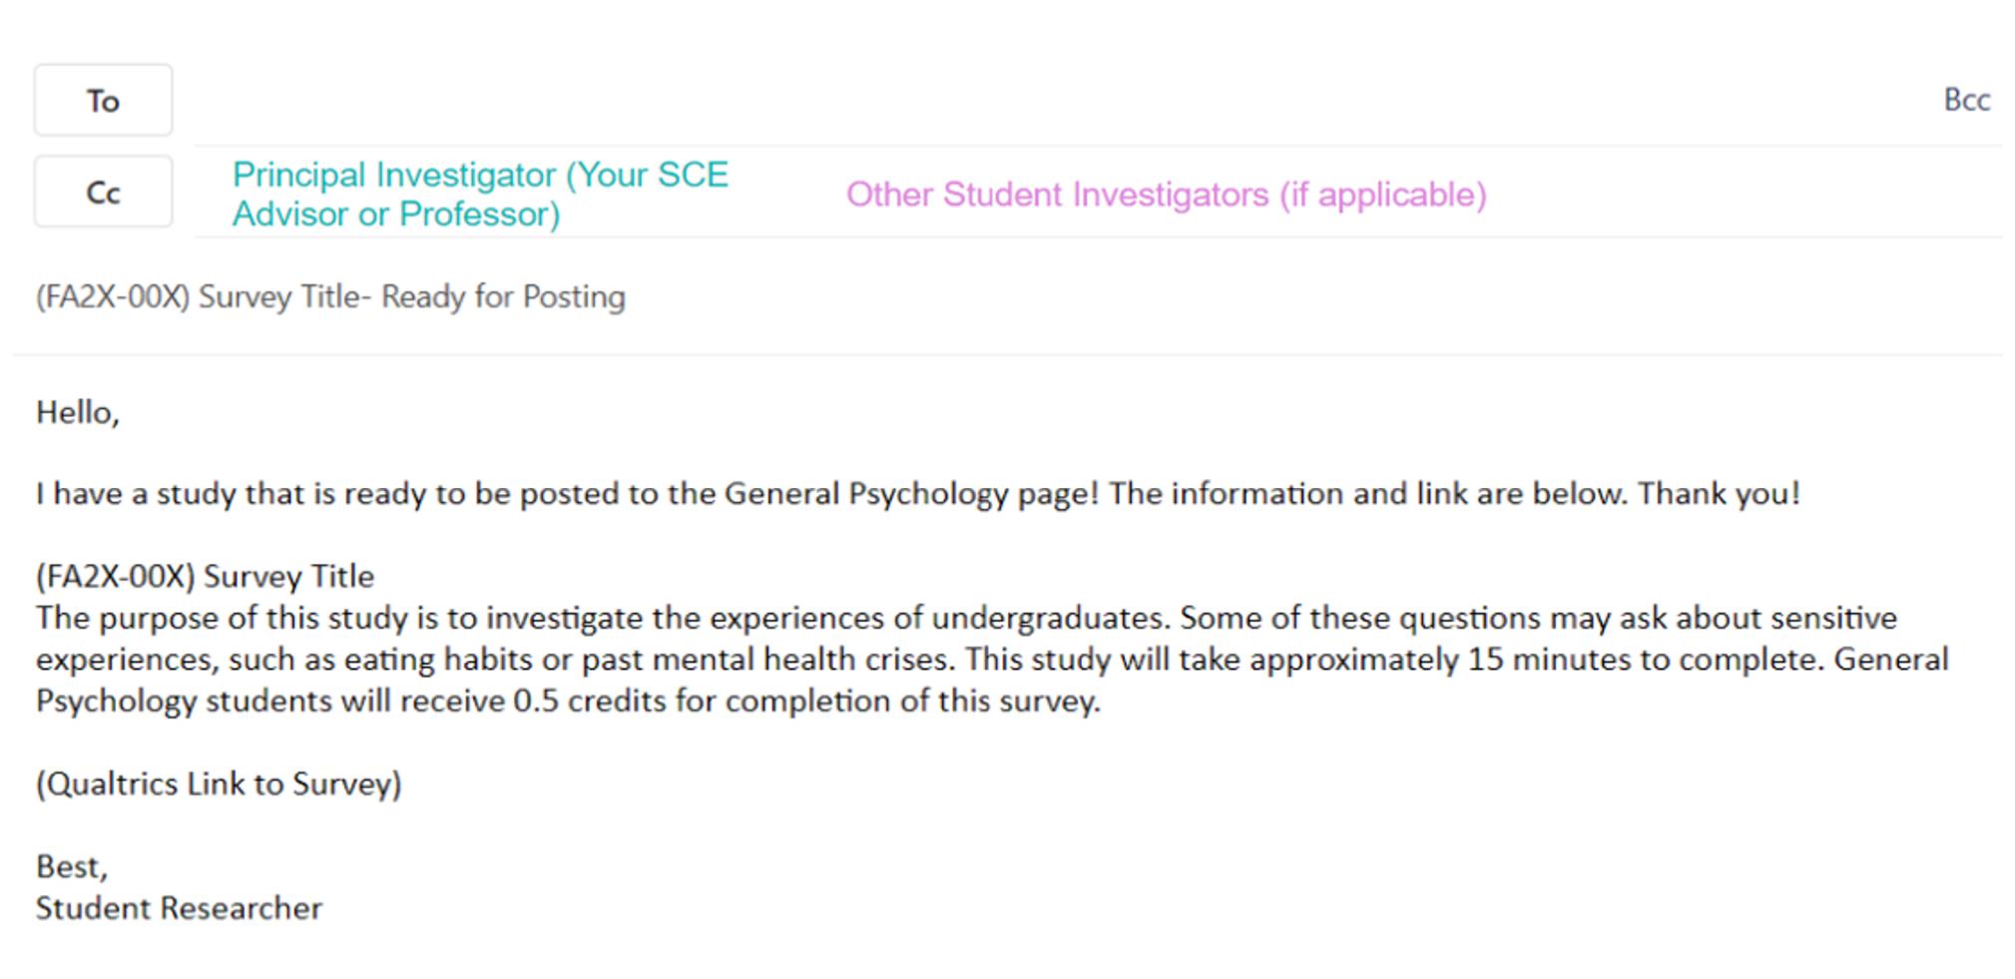
- Your Qualtrics survey link (make sure it is the published link and not a link to a preview version of your survey!)

To put that all together, here’s an example of what this might look like:

Once you have this written, you can send it to the Student Worker and they will post it to the General Psychology Canvas pages. You will receive confirmation that your study is posted through a “Like” notification or via e-mail from the Student Worker.

2. Closing Your Survey
If possible, try to let the student worker know before your survey is closed that you are planning to close it. If you know your exact data collection time frame when you send your survey for posting, feel free to include this information then. Since most students do not know their time frame prior to beginning data collection, this is not required.
When you are ready to close your survey, send the student worker a brief email about 2-3 days before closing. Simply state the date you intend to close the survey (if you have a specific time, this can also be included, but is not necessary). The Student Worker will send out a “last call” to General Psychology students to inform them that the study is closing, which may add a few more responses just prior to the survey’s close date. Then, the Student Worker will mark your study as “closed” on the Canvas pages on your close date.

3. Sending in Experimental Credit Numbers
When sending in your experimental credit numbers, please submit them as an Excel file containing one column of ID numbers. Please title the file with your IRB identifier, your survey title, and the word “IDs” (ex: FA2X-00X Survey Title IDs). This is all you need to do! At this point, if any complications arise, you will be contacted by the Student Worker to sort out lost ID numbers, but you have otherwise completed the credit reporting process. Congratulations on completing your survey, and good luck with the rest of your project!

The number of credits given per survey will be dependent upon the time it takes to complete the survey:
- Online surveys lasting up to 30 minutes = ½ credit
- Online surveys lasting 30-60 minutes = 1 credit
- Online surveys lasting 1-2 hours = 2 credits
________________________________________________________________________

SCE Tips from Past Psychology Majors
- You’ll be working with your topic for the whole year; make sure it’s something that really interests you!
- Make sure that your thesis topic applies to your concentration, if you have one.
- Your senior year flies by, so start reading applicable literature in research journals as soon as possible.
- Communicate regularly with your thesis advisor to make sure that the two of you are always on the same page.
- Be open to new ideas and ways of studying what you are interested in.
- Design an experiment you know how to analyze. Before creating a data file, play with some sample data to make sure that you understand how to analyze it.
- Be prepared to make adjustments if something goes wrong or circumstances interfere (i.e. snow days).
- Begin your data collection and analysis as soon as possible. Try to get the largest subject pool possible.
- The more revisions, the better the thesis.
- Try to meet, or beat, all deadlines.
- If you want honors on your thesis try to finish early enough in order to present your thesis at a conference – this will set you apart from the rest.
- Always keep the most updated electronic copy of your thesis in more than one place – mistakes/accidents happen!
- If you are a double major and you have to do two theses, do yourself a favor and try to finish one in the fall and one in the spring. You will thank yourself later!
- Practice running experiments on, and giving your final presentation to, your friends. This way you will have experience performing both tasks before the real thing, and your friends can give you suggestions for improvement.
- Everything will get done. Try not to get discouraged! Remember, this is all a learning experience!

