# Douglass Cater Society of Junior Fellows Application for Junior Fellows Membership

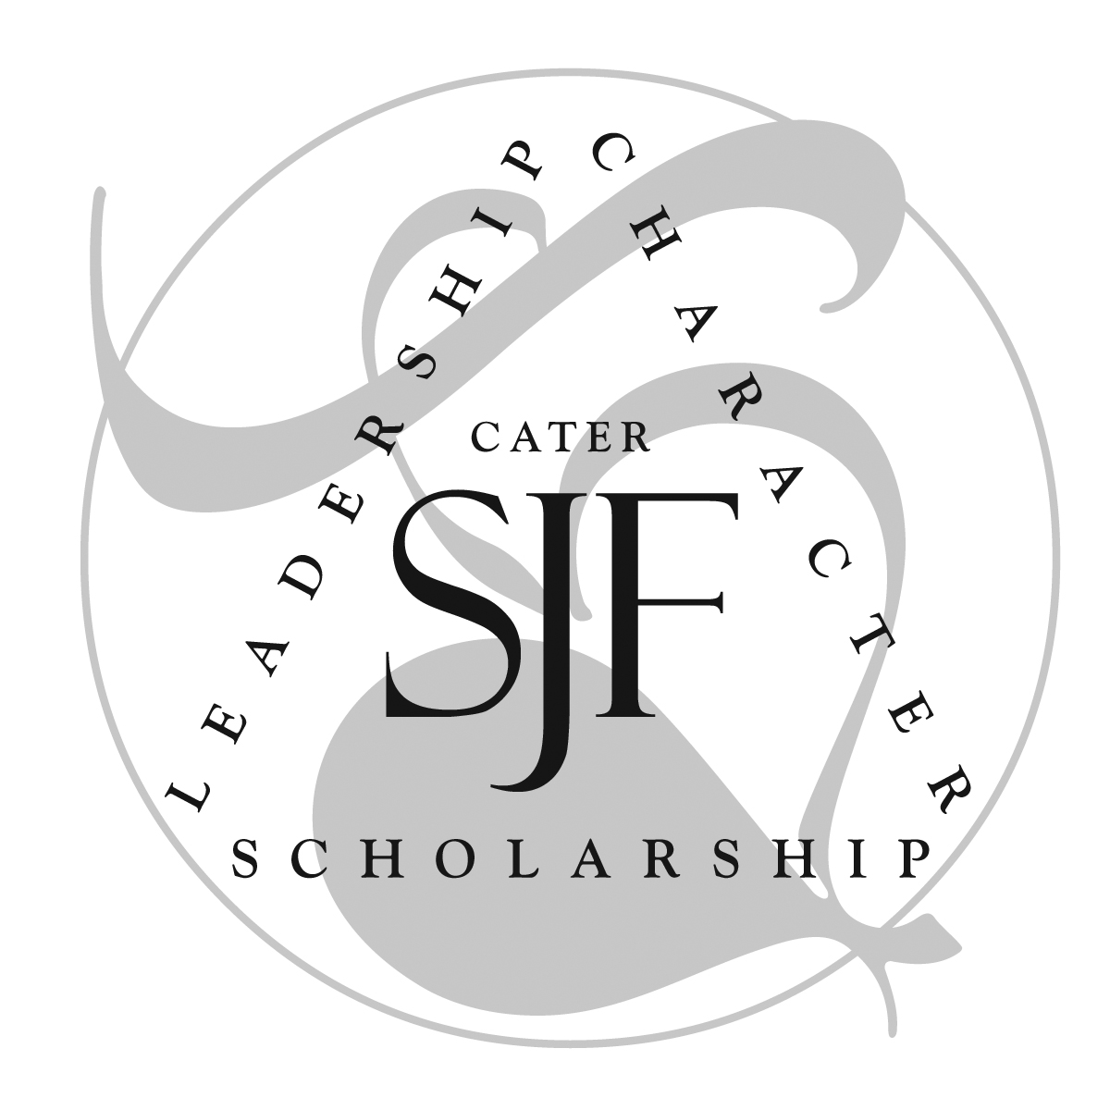

Named for journalist, educator and twenty-first president of Washington College Douglass Cater, the **Cater Society of Junior Fellows** was founded in 1992. The Society was intended "to create a collegium of students motivated to reach beyond classroom performance," both by "supporting internships or other projects individually designed by them" and fostering a "companionship of learning," "limited only by the imagination."

The Society meets regularly to hear reports from those members who have carried out projects of the kind outlined above, holds workshops on topics ranging from public speaking to the writing of grant proposals, meets from time to time to discuss anything from timeless moral questions to the pressing issues of the day, and participates in the publication of the *Washington College Review*, an annual journal of undergraduate research and writing. Members of the Society are active contributors to the intellectual, ethical, and social life of the College.

Students can apply for membership in the spring semester only. Students meeting the criteria for membership are elected to the Society by an Advisory Council, consisting of the Provost and Dean of the College, the Vice President and Dean of Student Affairs, the Chairs of the three Divisions (or their designates), the Curator, and the Student President and Vice President of the Society. The Committee looks for candidates committed to the principles of a liberal education who have shown excellence in leadership, scholarship, and character. **Admission is through a vote by the Committee after taking these attributes and other criteria into account.**

Academically, the candidate must be a full-time student who has completed three semesters in residence at Washington College (which may include a semester off-campus as an exchange student) and must plan to be in residence at Washington College for at least one more semester past the semester of admission. A GPA of 3.6 is required and the candidate should have completed the Distribution Requirements or be within one course of doing so (in such circumstances, admission will be provisional and contingent on the student completing the distribution requirement in the semester immediately after being admitted to the Society). The applicant must be of good character and in good judicial standing on and off campus, and should be engaged in extra-curricular activities that give some indication of the student’s potential for leadership. The CSJF’s Curator and Advisory Board will base their decision on these and other criteria.

Members are required to attend the bi-weekly meetings of the CSJF so as to absorb ideas and learn from the experience and example of CSJF members. They are invited to participate in activities sponsored by the CSJF for its members. Members may apply for competitive grants to fund self-designed research projects on any appropriate topic anywhere in the world. The most significant benefit to members is the intellectually stimulating environment and the opportunity to explore and experience things beyond the walls of a classroom. Many of the members are elected to the most prestigious Honor Societies on campus and have been given the highest awards at graduation. Past members are continuing to make significant contributions to their communities, the nation, and the world.

Continuation of membership is contingent upon the member maintaining academic excellence (once accepted, maintenance of a minimum GPA of 3.5 is mandatory), and remaining in good judicial standing in all walks of life. Candidates must at all times conduct themselves in a manner that does not reflect negatively on the Society. Eligibility for grants ends at graduation or at the conclusion of a maximum of five semesters including the semester in which a candidate was admitted.

**Application Checklist**

The application packet consists of:

1. A completed and signed *Membership Application Form* (found below). **A printed copy of the completed student application must be submitted to Bari Lynne Kersey, Faculty Secretary, in Toll N117 no later than** the stated deadline with no exceptions. You do not need to turn in a transcript. The committee will obtain an official WC transcript to be considered along with your application.
2. **Two letters of recommendation** from full-time faculty members who have taught you and know you well. It is your responsibility to ask these professors to separately submit these written recommendations using the faculty recommendation form. We suggest you provide the faculty members with the recommendation forms, or direct them to the downloadable form at <https://www.washcoll.edu/academics/cater-society/forms-and-downloads.php>. You should contact these professors early enough to give them the lead time they need to write your recommendation letters. **Faculty recommendations are due by the stated deadline with no exceptions**. If these recommendations are not on time, your application will not be considered.

Each applicant is responsible for submitting the signed original and for ensuring that all supporting documents are submitted as required**.** Do not submit a handwritten application. Use a word processor to fill out the form, and print your documents on a laser printer for clarity.

Summary of Deadlines:

1. Student Application Form due by the stated deadline.
2. TWO Faculty Recommendations due by the stated deadline.

**Late or incomplete applications will not be processed, so be sure to ask your professors for recommendations well in advance.**

# Douglass Cater Society of Junior Fellows Application for Junior Fellow Membership.

|  |  |
| --- | --- |
| Contact Information | |
|  | |
| Name |  |
| Post Box No. |  |
| Campus Address |  |
| Campus Phone |  |
| E-Mail Address |  |

|  |  |
| --- | --- |
| Academic Information | |
|  | |
| Class (indicate SO, JR, SR) |  |
| Majors and Minors (if declared) |  |
| Academic Advisor |  |
| Career/Professional Goals |  |

|  |  |
| --- | --- |
| Academic Record (The CSJF will obtain your GPA and rank from the Registrar. Fill out only the first six lines.) | |
|  | |
| When did you first enroll at Washington College? |  |
| How many semesters have you completed at WAC? |  |
| Student ID |  |
| Name of Recommender #1 |  |
| Name of Recommender #2 |  |
| Name of Recommender #3 |  |
| Current GPA and Class Rank |  |
| Registrar’s Attestation |  |

|  |  |
| --- | --- |
| Agreement and Signature | |
| By submitting this application, I affirm that the facts set forth in it are true and complete. I understand that if I am accepted as a full member of the Douglass Cater Society of Junior Fellows, I will be expected to attend weekly meetings regularly, to maintain a minimum GPA of 3.5 and be in good standing with the Washington College Honor Board. Failure to do so may subject me to dismissal from the Society. | |
|  | |
| Name (printed) |  |
| Signature |  |
| Date |  |

|  |
| --- |
| Academic Honors and Awards |
| Briefly list all scholastic distinctions or honors you have earned to date. List the honors and distinctions earned prior to attending Washington College separately from those you have received while attending this college. Use as much space as required. |

|  |
| --- |
| Leadership Experience & Extra Curricular Activities |
| Briefly list any leadership experience you have acquired through activities such as community service, relevant employment, volunteer work, hobbies and engagement in sports, etc. List the experience gained prior to attending Washington College separately from what you acquired while attending this college. Use as much space as required. |
|  |

|  |
| --- |
|  |

|  |
| --- |
| Applicant’s Personal Statement |
| In the space below or on a separate sheet of paper describe why you are a good fit for the Cater Society of Junior Fellows. How do you define the notion of a “companionship of learning,” and what personal strengths, experiences, convictions and goals do you have that would contribute to this companionship? The length of your statement should be at least two paragraphs and not more than one page in the Tahoma 10pt. type with interline spacing of 1.15 |
|  |

|  |
| --- |
| Applicant’s Essay |
| In the space below or on a separate sheet of paper please broadly describe some preliminary ideas for research projects that you would like to engage in with the funding available from the Cater Society of Junior Fellows, and explain how this research will build on your personal strengths to transform you as an academic and citizen-leader in the future.  Responses may describe any number of research interests but please note that research interests and potential projects will notbe evaluated based on the specificity of the interest(s) or the feasibility of the project. Rather, an ideal response should include a description of your research interest(s), a brief narrative detailing why you are passionate about these interests, and a mention of how you as a Cater Society Fellow might pursue these interests in the context of a Cater-funded project. Where might you go and what questions might you ask to further your understanding? How will this research help you to develop personally, academically, and professionally both at Washington College and beyond? If accepted to the Society, you are not required to carry out the projects you describe herein. We simply want to see what ideas you have at this point in time. The length of your statement should be at least two paragraphs and not more than one page in the Tahoma 10pt. type with interline spacing of 1.15 |