Cater Seminar Program Information and instructions for filling the Grant Application Form
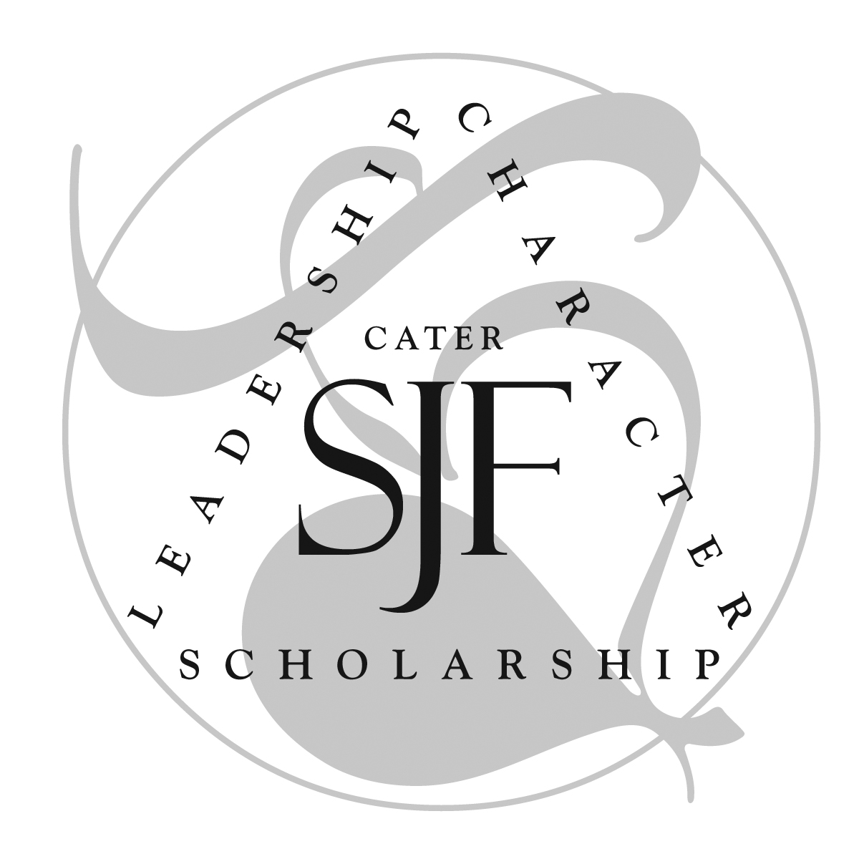
The Cater Seminar program builds on the work of the Douglass Cater Society of Junior Fellows by providing funding for faculty members who engage in highly interactive, face-to-face work with Cater Society Junior Fellows on research and other creative and/or scholarly endeavors outside of the classroom setting. The program provides support to faculty in the form of stipends and funds to offset costs associated with travel and/or materials. If you are working closely with a Junior Fellow on archival research, lab research, field research, or creative/academic writing for presentation, exhibition, performance or publication, you are eligible to apply for these funds.

The Cater Seminar Program, which funds only faculty, is separate and distinct from the Cater Society of Junior Fellows, which funds only students who are members of the Cater Society. This program is also distinct from the existing Dean’s Collaborative Grants. Cater Seminar Program funds are provided to support faculty members who are working with Junior Fellows.

Eligible faculty members may each apply for funding from the Cater Seminar Program to fund any well-conceived scholarly/creative work conducted with Cater Society Junior Fellows including research, conference presentation, or co-authorship. There must be demonstrable learning outcomes for the Junior Fellow who collaborates with the faculty member. For example, Cater Seminar Awards may be used:
- to fund a faculty member who engages a Junior Fellow in data collection in the field.
- to fund a faculty member who engages a Junior Fellow in the creation or production of an artistic work, composition, performance or exhibition.
- to fund a faculty member who engages in archival work with a Junior Fellow, or who engages a Junior Fellow in the research process for an article or book.
- to fund collaborative research in a professor’s laboratory or at other research centers.
- to fund a faculty member who engages in a research project with a Junior Fellow during the summer or winter short-term courses.
- to fund the faculty member to travel to conferences to deliver papers or posters that involve the Junior Fellow as an author or co-author.
- In summary, the Cater Seminar projects can involve a wide variety of creative/scholarly research opportunities that provide sound learning outcomes and offer a key role to a Cater Society Junior Fellow.

Summer Cater Seminar Collaborative Projects:
For collaborative projects that include a Cater student that are conducted during the summer, the Cater Seminar Program can provide faculty with any of the following:
- A $300/week stipend of up to $2500 total to compensate the faculty member for his/her time working with the Junior Fellow.
- A $300/week stipend of up to $1800 total to compensate the collaborating student(s) for his/her/their time working with the professor.
- Other funds to cover or offset the cost of summer room or board for collaborating students at the WC summer housing price.
- Travel funds for the faculty member and students to engage in co-research at another location or co-present at a conference.
- Total capped at $5000.00

Semester Cater Seminar Collaborative Projects:
For projects conducted during the regular academic year, the Cater Seminar Program can provide faculty with any of the following:
- A $300/week stipend of up to $2500 total to compensate the faculty member for his/her time working with the Junior Fellow.
- Travel funds for a faculty member to engage in co-research at another location or co-present at a conference with a Junior Fellow.
- Other funds to cover or offset the cost of materials or equipment needed by the faculty member to conduct the collaborative research with a Junior Fellow.
- Total capped at $5000.

FAQ’s:

Question: Who can apply?
Answer: Any full-time faculty member working with a Junior Fellow from the Cater Society. The Junior Fellow must play a significant role in the creative work, research, writing or presentation. For example, if the faculty member wants to fund his/her costs for a conference, the Junior Fellow must also attend, and must either be the primary author whose work was overseen by the faculty member or a co-author with the faculty member.

Question: Can I fund both a stipend and travel costs?
Answer: Yes. The total award for both summer and semester project cannot exceed $5000, but you can split the funds in any way that best supports the project.

Question: Can I apply even if I am getting funds from the Faculty Travel Fund?
Answer: Yes, as long as you are working with a Junior Fellow and the Faculty Travel funds are not overlapping in purpose with the Cater Seminar funds.

Question: Can I apply even if I am getting funds from the Faculty Enhancement Fund?
Answer: Yes, as long as you are working with a Junior Fellow and the Faculty Enhancement funds are not overlapping in purpose with the Cater Seminar funds.

Question: Can I apply even if I am getting funds from the Dean’s Collaborative Grants?
Answer: No. The Dean’s Collaborative Grants provide ample funding for summer projects.

Question: Where do I find the application?
Answer: The application is located on the Cater Society of Junior Fellows Webpage under “Faculty Cater Seminar Program.”

Question: What is the deadline for Cater Seminar awards, and how are awards determined?
Answer: The deadline for applications is rolling. Awards are funded on a competitive basis.

Question: How do I determine a stipend amount?
Answer: Mirroring the Faculty Collaborative Grants, the cap for a faculty stipend is $300/week of collaborative work with a Cater Society Junior Fellow. To request a stipend, submit a timeline that indicates when the work will be conducted.

Question: How do I know if a student is a Junior Fellow in the Cater Society?
Answer: Ask the students with whom you are working! The student officers of the Douglass Cater Society of Junior Fellows also maintain a list of members on the Cater Society webpage that is updated at least twice a year. See the “Member List” at https://www.washcoll.edu/academics/cater-society/member-list.php

Guidelines and Requirements for Grant Applications

- Awards are given on a competitive basis.
- Fulltime faculty members are eligible to apply for multiple separate awards in a year.
- Awards are subject to the availability of funds over the entire academic year.

Cater Seminar Program Grant Application Form

Applicant Contact Information
Date of Application
Name and Title
Campus Phone
E-Mail Address

Project Information
Title of the Project
Project Location
Total Amount Requested
Start and End Dates of the Project
Contact hours expected with Junior Fellow

Information about the Junior Fellow engaged in the project
Student Name
Year at the college (Senior, Junior, etc)
E-Mail Address
Is the student applying for a Cater Society Grant to support their collaboration with you? If so, how much are they requesting?

Project Description – see following page
Section 1: In 1-2 paragraphs describe the aim and scope of the project, including the central academic goal (or nature of the artistic project, the research method (or creative process) that will be deployed in the project. In what ways will the Junior Fellow be involved? Clearly articulate the outcomes/deliverables of the project itself, and the learning outcomes for the Junior Fellow.

Section 2: Please provide a succinct timeline for the project and describe the responsibilities of both the faculty member and the Junior Fellow:

Section 4: Have you applied to other sources of funding (foundations, scholarships, other college grants such as the collaborative grant, etc.?) If so, please list the sources and amounts.

Budget
Provide an itemized budget and budget narrative. Please note the total budget for a semester project cannot exceed $5000. Summer projects must itemize all potential costs and are capped at $5000. Under “other” please include one-time and long-term expenses that are not in the other categories.

Agreement and Signature
By submitting this application, I understand that if I receive a grant I am obliged to submit a 1-page report detailing the outcomes achieved.
Name (printed)
Signature
Date

CSJF Use only
Approval Status
Amount Allocated
Comments

Curator’s Signature

